**The GEARS Online Publication**

**A Capstone Project Proposal**

**Presented to the Faculty of College of Computer Studies**

**Laguna State Polytechnic University**

**Santa Cruz Campus**

**In Partial Fulfilment of the requirements for the Degree**

**BACHELOR OF SCIENCE IN INFORMATION TECHNOLOGY**

**By:**

**DY, JEAL ANN E.**

**MACEDA, ERICCA P.**

**REYES, ROBIN J.**

**2021**

**VISSION AND MISSION**

**VISION**

The Laguna State Polytechnic University is a center of sustainable development initiatives transforming lives and communities.

**MISSION**

LSPU provides quality education through responsive instruction, distinctive research, sustainable extension, and production services for improved quality of life towards nation building.

**QUALITY POLICY**

LSPU Provides quality education through responsive instruction, distinctive research, sustainable extension, and production services. Thus, we are committed with continual improvement to meet applicable requirements to provide quality, efficient and effective services to the university stakeholders’ highest level of satisfaction through an excellent management system imbued with utmost integrity, professionalism, and in-novation.

**Goal of the College of Computer Studies**

The College of Computer Studies aims to develop globally competitive graduates equipped with the knowledge, skills, and values necessary for Information Technology Education programs undertaking instruction, research, extensions and production.

**Objectives of BS Information Technology Program**

**Instruction**

1. To provide theoretical and technical skill through instruction, seminars, and workshops.
2. To expose students to globally competitive IT atmosphere.
3. To develop locally and globally competitive graduates with desirable work values and attitudes.
4. To initiate creative and innovative professional enhancement among instructors and student through skill training, on-the-job training industry.

**Research and Development**

1. Strengthen competencies of both instructors and students in the field of research that will serve as a basis for technological problem-solving.
2. Conduct information technology survey, interview and feasibility studies meet the demands of the changing world through information technologies and processes.
3. Produce IT researchers to serve as a self-generating critical mass of human resources for research and development in Information Technology area.

**Extensions**

1. Forge critical linkage with local and foreign partners to support the activities of the department.
2. Conduct outreached program such as basic and advance computer literacy pro-gram and the like.
3. Create training plans and information technology packages to supply the need of the community.
4. Provide assistance for the project development.

**Production**

1. Produce information system and technologies that can be used as an income generating project of the college.
2. Produce information system and technologies that can be used as an income generating project of the college.

Republic of the Philippines

Laguna State Polytechnic University

Province of Laguna

**COLLEGE OF COMPUTER STUDIES**

**APPROVAL SHEET**

This Capstone Project entitled **“The GEARS Online Publication”** prepared and submitted by **Dy, Jeal Ann, Maceda, Ericca, Reyes, Robin** in partial fulfillment of the requirements for the degree Bachelor of Science in Information Technology is hereby recommended for approval and acceptance.

**REYNALEN C. JUSTO, MM-ITM, LPT**

Adviser

Date

=============================================================

APPROVED by the Committee on Final Oral Examination with a grade of ____ on DATE.

**RONNEL P. VIRTUCIO**

Specialization Expert

**ALLIANA M. ABLAN**

Technical Editor

**REYNALEN C. JUSTO, MM-ITM, LPT**

Chairman

**DR. CEAZAR D. PAMIN**

Language Critic

.

**JOSEPHINE A. VILLAMIN**

Statistician

=============================================================

ACCEPTED and APPROVED in partial fulfillment of the requirements in Bachelor of Science in Information Technology.

**REYNALEN C. JUSTO, MM-ITM, LPT**

Associate Dean, CCS

Date

Research Contribution Number

**RINA J. ARCIGAL Ed.D**

Chairperson, Research and Development

**ACKNOWLEDGEMENT**

This research would not be possible without those people who had helped provided technical assistance, advice and many other services

We would like to express our deep and sincere gratitude to our research advisor, **Mrs. Reynalen C. Justo, MM-ITM**, for giving us the opportunity to conduct a research and providing us the invaluable guidance and knowledge throughout this research. Her motivation, vision and sincerity to guide us deeply inspired us and push us to keep on going forward.

**Mrs. Josephine Villamin**, the researchers would like to express sincere gratitude to our statistician for the guide in interpreting the data collected to our research.

**Mrs. Alliana Miranda-Ablan,** our Technical Editor, for her assistance making a constructive research papers as well as forming this study.

**Mr. Ronnel Virtucio** our Specialization Expert who guided us on creating our mobile application and encourage us to finish this study.

**Dr. Ceazar Dela Rosa Pamin,** our English Critic, for sharing her time in editing this study.

**Dr. Mia V. Villarica**, Chairman of the College of the Computer Studies for allowing the proponents to conduct this thesis.

To the College of Computer Studies Department, to their kind and patient teachers who continuously guiding and supporting us.

We are extremely grateful to our parents for the support, patience, prayers, love and sacrifices for educating and preparing us for our future. We would also like to thank our friends for their support and love.

We are very much thankful to all people that participate in conducting our research, especially to the GEARS Publication Members Online for the support.

Lastly, To God, who guide us knowledge and strengthen us to finish this task

We are not in the place where we are now. Thankyou everyone for all the support.

**JA.E.D**

**E.P.M**

**R.R.**

**ABSTRACT**

The study entitled “the GEARS Online Publication” has general objectives: to develop a system that will preserve the GEARS Publication history and help to promote/endorse the LSPU main publication. It also has a several specific objectives: to create a system that will help the GEARS Publication work to be more efficient and convenient, to design a system that will help to improve the old process of the GEARS Publication, to evaluate the functionality of the system.

The following result of the performance of the application was shown as perceived by the respondents in terms of quality factors, perceive ease of use, perceived usefulness, actual use and maintainability of the system. These entire criteria were determining through data gathering and statistical tools such as surveys and interview, the researchers are able to determine the differences and measures the effectiveness of the existing and the proposed software by using purposive sampling method as their sampling tools.

When the evaluation was all settled, the researchers analyzed, tabulated and interpreted the result by computing the overall performance of the website, the study was evaluated by 44 respondents. The Coordinator of the GEARS Publication, secretary, 12 editorial boards and 30 active members of the publication.

The result of the questionnaire for is that there is an average mean of 4.6 on the criteria of Quality Factors of the website with standard deviation of 0.52. For the criteria of Perceive Ease of Use, the result of the questionnaire that there is an average mean of 4.64 with standard deviation of 0.39. Meanwhile, the result of the questionnaire is that there is an average mean 4.64 on the criteria of Perceived Usefulness with standard deviation of 0.44. The result of the questionnaire for is that there is an average mean of 4.6 on the criteria of Actual Use of the website with standard deviation of 0.42. Last, the result of the questionnaire is that there is an average mean 4.31 on the criteria of Maintainability of the System with standard deviation of 0.65. This means that all the criteria were interpreted as Acceptable.

The researchers cited several related studies from international, national and local researchers that provided direction for the competition of the website of the GEARS Publication. The researchers used Agile Software Development Method to develop a system that can monitor the release of articles of The GEARS Publication because this method has clear guidance and principles, and also adaptable to changing requirements throughout the process.

Based on the findings and conclusion, the following were recommended: 1. Future researchers may improve the design of the system making it more appealing. 2. Future researchers may add a feature to upload video contents.

For additional improvement of this application, the researchers propose that even if this study is effective as perceived by its respondents, it is still recommended to make more enhancements on its design.

***Keywords:*** *Online, Publication, Web base, Agile and TAM*

**TABLE OF CONTENTS**

**Preliminary Pages**

**The GEARS Online Publication** i

**VISSION AND MISSION** ii

**APPROVAL SHEET** iv

**ACKNOWLEDGEMENT** iv

**ABSTRACT** vi

**TABLE OF CONTENTS** viii

**OPERATIONAL TERMS** xvi

**TECHNICAL TERMS** xviii

**CHAPTER I** 1

**INTRODUCTION** 1

**Project Context** 2

**Research Objectives** 3

**Conceptual Framework** 4

**Project Purpose** 5

**Scope of the Study** 5

**Limitations of the Study** 6

**CHAPTER II** 7

**REVIEW OF RELATED LITERATURE** 7

**Synthesis** 25

**CHAPTER III** 32

**RESEARCH METHODOLOGY** 32

**Research designs** 32

**Population of the Study** 33

**Locale of the Study** 33

**Sampling Design** 35

**Data Collection Instruments** 35

**Observations** 36

**Interviews** 36

**Research** 37

**Statistical Treatment** 37

**Likert Scale** 38

**Project Design** 39

**Software Development Model** 39

**Evaluation and Testing Procedure** 42

**Evaluation tool** 43

**Evaluation Procedure** 43

**Testing Tool** 45

**Testing Method** 46

**CHAPTER IV** 57

**RESULTS AND DISCUSSION** 57

**Research Objectives** 57

**CHAPTER V** 86

**SUMMARY, CONCLUSION AND RECOMMENDATION** 86

**BIBLIOGRAPHY** 89

**APPENDICES** 96

**LIST OF FIGURES**

Figure 1. Conceptual framework of the study…………………………………….…...4

Figure 2. Respondents for TAM……………………………………………………...34

Figure 3. Agile Software Development……………………………………….….......39

Figure 4. Technology Acceptance Model Questionnaire………………………….....42

Figure 5. Shows the Main Page of the Online publication and the category………...59

Figure 6. Homepage……………………………………………………………….....60

Figure 7. Announcement Page…………………………………………………….…60

Figure 8. About us…………………………………………………….……….……..60

Figure 9. Contact Details………………………………………………………..……61

Figure 10. Dashboards………………………………………………………..………61

Figure 11. Add Category…………………………………………………….…...…..62

Figure 12. Manage Categories………………………………………………..….…...62

Figure 13. Sub Category…………………………………………………………..….62

Figure 14. Manage Sub-Categories………………………………………………......63

Figure 15. Add Posts……………………………………………………………..…..63

Figure 16. Manage Posts…………………………………………………………..…64

Figure 17. Recycle Bin…………………………………………………………….....64

Figure 18. About Page………………………………………………………….….....64

Figure 19. Contact Us………………………………………………………………...64

Figure 20. About Us………………………………………………………………….65

Figure 21. Manage Comments……………………………………………………….65

Figure 22. Publication Reports Distribution………………………………………….65

Figure 23. Distribution Items………………………………………………………...66

Figure 24. Distribution Details…………………………..…………………………...66

Figure 25. Client Details………………………………………………...…………...66

Figure 26. Evaluated System…………………………………………………………67

Figure 27. Testing Questionnaire Adding Post to the Online Publication…………...69

Figure 28. Testing Questionnaire Adding Categories……………………..…….…...69

Figure 29. Testing Questionnaire Adding subcategories ……………………...….....70

Figure 30. Testing Questionnaire Editing Homepage ……………………………….70

Figure 31. Testing Questionnaire Editing About Us Page…………………………...71

Figure 32. Testing Questionnaire Editing Contact, Us Page ………………………...71

Figure 33. Testing Questionnaire Editing Announcement Page ………………..…...72

Figure 34. Testing Questionnaire Managing Comments …………………………….72

Figure 35 Testing Questionnaire Managing Records …………………………….….73

Figure 36. Testing Questionnaire IT experts Adding Post…………………………...74

Figure 37. Testing Questionnaire IT experts Adding Categories……..…….…..........74

Figure 38. Testing Questionnaire IT experts Adding subcategories …………….......75

Figure 39. Testing Questionnaire IT experts Editing Homepage ……………………75

Figure 40. Testing Questionnaire IT experts Editing About Us Page……………......76

Figure 41. Testing Questionnaire IT experts Editing Contact, Us Page ………….....76

Figure 42. Testing Questionnaire IT experts Editing Announcement Page ………....77

Figure 43. Testing Questionnaire IT experts Managing Comments ……………...…77

Figure 44. Testing Questionnaire IT experts Managing Records …………….……..78

Figure 45. HIPO Model……………………………………………………………..111

Figure 46. User Manual Home Page……………………………………………......126

Figure 47. User Manual Admin……………………………………………………..127

Figure 48. User Manual Dashboard……………………………………………...…127

Figure 49. User Manual Add Category……………………………………………..127

Figure 50. User Manual Sub-Category……………………………………………...128

Figure 51. User Manual Manage Category……………………………………...….128

Figure 52. User Manual Add Post…………………………………………………..128

Figure 53. User Manual Manage Post………………………………………………129

Figure 54. User Manual Comment Page…………………………………………....129

Figure 55. User Manual Publication Reports………………………………...……..129

Figure 56. User Manual Distribution Item page…………………………………….130

Figure 57. User Manual Details Page……………………………………...………..130

Figure 58. User Manual Client Details……………………………………..……….130

**LIST OF TABLES**

Table 1. Frequency Distribution of Respondents…………………………………….33

Table 2. Likert Scale…………………………………………………………………39

Table 3. Shows the Questions for Quality factors……………………………….…..44

Table 4. Shows the Questions for Perceive Ease of Use…………………………….44

Table 5. Shows the Questions for Perceived Usefulness…………………………….44

Table 6. Shows the Questions for Actual Use………………………………………..45

Table 7. Shows the Maintainability of the System…………………………………...45

Table 8. Adding Post to the Online Publication……………………………………...47

Table 9. Adding Categories……………………..…………………………………...48

Table 10. Adding subcategories to the Online Publication……………………...…...49

Table 11. Editing Homepage of the Online Publication……………………………..50

Table 12. Editing About Us Page of the Online Publication…………………………51

Table 13. Editing Contact, Us Page of the Online Publication………………………52

Table 14. Editing Announcement Page of the Online Publication………………..…53

Table 15. Managing Comments from the Online Publication……………………….54

Table 16. Managing Records from the Online Publication Distribution System…….55

Table 17. Quality Factors…………………………………………………………….81

Table 18. Perceive of Use…………………………………………………………….82

Table 19. Perceived Usefulness………………………………………………………83

Table 20. Actual Use…………………………………………………………………84

Table 21. Maintainability of the System……………………………………………..84

Table 22. Overall Mean Results……………………………………………………...85

Table 23. Testing Questionnaire Adding Post to the Online Publication…………..114

Table 24. Testing Questionnaire Adding categories to the Online Publication...…..115

Table 25. Testing Questionnaire Subcategories to the Online Publication………....116

Table 26. Testing Questionnaire Homepage of the Online Publication…………….117

Table 27. Testing Questionnaire About Us Page of the Online Publication……..…118

Table 28. Testing Questionnaire Contact, Us Page of the Online Publication…......119

Table 29. Editing Announcement Page of the Online Publication……………...…..120

Table 30. Managing Comments from the Online Publication…………………..…..121

Table 31. Managing Records from the Online Publication Distribution System…...122

**APPENDICES**

**A. TECHNICAL BACKGROUND**

Process Flow Charts

Proposed Process Flow Charts

Use Case Diagrams

Data Dictionary

HIPO Model

Project Schedule

Testing and Evaluation Instruction

User’s Manual

Relevant Source Code

**B. COMMUNICATION LETTER & FORMS**

Request Letter

Proposal Approval

Summary of Recommendations

Operation Terms

Technical Terms

**C. CURRICULUM VITAE**

**OPERATIONAL TERMS**

The proposed system has the following terms that has been operationally defined for a better understanding of the study

|  |  |
| --- | --- |
| **Database Schema** | We used this logically group objects such as tables, views, stored, procedures etc. |
| **Data Dictionary** | This were we described the contents, format and structure of a database and the relationship between its elements, used to control access to and manipulation of the database. |
| **Data Flow Diagrams** | We used this as graphical representation of the flow of data through an information system and modelling its proper aspects. |
| **Fishbone Diagram** | It refers to the visualization tool for categorizing the potential causes of a problem in order to identify its root causes. |
| **Process Flow Chart** | It is a diagram of the sequence of movements or actions of people or things involved in a complex system or activity. |
| **Project Schedule** | This chart was used in order to show the amount of work done or production completed in certain period of time. |
| **Use Case Diagram** | It is a presentation of a user’s interaction with the system that shows the relationship between the user and the different use cases in which the user is involved. |
| **System Context Diagram** | It defines the boundary between the system or part of the system. |

**TECHNICAL TERMS**

|  |  |
| --- | --- |
| **Computer** | This refer to an electronic device that accepts, processes, stores and outputs data at high speeds according to programmed instructions. |
| **HTML** | It is the standard markup language for creating web pages. |
| **JAVASCRIPT** | This refer to a programming language used in web development |
| **PHP** | It is a general-purpose scripting language especially suited to web development. |
| **Prototype** | An early sample, model, or release of a product built to test a concept or process. It is a term used in a variety of contexts, including semantics, design, electronics, and software programming |
| **Sublime** | this refer to a sophisticated text editor for code, markup and prose. |
| **Technology** | This refers to a broad term that refers both to artifacts created by humans, such as machines and the methods used to create those artifacts. |
| **Weighted Mean** | A weighted mean is a kind of average. Instead of each data point contributing equally to the final mean, some data points contribute more weight than others. |
| **XAMPP** | This refers to a broad term that refers both to artifacts created by humans, such as machines and the methods used to create those artifacts. |

**CHAPTER I**

**INTRODUCTION**

Today, most of the people rely on the modern technology in terms of studying, business, medicine, communication, entertainment and so on. Technology brings so much greater comfort in living than these past few years and technology is even more innovating. It is a big proof that most of the Filipinos rely with the help of technology.

Laguna State Polytechnic University Main Campus in Santa Cruz Laguna have their official publication named the GEARS. The Publication was known for providing information in every events and activity that happen inside the campus for a sustainable amount of time. All the news and articles that the publication develop will be distributed for the students, offices, and departments. Ms. Chiqui Labastilla is the coordinator of the GEARS Publication, for almost one and a half year. The said Publication already has a great amount of achievements some of these great achievements are the following, 10th university wide press conference –BEST CONTINGENT PUBLICATION, Regional Higher Education Press Conference (RHEPC) 2019 -3RD TOP PERFORMING PUBLICATION IN CALABARZON. Yearly, the publication releases magazines, newsletters, tabloids and literary folios. These are also used as outputs for press-conferences.

In addition, they release newsletters monthly inside the school which are distributed for all the school offices and departments. The quantity of outputs being released depends on the agreement of the accounting, publication, and the ones who will be printing each output. When publishing a newspaper, what they usually do is using a printing press and distributing the news/article manually by offices and departments.

**Project Context**

The GEARS Publication the official publishers of Laguna State Polytechnic University Main Campus in Sta Cruz Laguna releases newspaper for the campus monthly to be distributed to every department of the said campus. The GEARS Publication uses logbook to record manually the distribution of their output which is to this time is very outdated. Due to using a logbook it causes issues and problems for the GEARS Publication, distribution isn’t accurate and some lose a copy of their printed articles.

But now that we are living in the technology era the researchers proposed an Online Publication that aims to help the GEARS improve their old way of recording data that causes inconvenience and errors. The said system will provide efficiency, convenience, and accuracy for the publication. Efficiency in the sense of they can access and monitor the activities in publication anytime and anywhere as long as there is an internet access. It will not only bring efficiency to the publication but also to its readers because they will now be able to access the publications articles anytime and anywhere as long as there is an internet connection because of the systems post feature. The publication will now be able to publish and reach their readers despite of the pandemic because of the systems post feature. The GEARS Publication will be more practical spending their budget during this pandemic because there’s no need to print out their outputs that wouldn’t reach the students because they will use now the system to publish their articles during pandemic and with the utilization of the budget they will now be able to use it for improvements of material for the publication. This will also provide safety because the records will now be intangible meaning that it is safe for being broken from accident.

And since The GEARS Publication doesn’t kept record of its history, having this site will now preserve the GEARS Publication history, like keeping the Publication’s records of achievements, records of events and records of who managed the publication for future references of researchers who may also be interested in using The Publication as a center of their research.

**Research Objectives**

The General Objectives objective of the study is to design and develop a GEARS Publication History and Achievements. System that would serve as proposal to help the LSPU the GEARS Publication for their operation and provides an easier, faster, more organized, secured and accurate system.

Specifically, the study aims its specific objectives.

1. Test the functionalities of the GEARS Online Publication on its major features:

1.1 Post and make an Announcement.

1.2 Monitor the distribution of published articles.

1.3 Records and Inventory of published articles.

1. Assess the GEARS Online Publication members with the user acceptance and behavioral intention using Technology Acceptance Model (TAM) criteria.

2.1 Quality Factors

2.2 Perceived Ease of Use

* 1. Perceived Usefulness
  2. Actual Use

2.5 Maintainability of the System.

**Conceptual Framework**

To outline possible courses of action in presenting the preferred approach to the study, the researcher used an IPO model. Using this would show the primary purpose of developing the system and how it functions.

**REQUIREMENTS**

Software and Hardware Requirements

**INITIAL PLANNING**

Research

**PLANNING**

Innovative Idea



**ANALYSIS AND DESIGN**

Coding





**IMPLEMENTATION**

Trial Run

**TESTING AND EVALUATION**

Debugging



**DEPLOYMENT**

**TITLE**

Figure 1. Conceptual framework of the study**:** The figure above is the input, process, and output model of the developed system. The conceptual framework defines the relationship between specific details mentioned and the flow of the developed system.

**Project Purpose**

The proposed system aimed to help the Publication of the Laguna State Polytechnic University named the GEARS Publication. This system can help them through monitoring the distribution of published and finished project of the publications.

The following are the beneficiaries of this study: University**,** the university can use the system to promote their outputs in publications and the same time they can used the system for showing the achievements of all the members of the publications. Coordinator of the Publication**,** the coordinator can use the system by monitoring all the events, and published project of the publication and also to monitor the posting of all the achievements of the publications. University Students, they can view the post, the achievements of the publication, and can comment to all the post of the GEARS. Future Researchers, they can use this study as the reference in their study and to have an idea to their study if it is related to their thesis. They can get an idea on how the system developed in this study.

**Scope of the Study**

The scope of the study is used by the researchers to set the boundaries and limitations within which the study will be performed.

* The scope of this study is to monitor the released articles and news that will be distributed by the GEARS Publication.
* The Online Publication which aims to lessen the problems that the publication encountered.
* All the news and article that will be posted will only include the events that occurred inside the LSPU Main Campus.

**Limitations of the Study**

* All the news that will published will only include happenings inside the institution.
* Any article that was published on this website should not be republished on the other side unless there is permission from the editorial board of each campus.

**CHAPTER II**

**REVIEW OF RELATED LITERATURE**

This chapter includes of related literature and studies which related and applicable to the study. Related literature and studies are a set of ideas which the researchers use to explain the actuality of a research problem. This chapter will give information to the readers and also give knowledge.

**Internet**

Discover by Paulussen (2017) entitled Online News Production in Flanders: How Flemish Online Journalists Perceive and Explore the Internet's Potential. The study focuses on how the internet provides the online journalist with a vast range of new opportunities for feedback, customization of content, instant publishing and archiving. Our system aims to provide proper communication for the viewers of the Publication, portal that can publish their released article online and centralized the happenings inside the campuses.

According to Kaul (2016) entitled Journalism in the Age of Digital Technology. The study stated that now that a lot people are turning to the internet for their information needs, print journalism is slowly being cast aside and some even consider print journalism a dying art, as shown by the steady decline of print newspaper sales. The journalism landscape is constantly changing, with new technologies and media re-defining the relationship between the news media and the public. The new technology is reshaping the most fundamental aspects of our communications system, and we are now forced to reconsider our most basic assumptions about how that system will be used to gather and to distribute the news.

Discover by Paulussen (2017) entitled Online News Production in Flanders: How Flemish Online Journalists Perceive and Explore the Internet's Potential. The study focuses on how the internet provides the online journalist with a vast range of new opportunities for feedback, customization of content, instant publishing and archiving. The researchers aim to provide proper communication for the viewers of the Publication, portal that can publish their released article online and centralized the happenings inside the campuses.

Stated by Kuyucu (2016) entitled Online magazine journalism: a research about the contents of online magazine, according to kuyucu internet journalism has become prominent in as a result of transport printed newspapers to the internet environment, it is now a special type of journalism that make an advantage to spread the news and update the community.

**Monitoring/Distribution System**

According to Delmar, (2015) “Comprehensive Assisting Administrative and Clinical Comprehensive” stated that the medical record system, must be one that fits the facility and satisfies the needs of the providers. Usually, medical record systems are adapted for a particular facility using certain common components. Whatever system is used, the management of medical records must provide easy retrieval of information. Wording must be easily understood and grammatically correct.

Based on Wang (2016) entitled Improvements to Online Distributed Monitoring Systems. The study stated that online monitoring, providing the real-time status information of servers, is indispensable for the management of distributed systems and resource scheduling. The main design challenges for distributed monitoring systems include scalability, fine granularity, reliability and low overheads. And the challenges are growing with the increase of the scales of the distributed systems.

Discover by Otieno (2019) entitled “The Roles of Monitoring and Evaluation in Projects” stated that a monitoring system can ensure successful of completion of projects. Monitoring is viewed as a process that provides information and ensures the use of such information by management to assess project effects. Both intentional and unintentional and their impact. It aims determining whether or not be intended objectives have been met.

According to Snatkin, Eiskop, and Majak et al (2015) in their study entitled “Production Monitoring System Development and Modification” they stated that monitoring was always an essential part of the information systems. Monitoring system is necessary component of the information systems that are used in the production industry to improve efficiency and reduce losses.

Stated by Wi-Geun (2016) entitled The Influence of Portal Site News Services on Online Journalism in Korea: The Structural Transformation or the Power Change in the News Distribution. The study stated that the news current journalism-oriented news distribution has been completed by the portal site, news services became the symbol of online journalism. The portal site news services performing only news distribution have more influence than the paper based online newspapers and Internet based online newspapers producing news means the change of media power.

Discover by Jameel (2021) entitled Recourses Utilization in a Distributed System: A Review. This paper focuses on resource utilization in different techniques and different domains that motivate and support a distributed system. Many previous works related to this subject have been addressed, explained in detail. The results showed that resources play a vital role in facilitating organizational processes, reduce work runtimes, and achieve a performance improvement; it was also beneficial for helping users' process massive data. The findings also explored that resource utilization aspects and factor's impact are varied from the distributed system.

According to Cuadra (2017) identified two major tools that will facilitate electronic publishing as computers and communication network. Computers facilitate the production process, while distribution is handled through the communication networks, enabling the users to access data produced electronically. It can be concluded that electronic publishing is the process of production, dissemination, storage and retrieval of information in an online environment.

Based on Gibbon (2016) cites that monitoring is way of examining quality or performance, largely by the use of indicator focused on outcomes. However, by monitoring, it shall generally mean the use of performance indicator not only regularly collected but also being reported back to the units responsible. This definition often uses concepts such as performance, outcomes and feedback.

According to Brandao et al (2018) entitled Distributed generation systems: an approach in instrumentation and monitoring. The study stated that this paper presents an active instrumentation approach for distributed generation systems. The basic inherent tasks of such active instrumentation are (1) measurement, (2) control, (3) operation, (4) monitoring. The technology discussed in this paper is an approach to improve the life-cycle cost applied to distributed generation systems for instrumentation and monitoring in smart grids. It is based on designing an intelligent instrument to achieve the highest performance, to allow for flexibility in generating data suitable for each destination, to involve validation for the credibility of operation, and to adapt itself to new grid codes. Such intelligent power instruments are implemented with knowledge of measurement processes, their variables, and parameters, with a response to the universe of data that must be monitored and controlled.

Stated by Brian (2016) entitled Publishing a paper magazine online is the first step towards converting your paper subscribers to digital ones and thereby saving yourself the expense and hassle of printing and distribution. Due to improved distribution accuracy, efficiency, and product flow, good inventory management results in saved time and money according to Racielle Brown (2016).

Discover by Ortlepp et al (2015) entitled “Canada’s National Deforestation Monitoring System” on their study the needs of a monitoring system is very high as it provides important information in public, government policy makers, scientists. It was stated that improving the monitoring process with the advancement of technology might be considered as a great innovation. It is better to provide information as soon as it was requested.

**Inventory/Dissemination**

Stated by Ciucu (2017) entitled Online dissemination of news in Nicolae Titulescu University. The study stated that methods of disseminating information for students are through the University websites, forums or more popular now for students through social network websites a main website. Websites are a very good method of disseminating information for students in online environment. We might thing that with this new trend, people prefer to get information on a social network website, but actually for complex information the websites are better.

According to Ujunwa et al (2020) entitled Online Building Materials Inventory System.The inventory management system is a web-based application designed to keep detailed records of each new or returned product as it enters or leaves a warehouse or point of sale. This assists in the effective management of materials and equipment and thus improve warehouse management, cash flow and saves time.

Based on Wang (2016) entitled Improvements to Online Distributed Monitoring Systems. Online monitoring, providing the real-time status information of servers, is indispensable for the management of distributed systems and resource scheduling. The main design challenges for distributed monitoring systems include scalability, fine granularity, reliability and low overheads. And the challenges are growing with the increase of the scales of the distributed systems.

Discover by Brandao et al (2018) entitled Distributed generation systems: an approach in instrumentation and monitoring. The technology discussed in this paper is an approach to improve the life-cycle cost applied to distributed generation systems for instrumentation and monitoring in smart grids. It is based on designing an intelligent instrument to achieve the highest performance, to allow for flexibility in generating data suitable for each destination, to involve validation for the credibility of operation, and to adapt itself to new grid codes. Such intelligent power instruments are implemented with knowledge of measurement processes, their variables, and parameters, with a response to the universe of data that must be monitored and controlled.

Based on Andres (2016) entitled Online dissemination of information on sustainability in regional governments. The study stated that this paper identifies determinant factors that can help website developers and managers enhance the online transparency on sustainability provided. Identified technological factors such as broadband availability and the online compilation of information and transparency-stimulating factors, such as convergence with the information society, accessibility and usability that can be useful to increase the volume of social, economic and environmental information published on their websites.

Cited by Bashorun (2016) entitled the evolution of electronic publishing: a literature review**.** The study stated thatInformation Technology has changed the way information is processed, stored and disseminated. The prime aim of publishing is to disseminate new research findings as widely as possible in a timely and efficient manner. The ultimate goal is to provide fast and easy access to information contained in the publications with simple, powerful search and retrieval capabilities.

According to Ashuri (2016) entitled When Online News was New Online technology use and constitution of structures in journalism. The study stated that the traditional news producers expand their strategies from newspaper publication alone to online news dissemination. Relying on the structuration approach, describe how the structural shifts identified reflect neither technological necessity nor autonomous managerial schemes, but are constituted in and through the practices of journalists, as shaped by the emerging networked media.

Stated by Matthews (2017) With proper inventory management in place, less time and resources are spent invested in managing inventory and can be allocated to other areas. Technology is often used to speed up tracking and fulfillment operations, ensuring inventory records are accurate. These statements were also supported by Reynold (2017) Perhaps the biggest benefit to using inventory management software is that it makes the process of managing your inventory a whole lot easier, saving you time, money and quite frankly, sanity. Also discover by Ferrer (2018) stated that one of the clearest advantages of online inventory management is that it enables leaders and other workers to access their inventory data from virtually any location.

**Online Publication News Portal**

Discover by Kim (2020) entitled Extracting and searching news articles in web portal news pages. The study stated that recently, a large amount of news articles is being created online, and news articles are important resources for understanding social phenomena and trends. A web portal service provides a 'portal news page' that classifies news articles published from various news sources into sections and provides each news article with a certain structure. Therefore, by analyzing portal news pages, it is possible to automatically extract information about news articles. These systems are expected to provide the foundation for news analytics and forecasting services.

According to Sakarkar (2019) entitled Online News Portal. The study stated that today the world totally relays upon the electronic media to its every day adventure. The people have no time to be updated through newspaper or watching or listening the news on television or radios. People today need to be updated on daily basis in this competitive world. Most of the people get the information about the world around through the internet which is fast, accessible, and reliable.

Cited by Panagiotidis (2020) entitled A Participatory Journalism Management Platform: Design, Implementation and Evaluation. The study stated that the news organizations include in their websites tools and applications that allow users to be active or even co-producers of journalistic content, by liking, commenting, sharing and submitting material. At the same time, large amounts of user-generated content are uploaded every day on social media platforms. Subsequently, media organizations must deal with continually available information which requires management, classification and evaluation not only to keep high journalistic standards, but also to avoid problems.

Stated by Haldar (2020) entitled Online news portal. The study stated that in a busy life, where we can’t spend any single moment without being online and without technology. From morning to night, we need the help of technology. This is the revolutionary time of computer technology, most of the works depend on the web application. For this reason, anytime, anywhere, anyone can access a website via the internet and we can find our expectable and most updated information from the website. So, they developed the Online news portal so that people can aware about recent events that are currently happening in our surrounding, life and day by day.

Based on Ismajli (2020) entitled Transforming News Journalism from Newspapers into Online Media in Kosovo. The development trend of online journalism continues with great progress in relation to newspaper journalism. This paper will examine the content of journalistic texts in newspapers and online media, measuring their main values. This paper will be seen the transformation, namely the change of journalism standards from traditional media (newspapers) to online media.

Discover by Bansi (2019) entitled Online news portal. The study concluded that today the world totally relays upon the electronic media to its every day adventure. People have no time to be updated through newspaper or watching or listening the news in the television or radio. People today need to be updated in daily basis, most of the people get the information through the internet which is fast, accessible and reliable.

Stated by Lee and Min (2021) entitled Diversity of online news media. They stated that development of the new communication technologies including newspaper, telegram, radio and broadcasting has brought about the hope that these technologies would successfully play the role of public sphere in society. They believe that new technologies will increase the amount of information in society and the new communication technology is considered a means for gathering preferences and opinions from a majority of people.

Cited by Magana and Perdomo (2020) entitled the Adoption of technology and Innovation Among Native Online News Media in Columbia. This study analyzes how entrepreneurial native online newsrooms implementing digital technologies and innovation in their workspaces. The article uses technology studies that native online outlets value people, quality of content, access to information and journalistic standards more than digital technology and platforms.

Discover by Johnson (2016) Online publications has the massive advantage of having more readers because the audience is limitless since content posted on the web can be viewed by anyone in the world with an Internet connection. These advantages of web publishing have led to a new era of personal publishing that was not possible before.

Based on Islam (2018) entitled Credibility of Online Newspapers: A Study on the University Students in Dhaka. The study stated that to analyze the trend and nature of online newspaper readership with a special focus on the readers’ perception on credibility of the same. A survey questionnaire was designed and distributed to gather data for the study. The findings indicate that almost all of the respondents have access to Internet and they read different online newspapers at least once a day. Most of the respondents read the online newspapers through smart phones and browse the news portals mainly at night. The participants read the online newspapers mainly because of their immediate update, easy accessibility and cost effectiveness.

Stated by Nawang (2020) entitled Online news portals in Malaysia-a revisit of the regulatory regime governing the media in the era of media convergence. The study stated that today's and many others have been instrumental in providing alternative news and information to the public. This is undesirable as there appears to be two different sets of regulatory frameworks for traditional media and new media. Hence, this paper will trace the historical development of online news portals, analyze the existing regulatory regime which govern print media and new media, and examine the potential application of these laws to regulate online news portals.

According to Ching (2016) entitled Lifestyles, reliance on traditional news media and online news adoption. This exploratory study examines the predictive power of lifestyle orientations, reliance on traditional news media, attributes of online news, traditional mass media use and demographics on online news adoption. The study found that experiencers, a lifestyle savoring the new, read more online international news. In contrast, survivors, who live narrowly focused lives, seldom do. Although lifestyles were not predictive as to whether internet users would adopt online news, they were the strongest predictors for the enjoyment of interactive capability of online news for adopters. Furthermore, as practical people, makers enjoy multimedia features for their functional purpose. In conclusion, some of the implications for news publishers in offering personalized editions of online news are discussed.

Stated by Salwen (2016) entitled Online news and the public. The stated that the volume offers unique and timely insights on the state of online news, exploring the issues surrounding this convergence of print and electronic platforms, and the public's response to it. It provides an overview of online newspapers, including current trends and legal issues and covering issues of credibility and perceptions by online news users.

Cited by Pulverer (2016) EMBO Press, a new way to publish. An online publishing, provides a platform to publish papers that are more discoverable in anyone, accessible and optimized for sharing the publish paper and news. Promoting important research findings. There are more approaches for the audience to gather the information regarding anything that happening in the surrounding.

Discover by Apejoye (2020) entitled Online news commenting platforms as space for democratic deliberation: a study selected Nigerian Online news websites. The study stated that new commenting has become part of the features of online news, providing space for readers to express their views on news content and to engage with other readers in discussion.

Based on Valeriy (2021) Compliance with journalistic standards in the headlines of print and online publications. The stated that the headline is the most important part of the news. The headline should be readable, attractive, informative and concise. In this study theoretical methods of scientific knowledge were used. In the process of work methods of analysis and synthesis of information, as well as a method of classification, were also used. The aim of this work is to define standards for titles of print and online publications. Also, the main goal of this study is to determine the level of adherence to journalistic standards in the most popular print and Internet publications. This paper provides a general description of journalistic standards, as well as standards for article titles. The study presents statistics on the popularity of mass media, characteristics and examples of the main mistakes in article titles. The information presented in the results of this work can be used in the process of studying the standards for the titles of articles, as well as for the analysis of typical mistakes using the example of publication.

Stated by Rahmah (2016) entitled Portal system for Indonesian online newspaper. The study stated that nowadays, information needs are the main requirement for the people. Along with the development of Internet technology, information sharing becomes more quickly with very broad coverage with the presence of online newspapers.

According to Liu (2017) entitled Study of Online Public Opinion in New Media Environment. Based on Liu the public opinion refers to the aggregate of feelings, wishes, attitudes and opinions held by the general public about public affairs with media as the carrier. In the new media environment, informatization is proceeding ever faster and computer and mobile phone are popularized, which drastically broadens the channels for people to express themselves. Moreover, social conflicts of all kinds have appeared one after another in the period of economic and social transformation, so online public opinion is never so flourishing as today, exerting major impacts on public power, management and supervision.

Based on Bugraf and Trilling (2017) entitled through a different gate: An automated content analysis of how online news and print news differ. The study stated that over the last years, citizens have become more reliant on online news at the expense of print news. An online newspaper allows the reader to interact with the news and article that will be posted in the websites.

**Web Portal**

Based on Raihan entitled Development of an Online News Portal (2019) The project's main objective is to develop a website for the news management. The portal offers a convenient and easy view to learning or knowing the world for the largest population in the world. It is a daily that produces crowds. The idea is to send your news item with your web-based gadget, which the administrator responsible for the mass visualization in the editor panel is responsible for. The portal was created using HTML, PHP & CSS and SQL Server technology.

According to Jim Foust (2017) entitled [Online journalism-principles and practices of news for the web](https://books.google.com/books?hl=en&lr=&id=dkErDwAAQBAJ&oi=fnd&pg=PP1&dq=web+journalism&ots=_4vXygBf6y&sig=Wl_viSv7aTq8JwsgSOjMjsnHwp8) stated that the internet has been the greatest advance for communication since the discovery of printing press. Stated by Foust that news and information are the major part on what people do in the internet and online journalism have played an important role in the internet growth. The future of online news offers a wealth and vibrant opportunities. It can give readers new forms of news and information at all hours.

Stated by Kanghui (2018) entitled A Study of the Relationships among Types of Web Portal Usage, Credibility of News on Web Portals, and Credibility of News Media Outlets. This study found that the reliability of news from the web portals showed positive relationships with both portal sites centered and news media outlet centered. The credibility of news from news media outlets had statistically significant relationships with the two types of web portal usage, but it differed depending on the audiences' preferences toward news media outlets.

Based on Soonho (2016) entitled Managing a web portal adapting to new technologies. Web content management systems are becoming essential for organizations with a significant Web presence as the volume of content continues to increase Content management systems (CMS) have evolved rapidly from the basic HTML. Editors in late 90's to the sophisticated CMSs and WordPress which allow publishing, editing and modifying content as well as maintenance from a centralized Web interface. Such systems of content management provide procedures to manage workflow in a collaborative environment.

According to Carvalho et al (2016) entitled Web Portal. The Web is an extraordinary success, for its simplicity. With this work, the authors intend to build a Web Portal to support one. A database is shared with the Web Portal. This portal will serve to make an interface between the user, for the dissemination and support of these and as a platform for managing and monitoring results.

Stated by Prasad Rao (2016) entitled A study of web portal features as a knowledge management. The development of Web has affected different aspects of our lives, such as communication, sharing knowledge, searching for jobs and social activities. The web portal as a gateway in the World Wide Web is a starting point for people who are connecting to the Internet. It is a type of knowledge management system provides a rich space to share and search information as well as communication services like free email or content provision for the users.

Discover by Ramona Winkler (2016), traditionally a portal denotes a gate, a door, or entrance. In the context of the world wide web, it is the next logical step in the evolution to a digital culture. Formerly, portals are defined as search engines where it offers a full text index of document content. Today's internet portals offer a more structured, navigable interface compare to internet search engines. Internet portal is more focused on better delivery of specific information among a group with the same interest.

**Agile**

According to Salinas et al (2015) entitled Estimating, planning and managing Agile Web Development projects under a value-based perspective. The rise of Agile methodologies and practices has provided some useful tools that can help to establish a framework to estimate, manage and plan Web development projects. This article presents a proposal for estimating, planning and managing Web projects, presenting them as a unified framework which is uses to guide the delivery features of the GEARS online publication.

Cited by Regan (2017) entitled Agile Methodology. This article discusses the Agile methodology which is a popular lightweight approach to software development. Agile provides opportunities to assess the direction of a project throughout the development lifecycle, and ongoing changes to requirements are considered normal in the Agile world. It has a strong collaborative style of working, and it advocates adaptive planning and evolutionary development.

Stated by Imperial (2020) entitled Development of a Pharmaceutical Inventory System using an Agile Methodology. There has a problem in their business with regards to their manual business process. The current system uses Microsoft Excel as its inventory tracker and product database. Through the use of an Agile driven approach, there are able to identify the company's issues. Through the use of this technique, the system is currently building is well aligned to address the issues identified. This is done through an iterative approach of interviews and feedback on their business process, possible solutions and constraints, and the system.

Discover by Cullen (2021) entitled Agile Design Processes and Project Management. Due to the changes in and flexibility of computing today, software engineering and instructional design have made major changes in their approach to development. This evolution to a knowledge economy required processes to change from approaches where planning and communication happen up front to more agile processes where projects are completed in smaller chunks with greater communication between team members and clients. Adopting these agile processes may enable instructional designers to create more flexible designs that better meet the needs of clients and allow for greater collaboration with others involved in the development process.

**System Development Testing and Evaluation**

According to Yoon (2016) at the study entitled “User Acceptance of Mobile Library Applications in Academic Libraries: An Application of the Technology Acceptance Model”, Technology Acceptance Model has been used in different studies in regards to the behavior related technologies and systems. The advantages of applying TAM to evaluate a system are to know the user’s perception to the developed system, allows to conduct assessment to determine the satisfaction of the user with the system and it contributes to the success rate of the system as this model has been used by a lot of studies in the past that was tagged as successful.

Based on Bhatti et al (2015) entitled An Investigation of University Student Readiness Towards M-learning Using Technology Acceptance Model and stated that TAM’s strong and frugal nature are the reasons why it is a popular choice among researchers in investigating the level of user acceptance in new technologies. This theory proposes that the behavior towards using innovation is impacted by the beliefs that it is undemanding to use and embracing this type of theory will lead to effectiveness and efficiency of the system.

Cited by Mohamad et al (2018) conducted a study entitled Assessing the Relationship Between TAM Constructs, Technology Characteristics, and Behavioral Intention to Use E-Learning stated that user acceptance is vital to be evaluated to calculate the successfulness and favorable outcome of any new system. It is important to determine the user’s intention to use and adopt new technology to obliquely measure the level of acceptance. It is widely used by the researchers as it helps the development team to improve and find ways to lure and attract users in adopting new technologies.

Discover by Barua (2014) entitled Methods for decision-making in the survey questioners based on the Likert scale, the study stated that the Likert scale is psychometric scale commonly involved in the research based on the survey question the researcher has identified that there are different kinds of Likert rating scale where the commonly used Likert scale is a five or seven point scales which is used to identify the individual to express how much they agree with particular statement.

**SYNTHESIS**

The researchers had research and gathered the literatures and studies that well related for well designing and developing the study. It was considered to identify and know all the details and information about the GEARS Online Publication for better understanding of the study which the researchers where trying to achieve and accomplish. These literature and studies, both local and foreign will serve as the reference and basis of information for the researchers who perform this study in conducting, presenting and would sustain the study.

Internet journalism has become prominent in as a result of transport printed newspapers to the internet environment, it is now a special type of journalism that make an advantage to spread the news and update the community stated by Kuyucu (2016) entitled Online magazine journalism: a research about the contents of online magazine. Now that a lot people are turning to the internet for their information needs, print journalism is slowly being cast aside and some even consider print journalism a dying art, as shown by the steady decline of print newspaper sales. The journalism landscape is constantly changing, with new technologies and media re-defining the relationship between the news media and the public. The new technology is reshaping the most fundamental aspects of our communications system, and we are now forced to reconsider our most basic assumptions about how that system will be used to gather and to distribute the news according to Kaul (2016) entitled Journalism in the Age of Digital Technology. Based on Wang (2016) entitled Improvements to Online Distributed Monitoring Systems. The study stated that online monitoring, providing the real-time status information of servers, is indispensable for the management of distributed systems and resource scheduling. The main design challenges for distributed monitoring systems include scalability, fine granularity, reliability and low overheads. And the challenges are growing with the increase of the scales of the distributed systems. Additionally, according to Snatkin, Eiskop, and Majak et al (2015) in their study entitled “Production Monitoring System Development and Modification” they stated that monitoring was always an essential part of the information systems. Monitoring system is necessary component of the information systems that are used in the production industry to improve efficiency and reduce losses. The news current journalism-oriented news distribution has been completed by the portal site; news services became the symbol of online journalism. The portal site news services performing only news distribution have more influence than the paper based online newspapers and Internet based online newspapers producing news means the change of media power stated by Wi-Geun (2016) entitled The Influence of Portal Site News Services on Online Journalism in Korea: The Structural Transformation or the Power Change in the News Distribution. As stated by Ciucu (2017) entitled Online dissemination of news in Nicolae Titulescu University. Methods of disseminating information for students are through the University websites, forums or more popular now for students through social network websites a main website. Websites are a very good method of disseminating information for students in online environment. We might thing that with this new trend, people prefer to get information on a social network website, but actually for complex information the websites are better. According to Ujunwa et al (2020) entitled Online Building Materials Inventory System.The inventory management system is a web-based application designed to keep detailed records of each new or returned product as it enters or leaves a warehouse or point of sale. This assists in the effective management of materials and equipment and thus improve warehouse management, cash flow and saves time. Based on Wang (2016) entitled Improvements to Online Distributed Monitoring Systems. Online monitoring, providing the real-time status information of servers, is indispensable for the management of distributed systems and resource scheduling. The main design challenges for distributed monitoring systems include scalability, fine granularity, reliability and low overheads. And the challenges are growing with the increase of the scales of the distributed systems.

The technology discussed in this paper is an approach to improve the life-cycle cost applied to distributed generation systems for instrumentation and monitoring in smart grids. It is based on designing an intelligent instrument to achieve the highest performance, to allow for flexibility in generating data suitable for each destination, to involve validation for the credibility of operation, and to adapt itself to new grid codes. Such intelligent power instruments are implemented with knowledge of measurement processes, their variables, and parameters, with a response to the universe of data that must be monitored and controlled discover by Brandao et al (2018) entitled Distributed generation systems: an approach in instrumentation and monitoring. As stated by Andres (2016) entitled Online dissemination of information on sustainability in regional governments. This paper identifies determinant factors that can help website developers and managers enhance the online transparency on sustainability provided. Identified technological factors such as broadband availability and the online compilation of information and transparency-stimulating factors, such as convergence with the information society, accessibility and usability that can be useful to increase the volume of social, economic and environmental information published on their websites. Cited by Bashorun (2016) entitled the evolution of electronic publishing: a literature review**.** Information Technology has changed the way information is processed, stored and disseminated. The prime aim of publishing is to disseminate new research findings as widely as possible in a timely and efficient manner. The ultimate goal is to provide fast and easy access to information contained in the publications with simple, powerful search and retrieval capabilities. In addition, according to Ashuri (2016) entitled When Online News was New Online technology use and constitution of structures in journalism. The study stated that the traditional news producers expand their strategies from newspaper publication alone to online news dissemination. Relying on the structuration approach, describe how the structural shifts identified reflect neither technological necessity nor autonomous managerial schemes, but are constituted in and through the practices of journalists, as shaped by the emerging networked media.

A large amount of news articles is being created online, and news articles are important resources for understanding social phenomena and trends. A web portal service provides a 'portal news page' that classifies news articles published from various news sources into sections and provides each news article with a certain structure. Therefore, by analyzing portal news pages, it is possible to automatically extract information about news articles. These systems are expected to provide the foundation for news analytics and forecasting services discover by Kim (2020) entitled Extracting and searching news articles in web portal news pages. Today the world totally relays upon the electronic media to its every day adventure. The people have no time to be updated through newspaper or watching or listening the news on television or radios. People today need to be updated on daily basis in this competitive world. Most of the people get the information about the world around through the internet which is fast, accessible, and reliable according to Sakarkar (2019) entitled Online News Portal. As cited by Panagiotidis (2020) entitled A Participatory Journalism Management Platform: Design, Implementation and Evaluation. The news organizations include in their websites tools and applications that allow users to be active or even co-producers of journalistic content, by liking, commenting, sharing and submitting material. At the same time, large amounts of user-generated content are uploaded every day on social media platforms. Subsequently, media organizations must deal with continually available information which requires management, classification and evaluation not only to keep high journalistic standards, but also to avoid problems. An online publishing, provides a platform to publish papers that are more discoverable in anyone, accessible and optimized for sharing the publish paper and news. Promoting important research findings. There are more approaches for the audience to gather the information regarding anything that happening in the surrounding as stated by Cited by Pulverer (2016) EMBO Press.

The portal offers a convenient and easy view to learning or knowing the world for the largest population in the world. It is a daily that produces crowds. The idea is to send your news item with your web-based gadget, which the administrator responsible for the mass visualization in the editor panel is responsible for. The portal was created using HTML, PHP & CSS and SQL Server technology Based on Raihan entitled Development of an Online News Portal (2019). news and information are the major part on what people do in the internet and online journalism have played an important role in the internet growth. The future of online news offers a wealth and vibrant opportunities. It can give readers new forms of news and information at all hours.as stated by Kanghui (2018) entitled A Study of the Relationships among Types of Web Portal Usage, Credibility of News on Web Portals, and Credibility of News Media Outlets. This study found that the reliability of news from the web portals showed positive relationships with both portal sites centered and news media outlet centered. The credibility of news from news media outlets had statistically significant relationships with the two types of web portal usage, but it differed depending on the audiences' preferences toward news media outlets.

The rise of Agile methodologies and practices has provided some useful tools that can help to establish a framework to estimate, manage and plan Web development projects. This article presents a proposal for estimating, planning and managing Web projects, presenting them as a unified framework which is uses to guide the delivery features of the GEARS online publication. As cited by Regan (2017) entitled Agile Methodology. This article discusses the Agile methodology which is a popular lightweight approach to software development. Agile provides opportunities to assess the direction of a project throughout the development lifecycle, and ongoing changes to requirements are considered normal in the Agile world. It has a strong collaborative style of working, and it advocates adaptive planning and evolutionary development. Additionally, stated by Imperial (2020) entitled Development of a Pharmaceutical Inventory System using an Agile Methodology. There has a problem in their business with regards to their manual business process. The current system uses Microsoft Excel as its inventory tracker and product database. Through the use of an Agile driven approach, there are able to identify the company's issues. Through the use of this technique, the system is currently building is well aligned to address the issues identified. This is done through an iterative approach of interviews and feedback on their business process, possible solutions and constraints, and the system.

Likert scale is psychometric scale commonly involved in the research based on the survey question the researcher has identified that there are different kinds of Likert rating scale where the commonly used Likert scale is a five or seven point scales which is used to identify the individual to express how much they agree with particular statement discover by Barua (2014) entitled Methods for decision-making in the survey questioners based on the Likert scale. In addition, according to Yoon (2016) at the study entitled “User Acceptance of Mobile Library Applications in Academic Libraries: An Application of the Technology Acceptance Model”, Technology Acceptance Model has been used in different studies in regards to the behavior related technologies and systems. The advantages of applying TAM to evaluate a system are to know the user’s perception to the developed system, allows to conduct assessment to determine the satisfaction of the user with the system and it contributes to the success rate of the system as this model has been used by a lot of studies in the past that was tagged as successful. Based on Bhatti et al (2015) entitled An Investigation of University Student Readiness Towards M-learning Using Technology Acceptance Model and stated that TAM’s strong and frugal nature are the reasons why it is a popular choice among researchers in investigating the level of user acceptance in new technologies. This theory proposes that the behavior towards using innovation is impacted by the beliefs that it is undemanding to use and embracing this type of theory will lead to effectiveness and efficiency of the system.

Therefor the researchers concluded that even there are some hindrance and constraints, our system is a web portal which users can comment, update, read some publish documents and aware of what’s happening inside the campuses. Having system like this will surely help the school to eliminate their printing press, easily announce of events, publishing book or documentaries and easily updated the students. All of this is just an evidence that our systems have a big part of everyone lives now.

**CHAPTER III**

**RESEARCH METHODOLOGY**

In this chapter, various elements and methods where be used by the researchers. This chapter discusses the method of research that used in the research design, locale of the study and data collection method.

**Research designs**

The researchers discussed the different methodologies and process used to the gather the necessary information for the study. In the study, the researcher’s used the descriptive research design. Descriptive research is a quantitative research method because it attempts to collect quantifiable information to be used for statistical analysis of the population sample. Asking questions about the client in natural situation helped the researchers to understand and gain more knowledge about the process and problems existing. Identifying and analyzing the problems helped the researchers to come up with a better solution.

Research Design is Descriptive Developmental for the development of the proposed system. This developmental focused on the progressive changes that occur as an organism develops.

The researchers used the survey method to gather required data. Survey method is a technique of gathering data by asking questions to people who are thought to have desired information. The respondents who were willing to share information were asked questions on their demographic interest opinion. By doing so, the researchers had a broader range information. In survey, the client shared what they thought and what experiences they had in using their system. Answers could be obtained in a short time

despite having a several respondents. The data gathered was reliable because the response was from the client itself who used the system.

**Population of the Study**

The study was conducted in Laguna State Polytechnic University at Sta. Cruz, Main Campus. The focused of the study is the Publication of the University named the GEARS. The prospective users were tasked to evaluate the proposed system according to the given criteria. There was a total of forty-four (44) respondents. It will be composed of one (1) coordinator, one (1) secretary of the publication, twelve (12) editorial board, and thirty (30) staffs of the publications. The chosen respondents will be tasked to evaluate the proposed system because they will be the one who will use the system.

**Locale of the Study**

The data gathered about the population of the study was accomplished by interviewing the coordinator and members of the GEARS Publication in the social media. This sampling method was conducted where each member of a population had chosen or opportunity to become part of the sample.

**Table 1.** Frequency Distribution of Respondents

|  |  |  |
| --- | --- | --- |
| **Respondents** | **Frequency** | **Percentage** |
| Coordinator  Secretary  Editorial Boards  Staffs | 1  1  12  30 | 2.27%  2.27%  27.27%  68.18% |
| **Total Average** | 44 | 100% |

The table above shows the frequency distribution of respondents needed in the study. After evaluating the study, the questionnaire will be distributed using purposive sampling method from the target population of 44 we divide the group to make the strata which give the accessible population of 30 staffs of the publication, 12 editorials 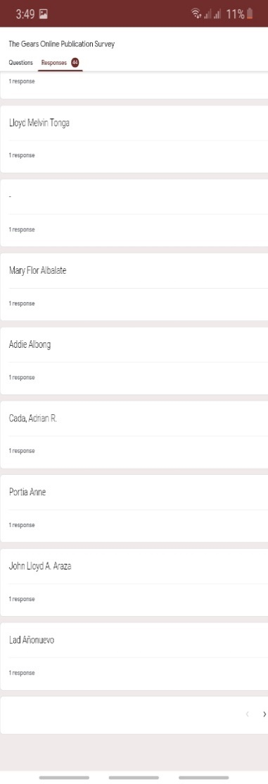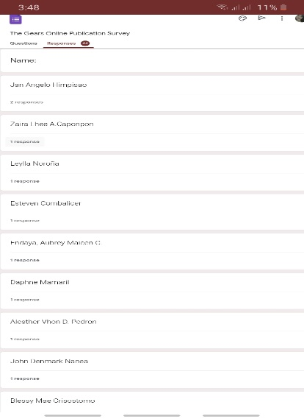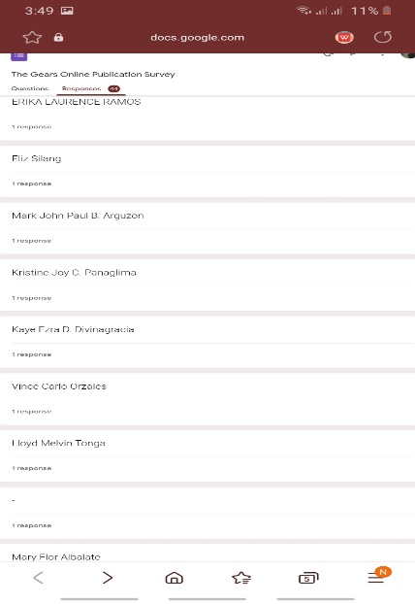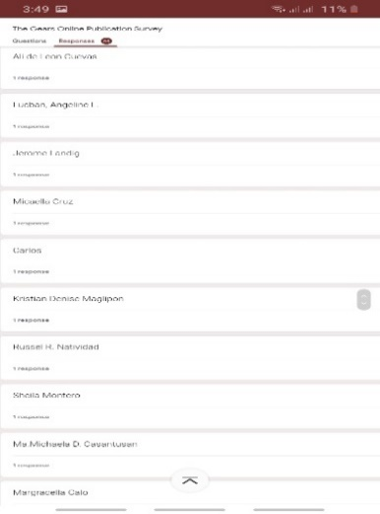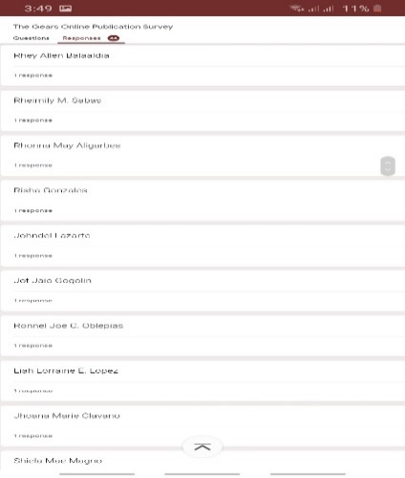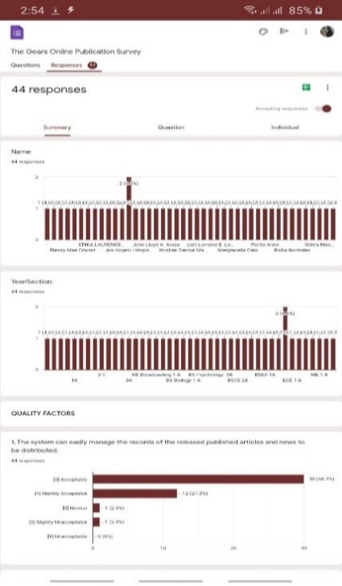board, secretary and the coordinator.

**Figure 2.** Shows the number of respondents who evaluated the system of the GEARS Online Publication.

The GEARS Online Publication : the staffs of the publication with a total of 30 respondents with percentage of 68.18% while the frequency of the Editorial Boards with the total of 12 respondents with percentage of 27.27%, the frequency of the secretary with the percentage 2.27% of and the frequency for the coordinator with the percentage of 2.27% and the overall total of frequency is 44 with a percentage of 100%.

Bernard, H. R. (2002) stated that purposive sampling technique, also called judgement sampling, is deliberate choice of a participant due to the qualities the participant possesses. It is a nonrandom technique that does not need underlying theories or a set number of participants. Simply put, the researchers decide what needs to be known and sets out to find people who can and are willing to provide the information by virtue of knowledge or experience.

**Sampling Design**

The evaluation is convenient for the researchers for it is easily reachable and will not exceed the offices of the GEARS which is the publication of Laguna State Polytechnic University. The researchers will pick random staff and Editorial Board of the GEARS, the coordinator, and secretary are belonging the users that need to evaluate the proposed system.

The study was conducted in Laguna State Polytechnic University. Respondents was the Staffs, editorial board, coordinator and secretary who will use the system. The researchers used non-probability sampling to obtain data from the sources. Cited on the article by Stephanie Glen (2020) Non-probability sampling is a sampling technique where the odds of any member being selected for a sample cannot be calculated. It’s the opposite of probability sampling, where you can calculate the odds. In addition, probability sampling involves random selection, while non-probability sampling does not it relies on the subjective judgement of the researcher. The researchers do not interview all of staffs of the GEARS but interviewed staffs will use the system.

**Data Collection Instruments**

The study entitled “The GEARS Online Publication” needed a very specific and large data from the Laguna State Polytechnic University. In the process of data

gathering, the researchers had to device a strategic course of action in collecting, analyzing and representing the data from various points of the study. The following are the main methods used in gathering the information needed for the study to proceed:

**Observations**

The researchers immersed themselves into the community in order to observe the state of technology in the area. In this method of data collection, the researcher’s main focus is to perceive the nature and extent of significant interrelated elements within complex social phenomena. The researchers needed to observe how the GEARS manage their documents.

The researchers took down notes on their observations and carefully analyzed the nature and the processes involved in the actual current state of the client’s technology.

**Interviews**

After careful observations, the researchers then proceeded to conduct a series of interviews with a sample from the population of the study. The interview method as a verbal method is quite significant in securing data about all these aspects. In this method a researcher or an interviewer can interact with his respondents and know their inner feelings and reactions. Interview is a direct method of inquiry. It is simply stated as a social process in which a person known as the interviewer asks questions usually in a face to face contact to the other person or persons known as interviewee or interviewees. The interviewee responds to these and the interviewer collects various information from these responses through a very healthy and friendly social interaction. The researchers used this method in order to further gain knowledge on the experience of the administrators.

**Research**

The Researchers used the internet for research since it has a large collection of information that is accessible anytime. The researchers read some journals, articles, and other published works to collect different information related to their study. The information gathered was used for the related literatures. Agile methods also emphasize working software as the primary measure of progress. Combined with the preference for face-to-face communication, agile methods produce very little written documentation relative to other methods.

**Statistical Treatment**

In analyzing the data, one of the most efficient way to gather data is using Statistical Treatments. To have a true and clear presentation data gathered. Liker scale method was use, this method was basically utilized to prove the validity and importance of the present study.

Weighted Mean

Weighted Mean = (A*5) + (SA*4) + (N*3) + (SU*2) + (U*1)

Total Number of Respondents

Standard Deviation = $\frac{\sqrt{{Σ\left(xi-μ\right)}^{2}}}{N}$

The researchers used weighted means to compute the total mean to get the verbal interpretation of the developed system. To compute the mean, get the number of the respondents that answered the Likert scale level of acceptance then multiply it by the number of Likert scale over the total population of the respondents. The standard deviation is used to know

the response of the respondents to the developed system. The formula in standard deviation is the square root of summation of number of respondents that answered in the Likert scale subtract the computed mean squared over the total population of the respondents. The higher standard deviation you get it means that the developed system meets their standard while the lower standard means the respondents is disagree to the developed system.

**Likert Scale**

Likert Scale was used by the researcher to obtain the user level of acceptance for the developed system to acquire the verbal interpretation of the respondent if the developed system is acceptable to use specifically for the GEARS Online Publication office needs.

Below is the table’s interpretation of the system based on the answered questionnaire.

**Where:**

**R=**Rating

**A**=Acceptable **SU**=Slightly Unacceptable

**SA**=Slightly Acceptable **U**=Unacceptable

**N**=Neutral **TNR**= Total Number of Respondent

**Table 2.** Likert Scale

|  |  |  |
| --- | --- | --- |
| **RATINGS** | **SCALE** | **VERBAL INTERPRETATION** |
| 5  4  3 | 4.20-5.00  3.40-4.19  2.60-3.39 | Acceptable  Slightly Acceptable  Neutral |
| 2 | 1.80-2.59 | Slightly Unacceptable |
| 1 | 1.0-1.79 | Unacceptable |

The table above shows the Likert Scale level of acceptance range from 1 to 5, 1 being the lowest and 5 being the highest. It depends on the summated scale type which was utilized to measure the level of acceptance of the respondents to the develop system “The GEARS Online Publication”

**Project Design**

This section discusses the software methodology used by the researchers. It consists of different phases on how the researchers conduct, formulate and develop the study.

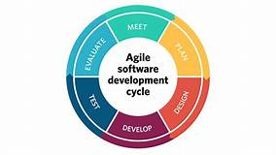**Software Development Model**

**Figure 3.** Agile Software Development**.** Shows the different stages or phases that was used in the development of “The GEARS Online Publication.” This method of software development divides the development process into four distinct phases.

The Agile Software Development Model as their research design for the study entitled The GEARS Online Publication.

Agile a type of development methodology that anticipates the need for flexibility and applies a level of pragmatism to the delivery of the finished product and requires a cultural shift in many companies because it focuses on the clean delivery of individual pieces or parts of the software.

Agile Software Development is the sample implementation of the system that shows limits and main functional capabilities of the system. After the system is created, it will be delivered to the client for the evaluation. The system will help the client to determine how the feature will function in the final software the client will provide suggestions and improvements for the manual process. The researcher will implement suggestions in the new program software, which is again evaluated by the client. According to Salinas et al (2015) in his study entitled Estimating, planning and managing Agile Web Development projects under a value-based perspective. The rise of Agile methodologies and practices has provided some useful tools that can help to establish a framework to estimate, manage and plan Web development projects. This article presents a proposal for estimating, planning and managing Web projects, presenting them as a unified framework which is uses to guide the delivery features.

The researchers used Agile Software Development Method for their study because this has a clear guidance and principles which is sustainable for the development of the system. The method is also adaptable to changing requirements all throughout the process. Cited by Regan (2017) Agile provides opportunities to assess the direction of a project throughout the development lifecycle, and ongoing changes to requirements are considered normal in the Agile world. It has a strong collaborative style of working, and it advocates adaptive planning and evolutionary development.

PHASE I. Planning Phase

The first phase of the whole process of the Agile Development Model is when the researchers conducted a brainstorming for ideas make necessary research and used data collection method such as Client interview, Observation, Survey, Questionnaire that allowed the researchers gain accurate information and data needed to the development of the system, this helps the researchers on planning and to move forward to the next stage of the study.

PHASE II. Requirement Analysis Phase

The second phase is the phase where needed data or inputs are gathered and analyzed so that the next phase can start. Inputs are commonly gathered through the help of interviews with people involved with the current process of the established or organized. The researcher has taken advantage of the internet to have an idea on how the web portal was developed and created. The researcher also used different programming language that suits in developing of the GEARS Online Publication.

PHASE III. Designing Phase

The next phase is the phase where the structure of the system is formed. It is the blueprint of the work that can be used for building the process of the GEARS Online Publication. Start planning, designing and thinking the best feature for the website that the proponents produce.

PHASE IV. Building Phase

The researchers looked over the work that has been done and to determine the ways on how to improve the methods and process that has been used to do the project. This is where designed or the blue prints gets their form. It is where the codes build the

structure and function and other feature added and where the GEARS Online Publication is nearly coming to its final phase.

PHASE V. Testing Phase

The testing phase, which is the last phase in the Agile Software Development Model, is where the researcher interacts with user or the client to test the GEARS Online Publication and change some aspects of the system to for its own improvement. Testing helps the researchers to assess the effectiveness of the end product and also modify the changes needed that would help the system perform the task it is made to do.

**Evaluation and Testing Procedure**

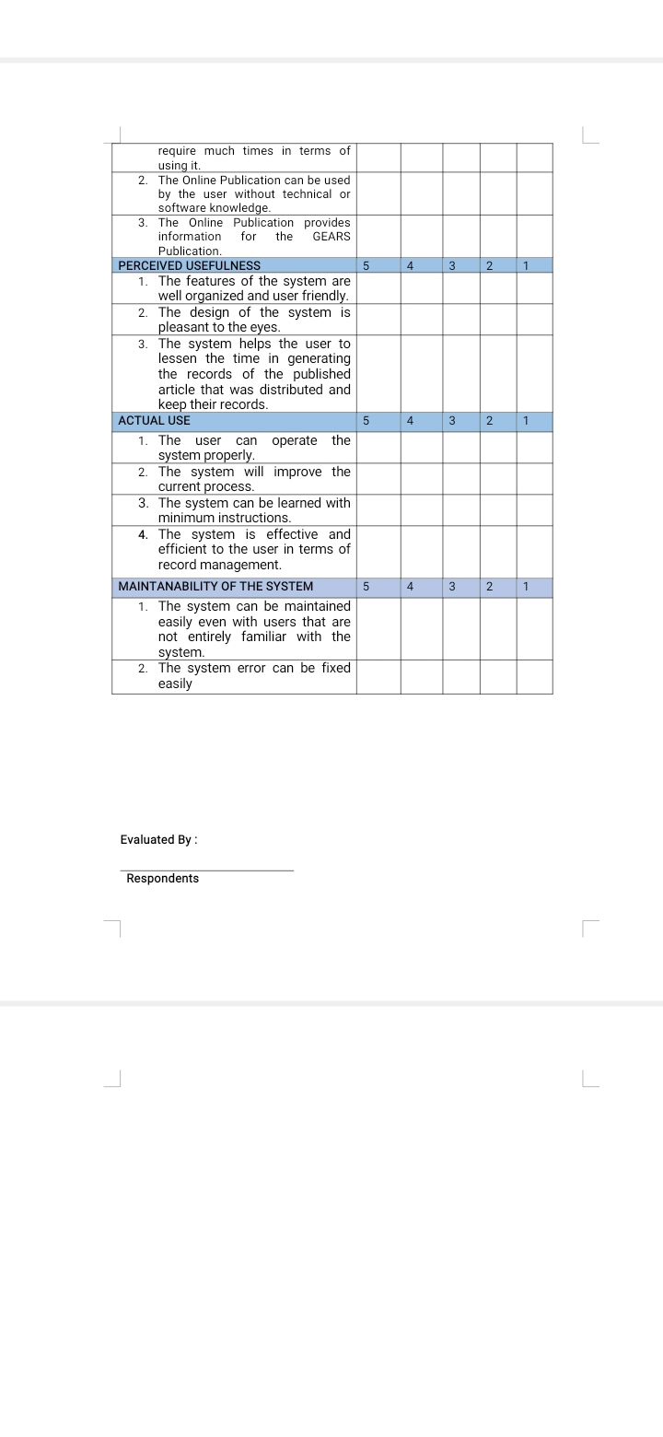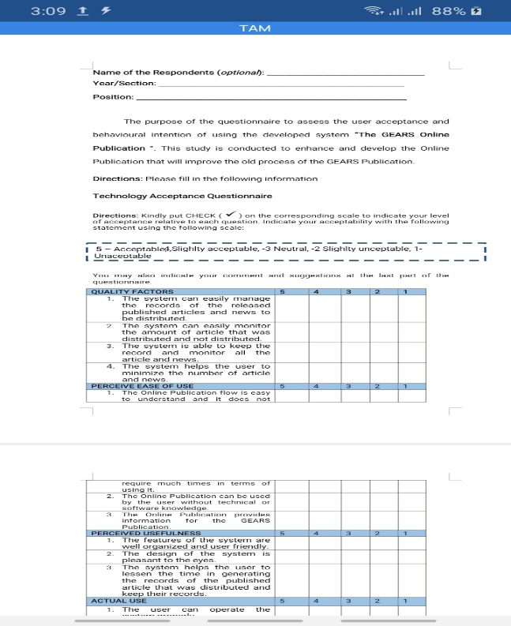The researchers used Technology Acceptance Model for category to create questionnaires to gather information about the user’s feedback to the GEARS Online Publication.

**Figure 4.** Technology Acceptance Model Questionnaire used by researchers to evaluated the system.

According to Yoon (2016) at the study entitled “User Acceptance of Mobile Library Applications in Academic Libraries: An Application of the Technology Acceptance Model”, Technology Acceptance Model has been used in different studies in regards to the behavior related technologies and systems. The advantages of applying TAM to evaluate a system are to know the user’s perception to the developed system, allows to conduct assessment to determine the satisfaction of the user with the system and it contributes to the success rate of the system as this model has been used by a lot of studies in the past that was tagged as successful.

**Evaluation tool**

Evaluation tool utilized by the researcher is a survey questionnaire that is consist of 5 factors the, Quality Factors, Perceive Ease of Use, Perceived Usefulness, Actual Use, and Maintainability of the System. The questionnaire utilizes 5-point Likert’s scale with five classifications in terms of level of acceptability ((1) Unacceptable; (2) Slightly Unacceptable 3) Neutral; (4) Slightly Acceptable (5) Acceptable.

**Evaluation Procedure**

For the evaluation of the study the researchers design a set of questionnaires the data procured from the study directed was analyzed and deciphered to obtain the result had to know the level of acceptability of the respondents involved. The questions used were based from the objectives of the study and was design with combination of Technology Acceptance Model. The questionnaire is validated by Dean Reynalen Justo one of the Panel Member in this study, and the researcher’s adviser for final evaluation before the distribution of the questionnaire. The researchers send a copy of the questionnaire online for validation.

**Table 3.** Quality Factors category.

|  |
| --- |
| **QUALITY FACTORS** |
| 1. **Correctness:** The system can easily manage the records of the released published articles and news to be distributed. |
| 1. **Reliability:** The system can easily monitor the amount of article that was distributed and not distributed. |
| 1. **Efficiency:** The system is able to keep the record and monitor all the article and news. |
| 1. **Integrity:** The system helps the user to minimize the number of article and news. |

The table above show the questions for the Technology Acceptance Model of the respondents in terms of Quality Factors.

|  |
| --- |
| **PERCEIVE EASE OF USE** |
| 1. **Operability:** The Online Publication flow is easy to understand and it does not require much times in terms of using it. |
| 1. **Understandability:** The Online Publication can be used by the user without technical or software knowledge. |
| 1. **Efficiency:** The Online Publication provides information for the GEARS Publication. |

**Table 4.** Perceive ease of use.

The table above show the questions for the Technology Acceptance Model of the respondents in terms of Perceive Ease of Use.

**Table 5**. Perceived Usefulness

|  |
| --- |
| **PERCEIVE USEFULNESS** |
| 1. **Learnability:** The features of the system are well organized and user friendly. 2. **Usability:** The design of the system is pleasant to the eyes. 3. **Accuracy:** The system helps the user to lessen the time in generating the records of the published articles that was distributed and keep their records. |

The table above show the questions for the Technology Acceptance Model of the respondents in terms of Perceived Usefulness.

|  |
| --- |
| **ACTUAL USE** |
| 1. **Operability:** The user can operate the system properly. |
| 1. **Accuracy:** The system will improve the current process. |
| 1. **Usability:** The system can be learned with minimum instructions. |
| 1. **Efficiency:** The system is effective and efficient to the user in terms of record management. |

**Table 6.** Actual Use

The table above show the questions for the Technology Acceptance Model of the respondents in terms of Actual Use.

|  |
| --- |
| **MAINTANABILITY OF THE SYSTEM** |
| 1. **Understandability:** The system can be maintained easily even with users that are not entirely familiar with the system. |
| 1. **Compliance:** The system error can be fixed easily |

**Table 7.** Maintainability of the System

The table above show the questions for the Technology Acceptance Model of the respondents in terms of Maintainability of the System.

**Testing Tool**

The testing questionnaire is consisting of step number, step details, and the expected result of each step that is based on the developed system requirements of the GEARS Online Publication. The testing questionnaire will provide the researchers the in-depth view if the developed system is functional or not.

**Testing Method**

The researchers formulate and used test case testing to test the functionality and performance of the GEARS Online Publication. The researcher creates a testing questionnaire that is based on the developed system’s step details and its expected result. On the stage, both individual components and the integrated whole were methodically verified to ensure that they were error free and fully meet the system’s requirements. If some features and function of the system were not working or if there were any errors, debugging would be done.

**Table 8.** Adding Post to the Online Publication

|  |  |  |  |  |
| --- | --- | --- | --- | --- |
| **Step #** | | **Step Details** | | **Expected Result** |
|  | | Navigate the Homepage | | Displays “Admin Log In” dashboard. |
|  | Click Login | | Filled Admin Login Information will redirect to admin dashboard. | |
|  | | Navigate the Left Side Bar | | Displays the features of the admin dashboard. |
|  | | Click Posts | | Open the feature within it. |
|  | | Select Add Post | | Display the add post feature that consists of insert category, insert subcategory, and the post’s content that can be either text or images |
|  | | Insert Post Title | | Give access to name the post’s title, |
|  | | Select Category | | Will give the option to choose what the main category of your post is. |
|  | | Select Subcategory | | Will give the option to choose what the subcategory of your post is. |
|  | | Insert Post Details | | Will give the option to insert the content of your post. |
|  | | Upload Image | | Should upload the image together with the details of the post. |
|  | | Save Posts | | Saves and confirms the post. |

The table above show the testing questionnaire for the GEARS Online Publication. It was based on the functions of the developed system that can be found in the GEARS Online Publication. Using this the tester can test the Adding Post functionality and observed if the developed system is behaving to its expected response.

**Table 9.** Adding categories to the Online Publication.

|  |  |  |
| --- | --- | --- |
| **Step #** | **Step Details** | **Expected Result** |
|  | Navigate the Homepage | Displays “Admin Log In” dashboard. |
|  | Click Login | Filled Admin Login Information will redirect to admin dashboard. |
|  | Navigate the Left Side Bar | Displays the features of the admin dashboard. |
|  | Click Category | Displays the options within it. |
|  | Select Add Category | Displays the insert category name feature, the insert category description feature, and the submit button. |
|  | Insert Category Name | Gives access to name the category. |
|  | Insert Category Description | Gives access to describe the category. |
|  | Click Submit | Confirms submitting the newly added category. |

The table above show the testing questionnaire for the GEARS Online Publication. It was based on the functions of the developed system that can be found in the GEARS Online Publication. Using this the tester can test the Adding categories functionality and observed if the developed system is behaving to its expected response.

**Table 10.** Adding subcategories to the Online Publication

|  |  |  |
| --- | --- | --- |
| **Step #** | **Step Details** | **Expected Result** |
|  | Navigate the Homepage | Displays the “Admin Log In” dashboard. |
|  | Click Login | Filled Admin Login Information will redirect to admin dashboard. |
|  | Navigate the Left Side Bar | Displays the features of the admin dashboard. |
|  | Click Subcategory | Displays the options within it. |
|  | Select Add Subcategory | Displays the insert subcategory name feature, the insert subcategory description feature, and the submit button. |
|  | Select Category | Will give the option to choose what the main category of your post is. |
|  | Insert Subcategory Name | Gives access to name the subcategory. |
|  | Insert Subcategory Description | Gives access to describe the subcategory. |
|  | Submit | Confirms submitting the newly added subcategory. |

The table above show the testing questionnaire for the GEARS Online Publication. It was based on the functions of the developed system that can be found in the GEARS Online Publication. Using this the tester can test the Adding subcategories functionality and observed if the developed system is behaving to its expected response.

**Table 11.** Editing Homepage of the Online Publication

|  |  |  |
| --- | --- | --- |
| **Step #** | **Step Details** | **Expected Result** |
|  | Navigate the Homepage | Displays the “Admin Log In” dashboard. |
|  | Click Login | Filled Admin Login Information will redirect to admin dashboard. |
|  | Navigate the Left Side Bar | Displays the features of the admin dashboard. |
|  | Click Pages | Displays the options like About Us, Contact Us, Announcements, and the Home Page. |
|  | Select Homepage | Displays a textbox that gives option to edit the content. |
|  | Insert Text or Image to Page Details | Gives access to insert text or image to the Page details. |
|  | Click Update and Post | Confirms and applies the newly added details for the home page. |

The table above show the testing questionnaire for the GEARS Online Publication. It was based on the functions of the developed system that can be found in the GEARS Online Publication. Using this the tester can test the Editing Homepage functionality and observed if the developed system is behaving to its expected response.

**Table 12.** Editing About Us Page of the Online Publication

|  |  |  |
| --- | --- | --- |
| **Step #** | **Step Details** | **Expected Result** |
|  | Navigate the Homepage | Displays the “Admin Log In” dashboard. |
|  | Click Login | Filled Admin Login Information will redirect to admin dashboard. |
|  | Navigate the Left Side Bar | Displays the features of the admin dashboard. |
|  | Click Pages | Displays the options like About Us, Contact Us, Announcements, and the Home Page. |
|  | Select About Us | Displays a textbox that gives an option to add page title and add page details. |
|  | Insert Text or Image to Page Details | Gives access to insert text or image to the About Us details. |
|  | Click Update and Post | Confirms and applies the newly added details for the “About Us” page. |

The table above show the testing questionnaire for the GEARS Online Publication. It was based on the functions of the developed system that can be found in the GEARS Online Publication. Using this the tester can test the Editing About Us Page functionality and observed if the developed system is behaving to its expected response.

**Table 13**. Editing Contact, Us Page of the Online Publication

|  |  |  |
| --- | --- | --- |
| **Step #** | **Step Details** | **Expected Result** |
|  | Navigate the Homepage | Displays the “Admin Log In” dashboard. |
|  | Click Login | Filled Admin Login Information will redirect to admin dashboard. |
|  | Navigate the Left Side Bar | Displays the features of the admin dashboard. |
|  | Click Pages | Displays the options like About Us, Contact Us, Announcements, and the Home Page. |
|  | Select Contact Us | Displays a textbox that gives an option to add page title and add page details. |
|  | Insert Text or Image to Page Details | Gives access to insert text or image to the Contact Us details. |
|  | Click Update and Post | Confirms and applies the newly added details for the “Contact Us” page. |

The table above show the testing questionnaire for the GEARS Online Publication. It was based on the functions of the developed system that can be found in the GEARS Online Publication. Using this the tester can test the Editing Contact, Us Page functionality and observed if the developed system is behaving to its expected response.

**Table 14.** Editing Announcement Page of the Online Publication

|  |  |  |
| --- | --- | --- |
| **Step #** | **Step Details** | **Expected Result** |
|  | Navigate the Homepage | Displays the “Admin Log In” dashboard. |
|  | Click Login | Filled Admin Login Information will redirect to admin dashboard. |
|  | Navigate the Left Side Bar | Displays the features of the admin dashboard. |
|  | Click Pages | Displays the options like About Us, Contact Us, Announcements, and the Home Page. |
|  | Select Announcements | Displays a textbox that gives an option to add page title and add page details. |
|  | Insert Text or Image to Page Details | Gives access to insert text or image to the Announcements details. |
|  | Click Update and Post | Confirms and applies the newly added details for the “Announcements” page. |

The table above show the testing questionnaire for the GEARS Online Publication. It was based on the functions of the developed system that can be found in the GEARS Online Publication. Using this the tester can test the Editing Announcement Page functionality and observed if the developed system is behaving to its expected response.

**Table 15**. Managing Comments from the Online Publication

|  |  |  |
| --- | --- | --- |
| **Step #** | **Step Details** | **Expected Result** |
|  | Navigate the Homepage | Displays the “Admin Log In” dashboard. |
|  | Click Login | Filled Admin Login Information will redirect to admin dashboard. |
|  | Navigate the Left Side Bar | Displays the features of the admin dashboard. |
|  | Click Comments | Automatically selects manage comments. |
|  | Select Manage Comments | Displays the comments, and displays the information of those who gave comments. |
|  | Delete Comments | Gives access to delete the comments. |

The table above show the testing questionnaire for the GEARS Online Publication. It was based on the functions of the developed system that can be found in the GEARS Online Publication. Using this the tester can test the Managing Comments functionality and observed if the developed system is behaving to its expected response.

**Table 16.** Managing Records from the Online Publication Distribution System

|  |  |  |
| --- | --- | --- |
| **Step #** | **Step Details** | **Expected Result** |
|  | Navigate the Homepage | Displays the “Admin Log In” dashboard. |
|  | Click Login | Filled Admin Login Information will redirect to admin dashboard. |
|  | Navigate the Left Side Bar | Displays the features of the admin dashboard. |
|  | Click Distribution | Redirect to Distribution dashboard. |
|  | Select Check distribution | Displays the features within it. |
|  | Add Items | Gives the option to add the item number, item name, description, and quantity. |
|  | Add Distribution Details | Gives option to add the client’s ID, Item number, and quantity. |
|  | Add Clients | Gives the options to add the Information of the client, department code. |
|  | Search Distribution Details | Allows to check the distributed items to the specific clients and their respective departments. |

The table above show the testing questionnaire for the GEARS Online Publication. It was based on the functions of the developed system that can be found in the GEARS Online Publication. Using this the tester can test the Managing Records functionality and observed if the developed system is behaving to its expected response.

Shows the testing questionnaire for the IT Experts, Coordinator and Editorial boards of the GEARS Publication (online). It was based on the functions of the developed system that can be found in the GEARS Online Publication. Using this the tester can test the functionality and observe if the developed system is behaving to its expected response.

**CHAPTER IV**

RESULTS AND DISCUSSION

This chapter discuss the results from the evaluation that the researchers conducted in this study. The data gathered whose main objective is to find out the expectations and perceptions of the study entitled “The GEARS Online Publication”. The researchers sought to answer the following questions:

**Research Objectives**

The aim of the study is to design and develop a GEARS Publication History and Achievements. System that would serve as proposal to help the LSPU the GEARS Publication for their operation and provides an easier, faster, more organized, secured and accurate system. The specific objective of this study is the following: 1) Test the functionalities of the GEARS Online Publication on its major features: 1.1Post and make an Announcement. 1.2Monitor the distribution of published articles. 1.3Records and Inventory of published articles. 2) Asses the GEARS Online Publication members with the user acceptance and behavioral intention using Technology Acceptance Model (TAM) criteria. 2.1 Quality Factors. 2.2 Perceived Ease of Use. 2.3 Perceived Usefulness 2.4 Actual Use. 2.5 Maintainability of the System. All of that is the need to meet in this study.

**Research Objectives No.1:** How to design and develop a GEARS Publication History and Achievements. System that would serve as proposal to help the LSPU the GEARS Publication for their operation and provides an easier, faster, more organized, secured and accurate system?

First the researchers conducted an interview with the Coordinator of the GEARS Publication about their history since The GEARS Publication doesn’t kept

record of its history, having this site will now preserve the GEARS Publication history, like keeping the Publication’s records of achievements, records of events and records of who managed the publication for future references of researchers who may also be interested in using the Publication as a center of their research. And instead of just using matrix of articles provided by writers, they can now use the system for their work to be more efficient and organized. After gathering the information needed, the researchers planned on how to develop a system that can preserve the GEARS Publication.

The researchers decided to use Agile Software Development Method to develop a system that can monitor the release of articles of The GEARS Publication because this method has clear guidance and principles, and also adaptable to changing requirements throughout the process.

Agile Software development has 5 processes. The first one is when the researchers conducted a brainstorming for ideas make necessary research and used data collection method such as Client interview, Observation, Survey, Questionnaire that allowed the researchers gain accurate information and data needed to the development of the system, this helps the researchers on planning and to move forward to the next stage of the study. The second one is the phase where needed data or inputs are gathered and analyzed so that the next phase can start. Inputs are commonly gathered through the help of interviews with people involved with the current process of the established or organized. The researcher has taken advantage of the internet to have an idea on how the web portal was developed and created. The researcher also used different programming language that suits in developing of the GEARS Online Publication. The third phase is where the structure of the system is formed. It is the blueprint of the work that can be used for building the process of the GEARS Online Publication. Start planning, designing and thinking the best feature for the website that the proponents produce. The fourth phase is where the researchers looked over the work that has been done and to determine the ways on how to improve the methods and process that has been used to do the project. This is where designed or the blue prints gets their form. It is where the codes build the structure and function and other feature added and where the GEARS Online Publication is nearly coming to its final phase. And the Final Phase The testing phase, which is the last phase in the Agile Software Development Model, is where the researcher interacts with user or the client to test the GEARS Online Publication and change some aspects of the system to for its own improvement. Testing helps the researchers to assess the effectiveness of the end product and also modify the changes needed that would help the system perform the task it is made to do.

Below are the functions and features of the said system:

Functions and Features

Main Page

**Figure 5.** Shows the Main page of the online publication and the category.

Home Page

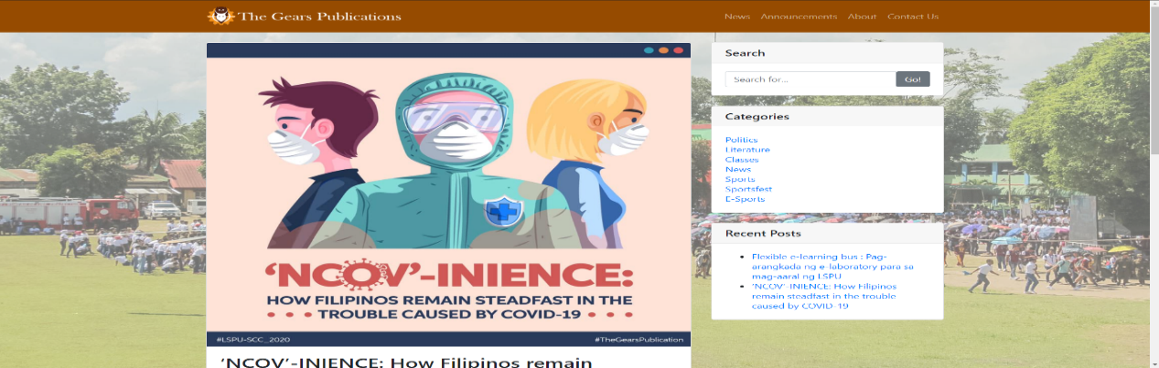

**Figure 6.** Shows the Home Page of the online publication.

Announcement

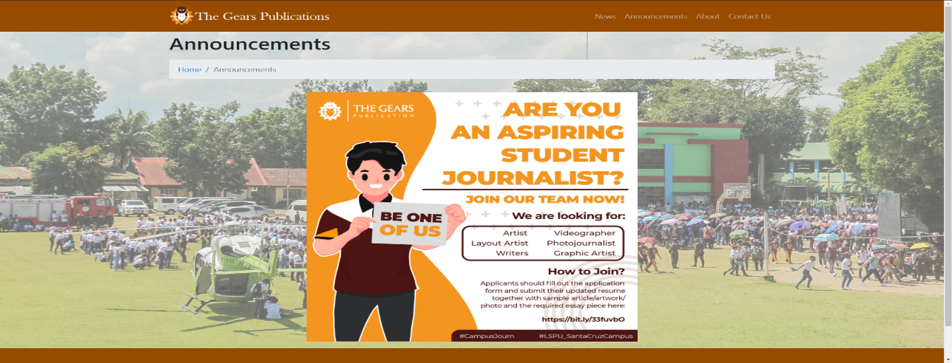

**Figure 7.** Shows an announcement feature where announcements made by the admins can be featured and easily seen.

About Us

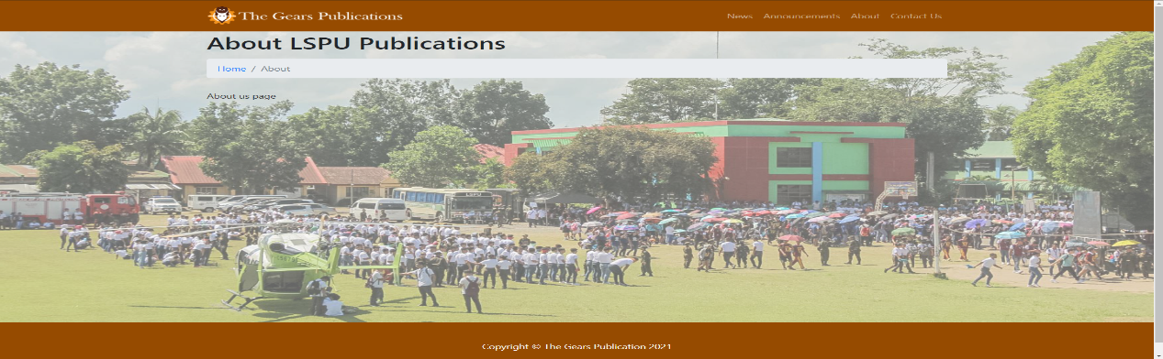

**Figure 8.** Show an About us feature, where readers can get to know more about the publication and what it does.

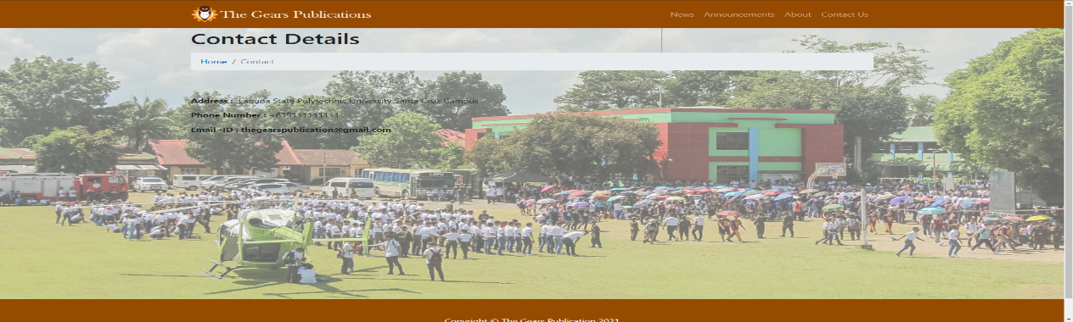Contact Details

**Figure 9.** Shows a feature where the contact details of the publication are given.

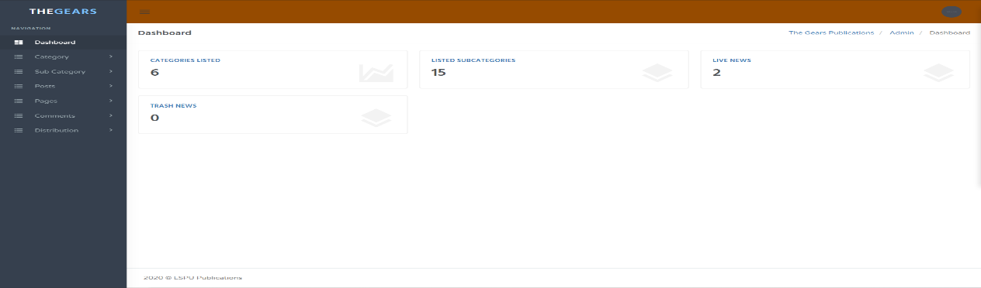Dashboard

**Figure 10.** Shows the dashboard where all the content of the online publication can be seen.

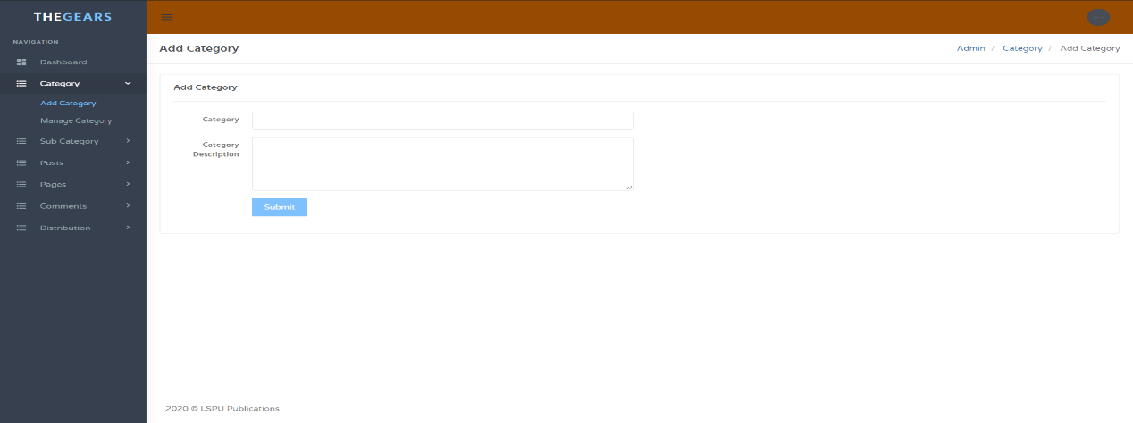Add Category

**Figure 11.** Shows the Add Category where you can add a category.

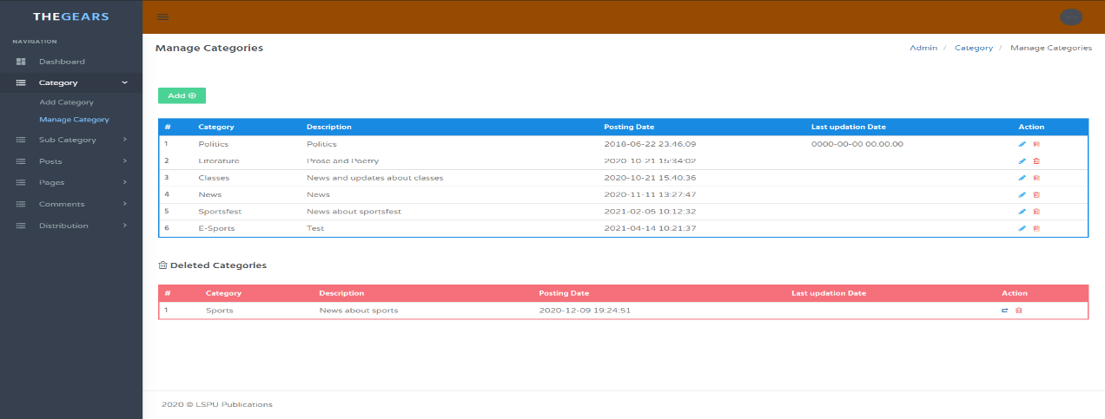Manage Categories

**Figure 12.** Shows how you can choose among different categories.

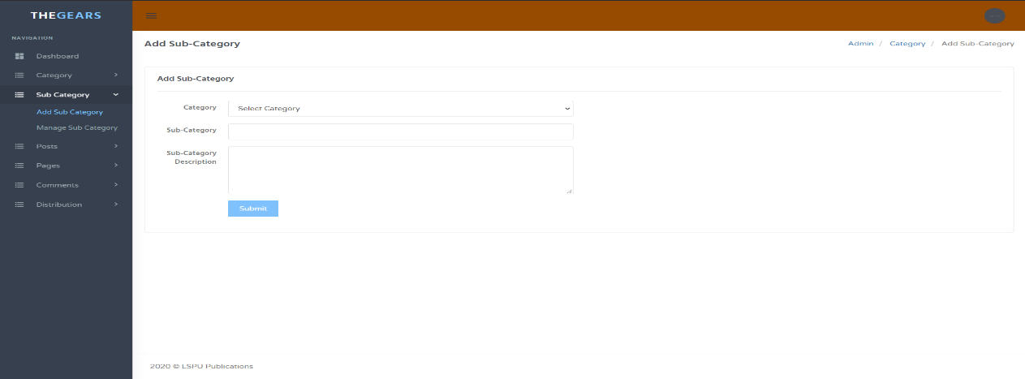Sub-Category

**Figure 13.** Shows the Sub-Category where you can add a sub-category.

Manage Sub-Categories

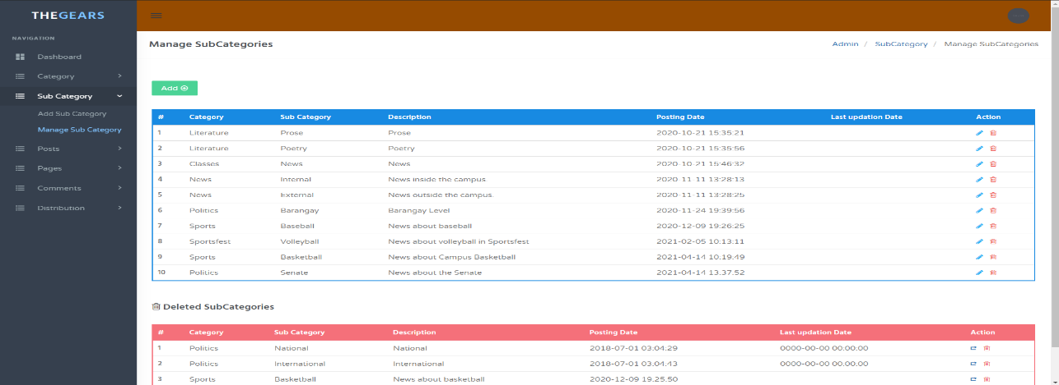

**Figure 14.** Shows how different sub-categories are organized for reader’s and staff’s conveniences.

Add Posts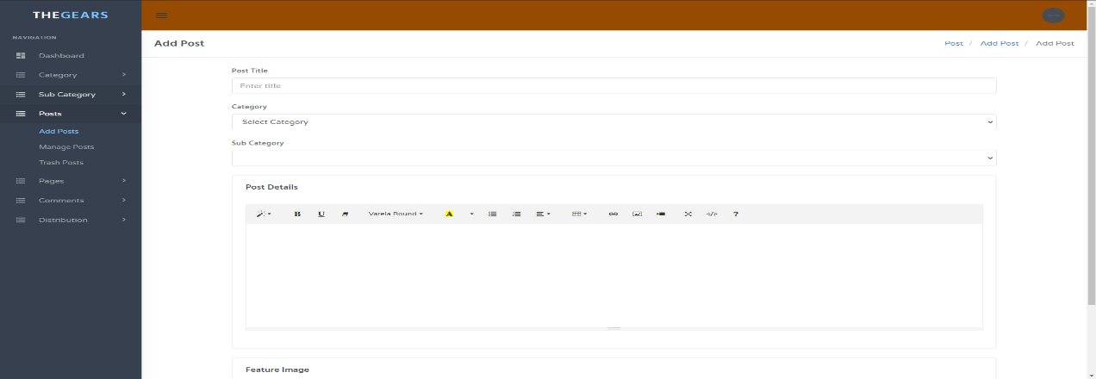

**Figure 15.** Shows an add post feature where admins can post stuff in the system.

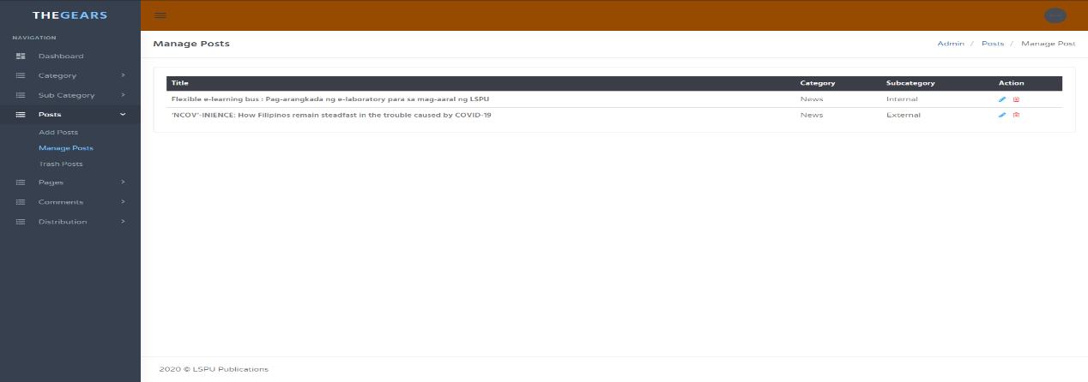Manage Posts

**Figure 16.** Shows how people with access to the system can manage posts.

Recycle Bin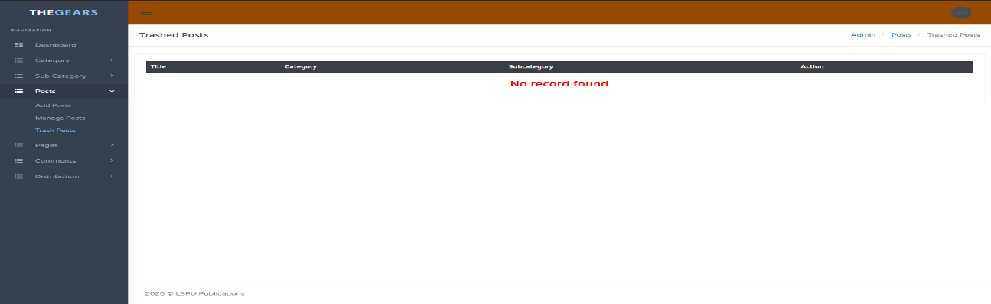

**Figure 17.** Shows a recycle bin feature where you can see deleted posts in the system.

About Page 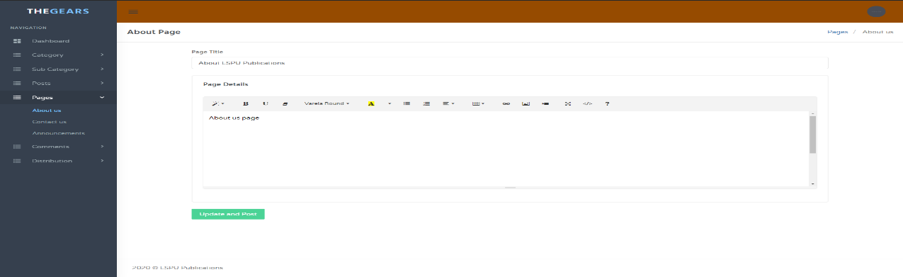

**Figure 18.** Shows an about page feature where readers can get to know more about the page.

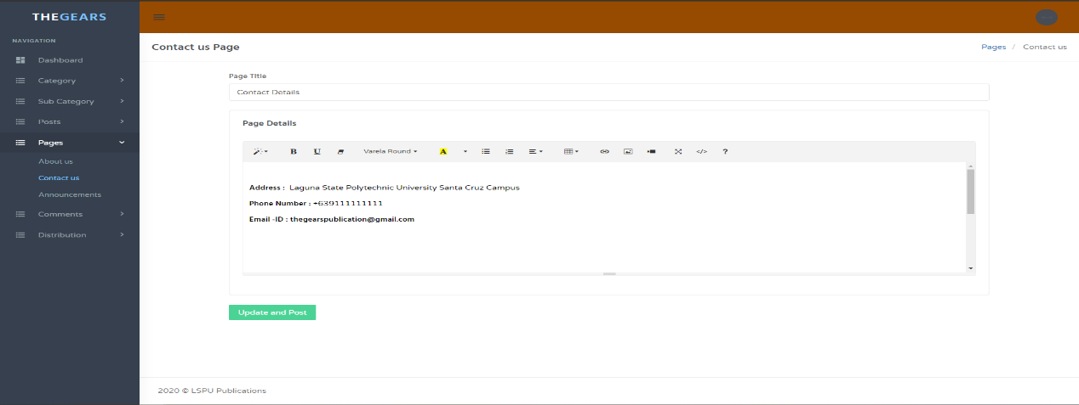Contact Us

**Figure 19.** Shows a feature where you can contact the publication.

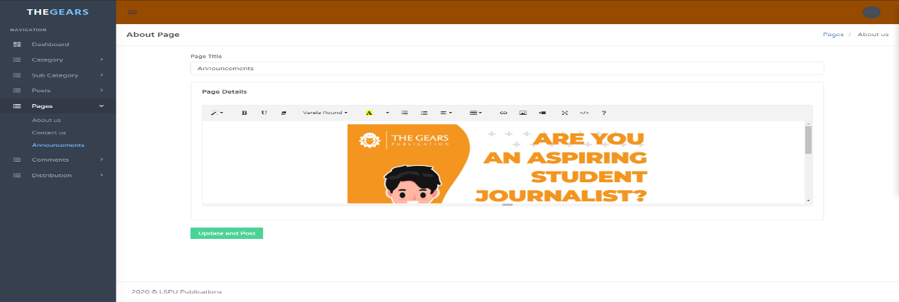About Us

**Figure 20.** Shows an about us feature where readers can get to know more about the page.

Manage Comments

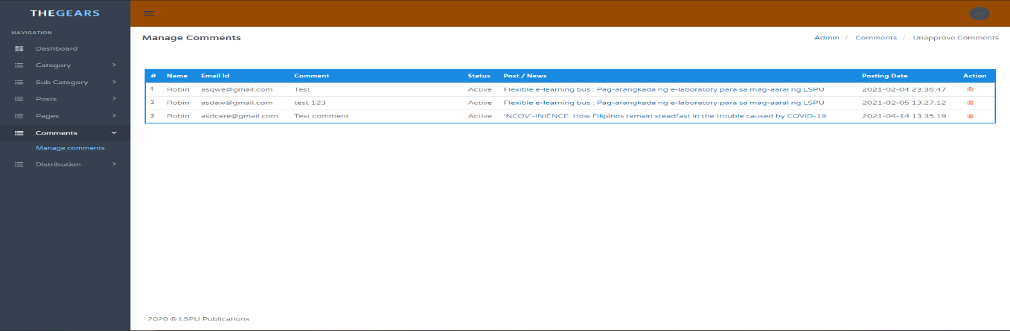

**Figure 21.** Shows how a person with authority can manage the comments in the system.

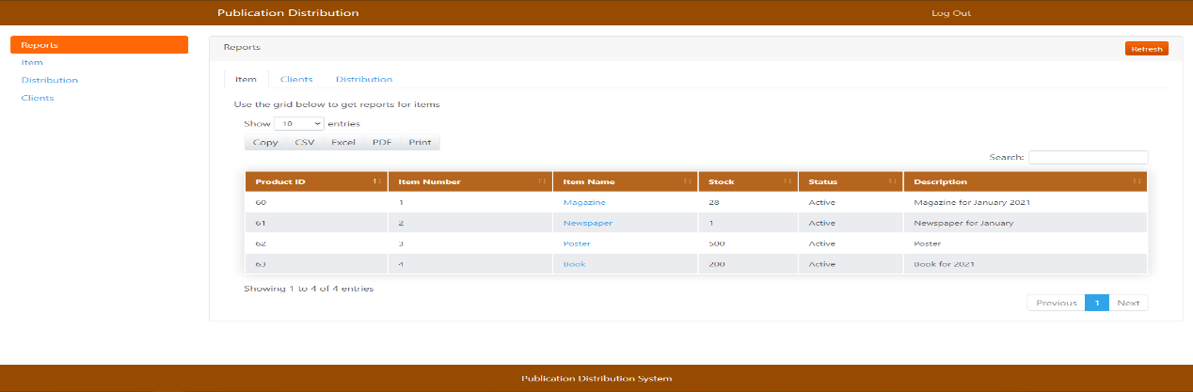Publication Reports Distribution

**Figure 22.** Shows the records of the released published article/news to be distributed.

Distributions Items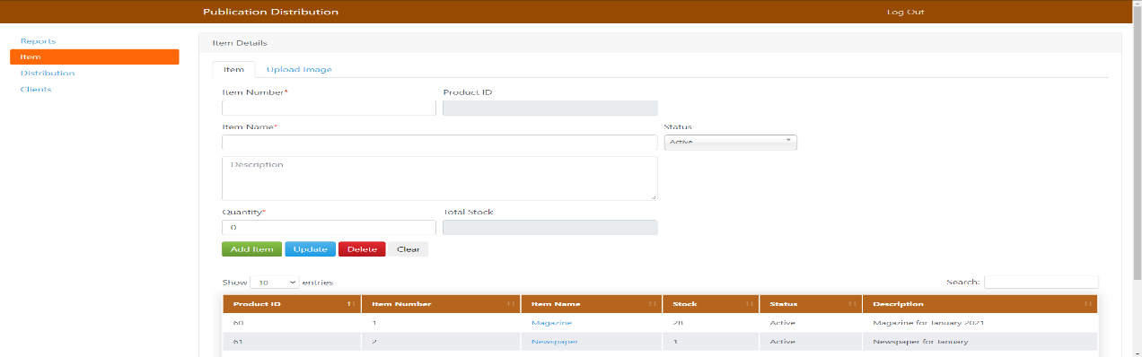

**Figure 23.** Shows where the items details manage the inventory of distribution articles/news.

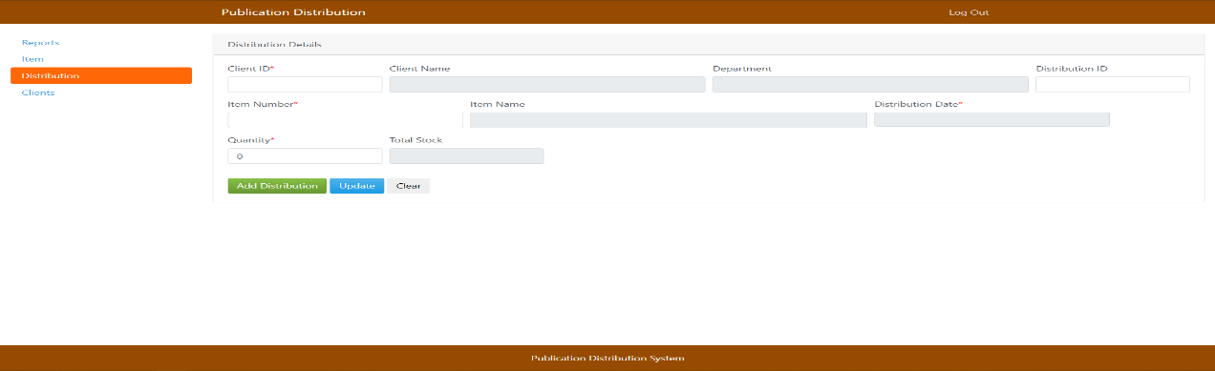Distributions Details

**Figure 24**. Shows where they manage the distribution details.

Client details

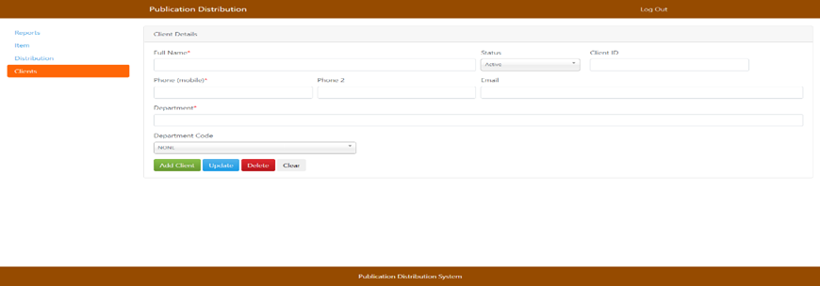

**Figure 25**. Shows where they manage the client details of distribution.

The researchers presented their system in front of three (3) IT professionals, the first IT Expert is Mr. Mark David B. Alberto, graduated of Bachelor of Science in Computer Science in AMA Computer College – Cavite Campus and currently working at NBI. The second IT expert is Mr. Link Chester Gonzales, graduated of Bachelor of Science in Computer Engineering in University of Rizal System and currently workingat Startek Frontera Verde Site – Pasig and the third IT expert is Mr. John Axl Martin, graduated of Bachelor of Science in Computer Engineering University of Rizal System and currently working at Associate Software Engineer in Accenture Inc.

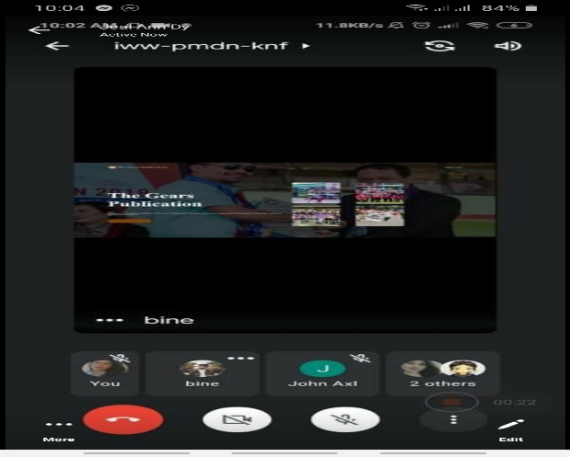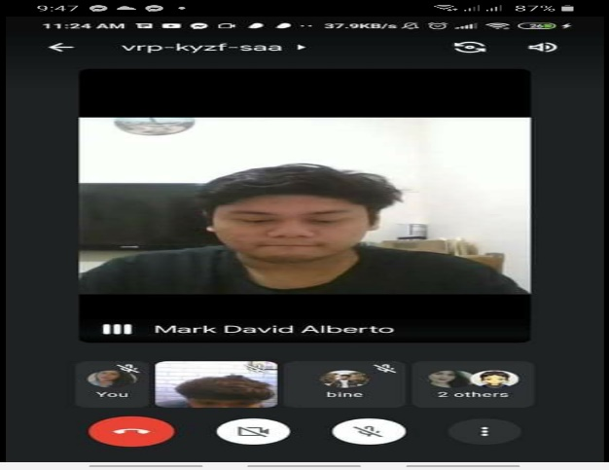Coordinator of the GEARS Publication Mrs. Chiqui Labastilla and Editorial board members Mr. Ranz Irish Enriquez, Ms. Erika Laurence Ramos, Mr. Jerome Landing and Mr. Lloyd Melvin MT through google meet live testing to test the functionality and features of the developed system if the function needed by “The GEARS Online Publication” are functioning properly.

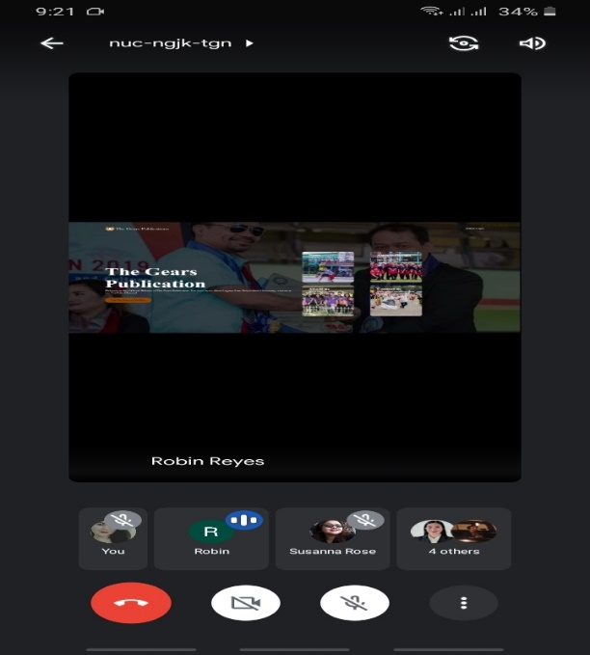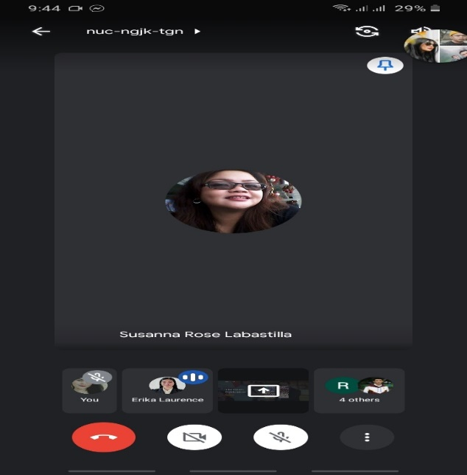

**Figure 26.** Shows who evaluated the system named the GEARS Online Publication through google meet.

The researchers formulate and used test case testing to test the functionality and performance of the GEARS Online Publication. The testing questionnaire is consisting of step number, step details, and the expected result of each step that is based on the developed system requirements. The testing questionnaire will provide the researchers the in-depth view if the developed system is functional or not.

**Testing Questionnaire Results**

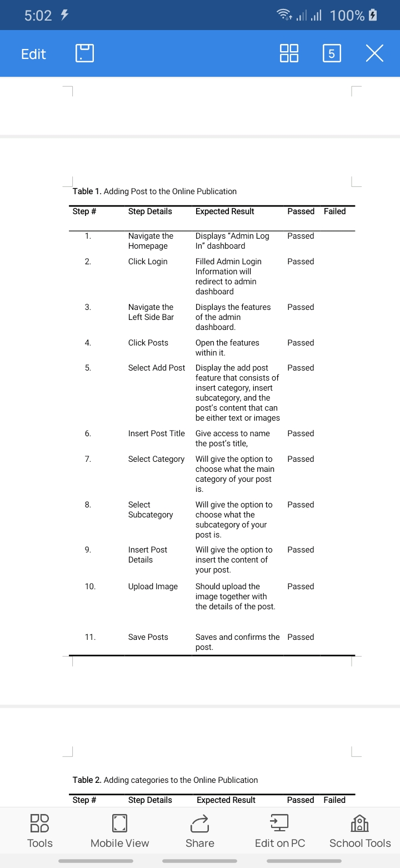The Coordinators and Editorial Boards of The GEARS Publication results who evaluated the system testing questionnaire online.

**Figure 27.** Show the testing questionnaire results for Adding post functionality that can be found in the GEARS Online publication.

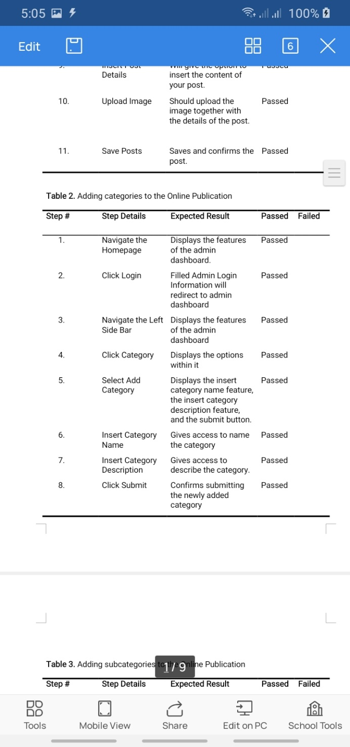

**Figure 28.** Show the testing questionnaire results for Adding Categories functionality that can be found in the GEARS Online publication.

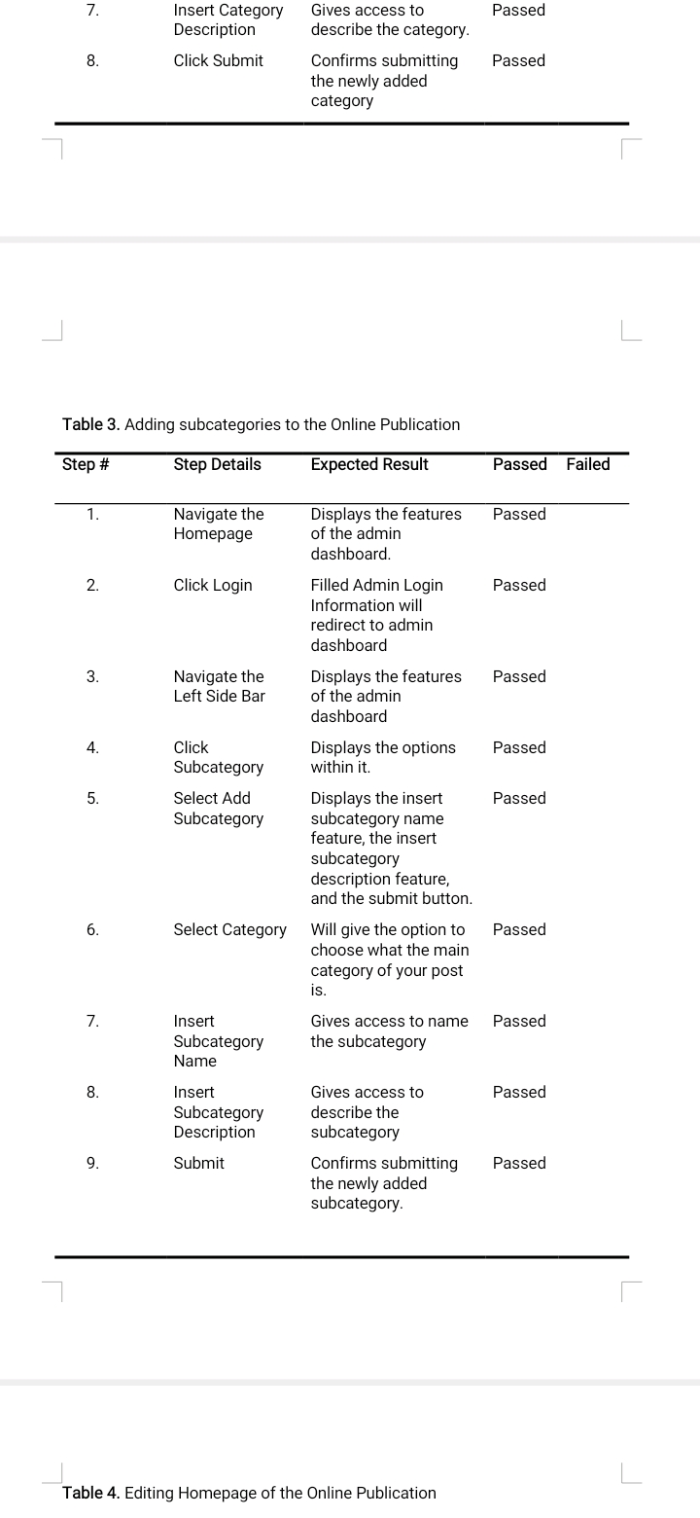

**Figure 29.** Show the testing questionnaire results for Adding Sub-categories functionality that can be found in the GEARS Online publication.

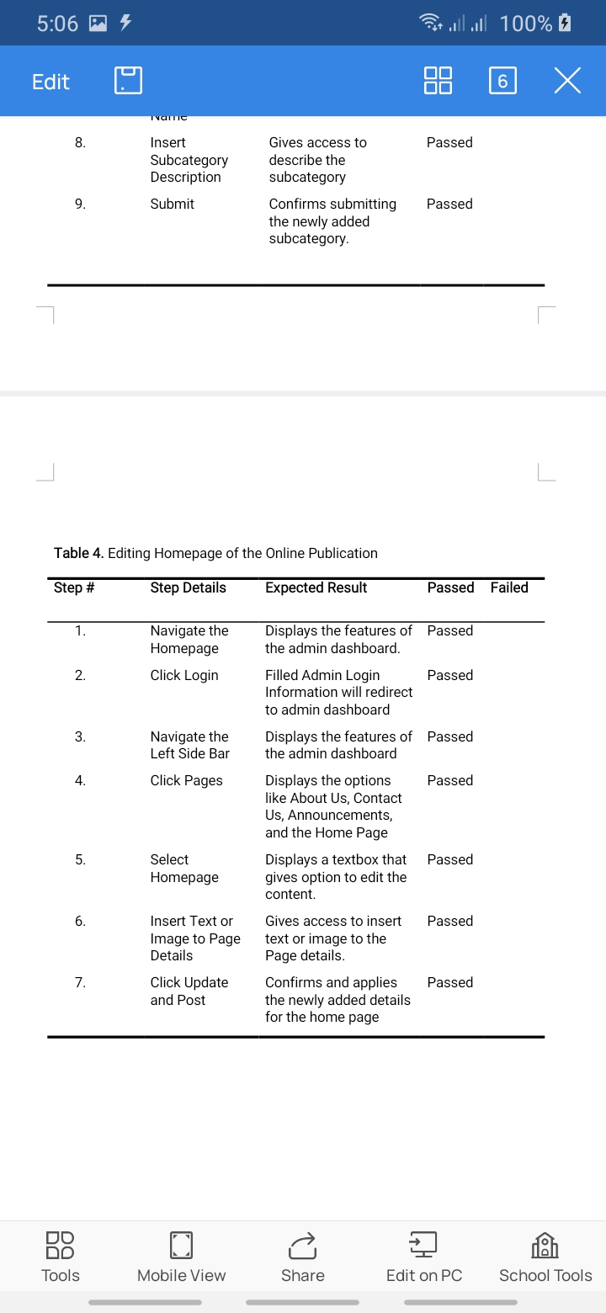

**Figure 30.** Show the testing questionnaire results for Editing homepage functionality that can be found in the GEARS Online publication.

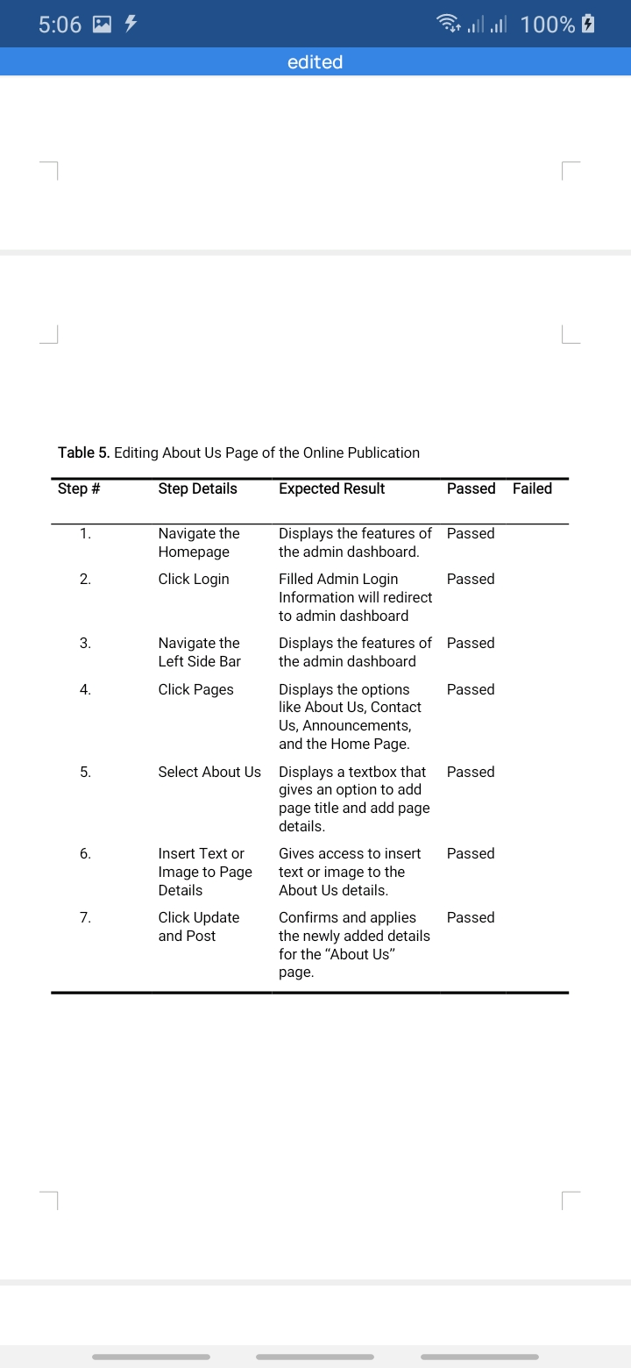

**Figure 31.** Show the testing questionnaire results for Editing About Us Page functionality that can be found in the GEARS Online publication.

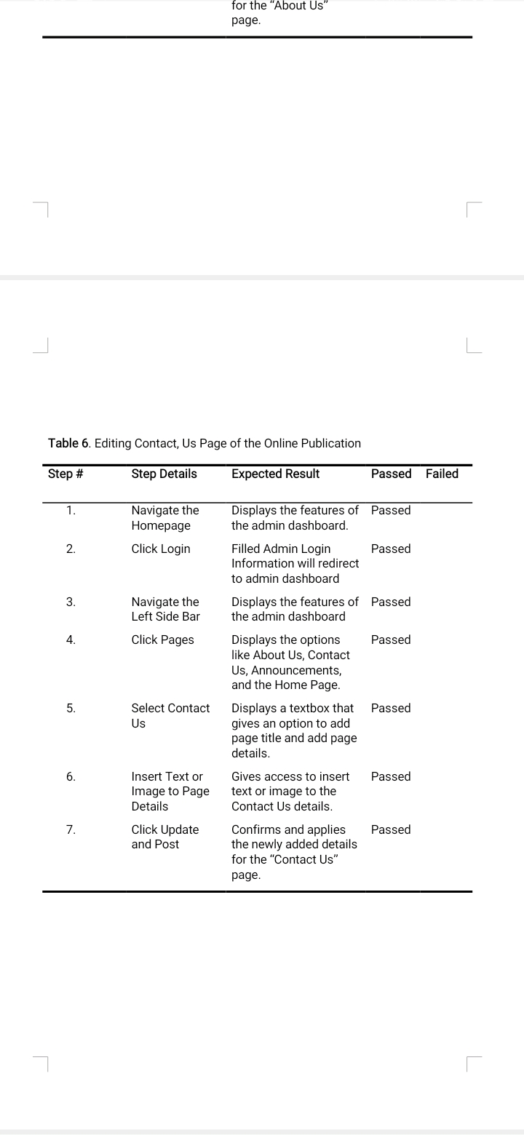

**Figure 32.** Show the testing questionnaire results for Editing Contact, Us Page functionality that can be found in the GEARS Online publication.

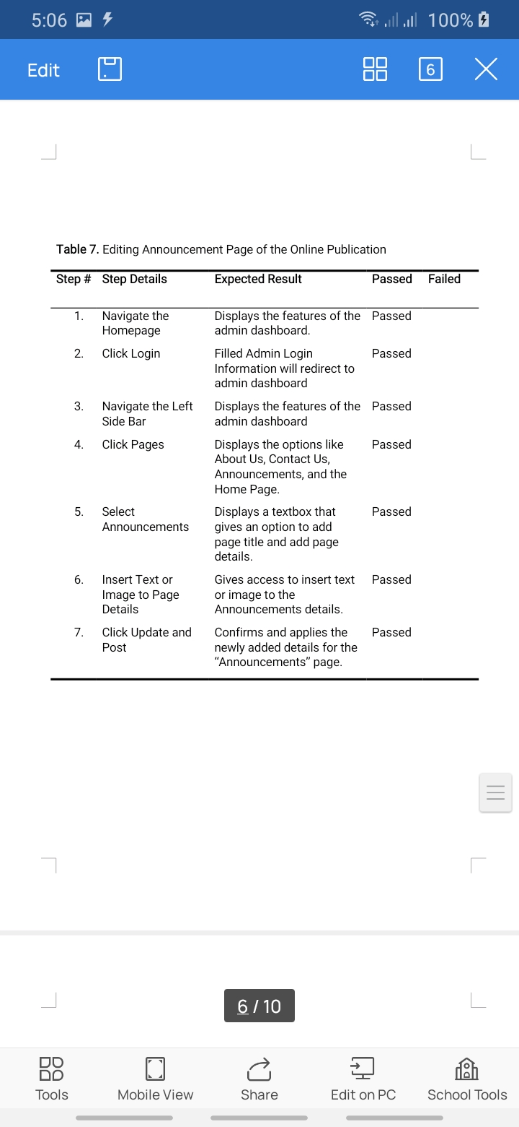

**Figure 33.** Show the testing questionnaire results for Editing Announcement Page functionality that can be found in the GEARS Online publication.

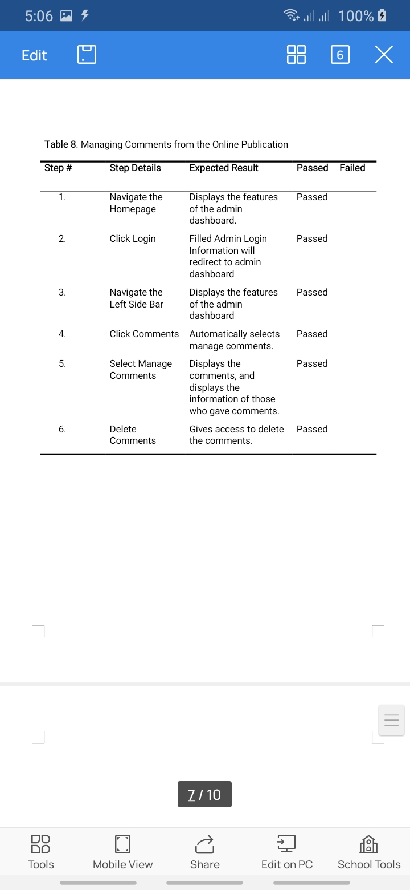

**Figure 34.** Show the testing questionnaire results for Managing Comments functionality that can be found in the GEARS Online publication.

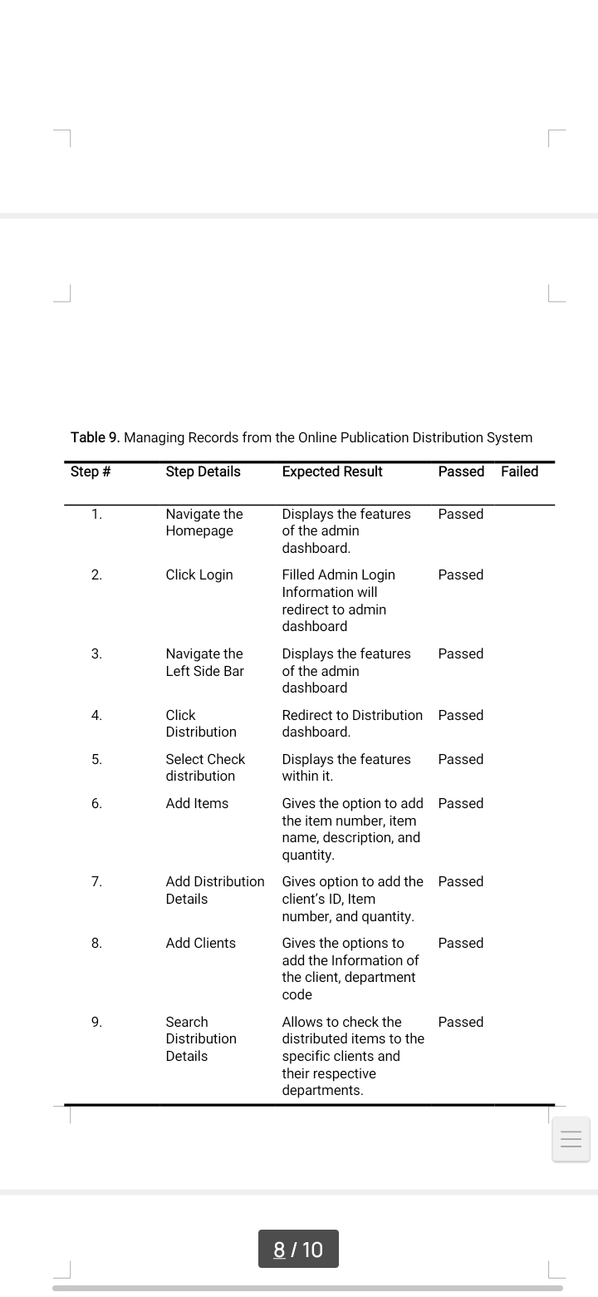

**Figure 35.** Show the testing questionnaire results for Managing Records functionality that can be found in the GEARS Online publication.

Shows the result of the test questionnaire for the GEARS Online Publication. The researchers conduct using google meet while sending the documents of forms to the tester. 5 out of 5 testers rate the test case for respondents’ forms passed.

The IT experts result who evaluated the system testing questionnaire online.

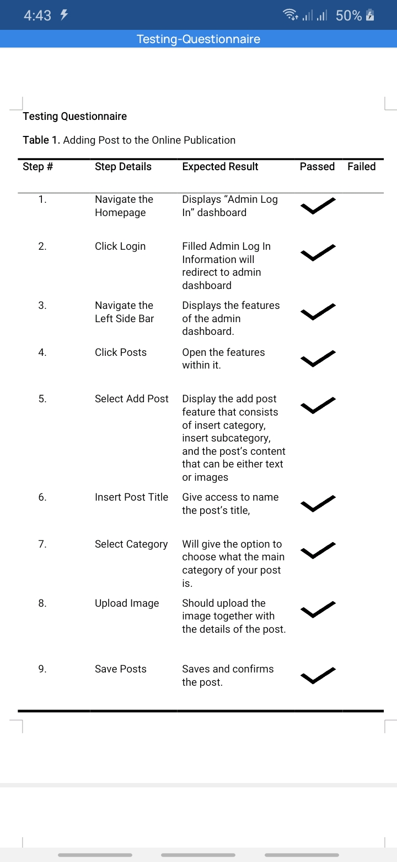

**Figure 36.** Show the testing questionnaire results of IT experts for Adding post functionality that can be found in the GEARS Online publication.

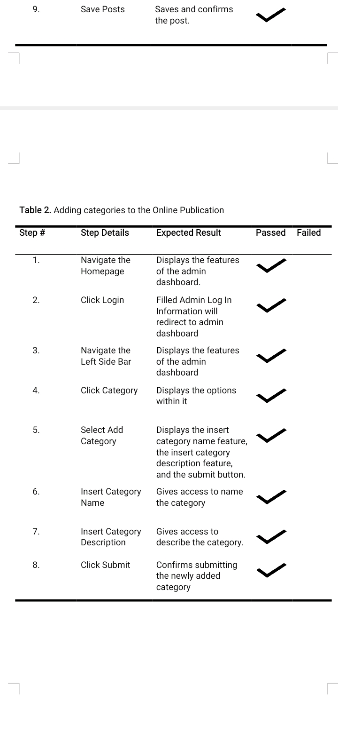

**Figure 37.** Show the testing questionnaire results of IT experts for Adding Categories functionality that can be found in the GEARS Online publication.

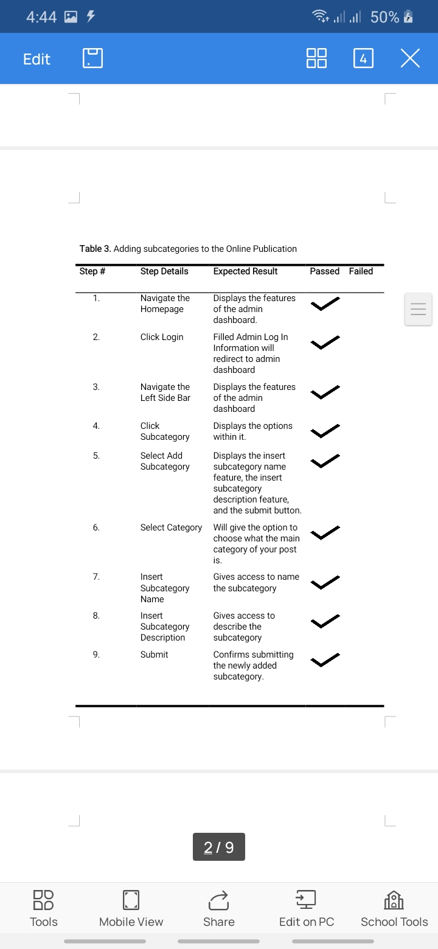

**Figure 38.** Show the testing questionnaire results of IT experts for Adding Sub-Categories functionality that can be found in the GEARS Online publication.

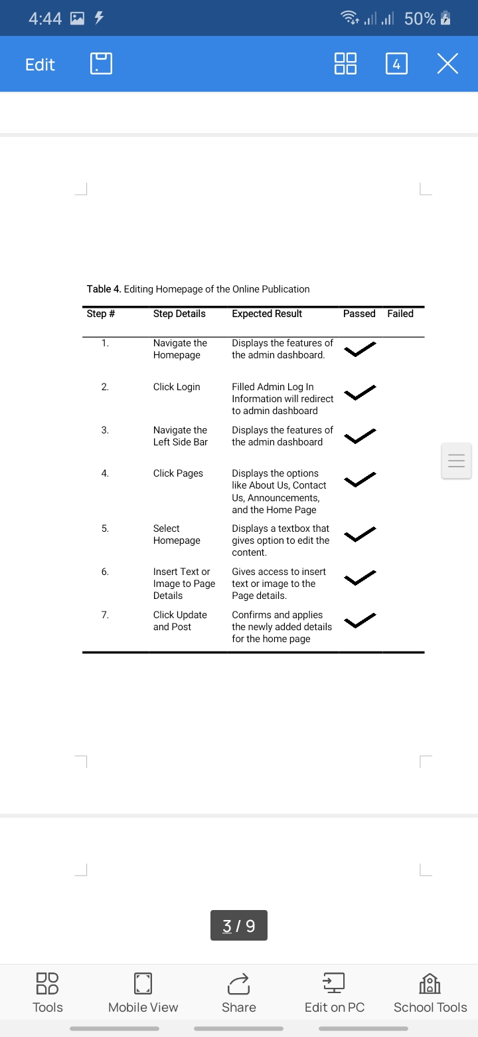

**Figure 39.** Show the testing questionnaire results of IT experts for Editing Homepage functionality that can be found in the GEARS Online publication.

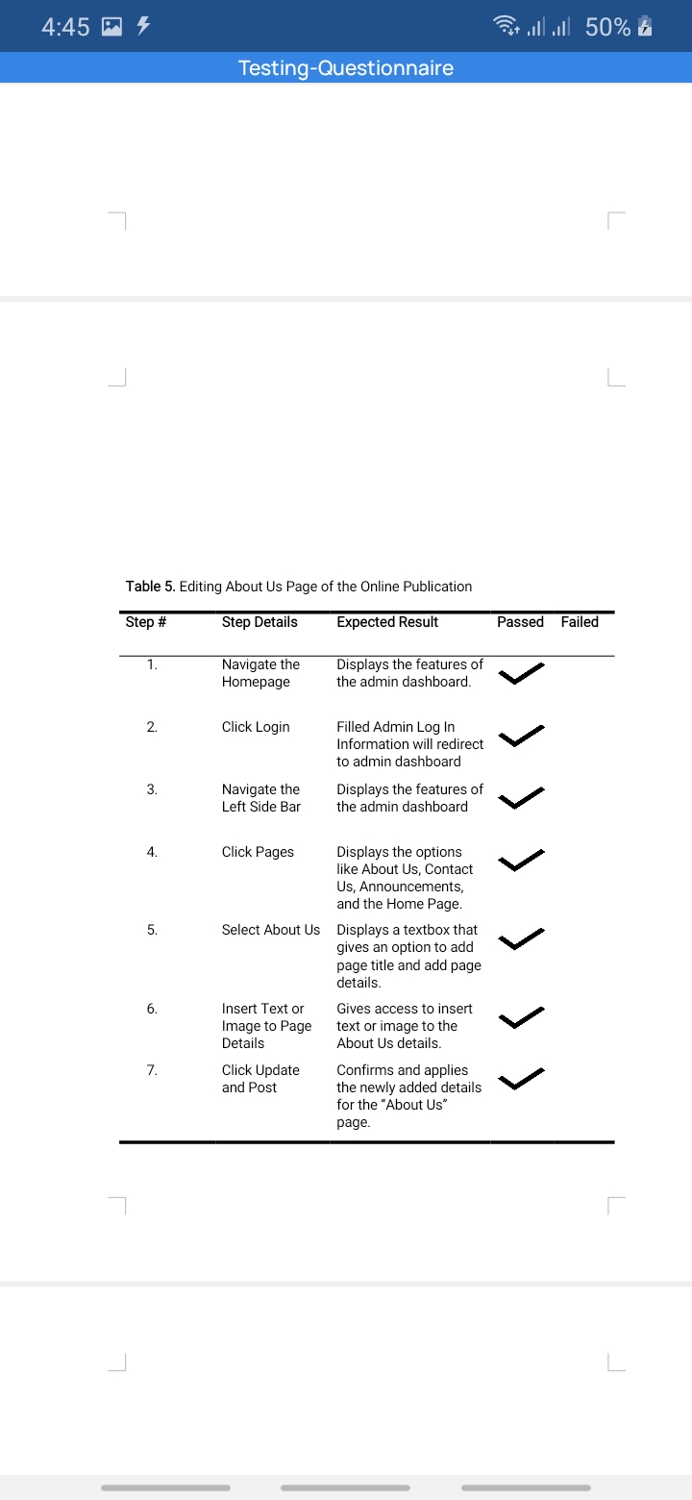

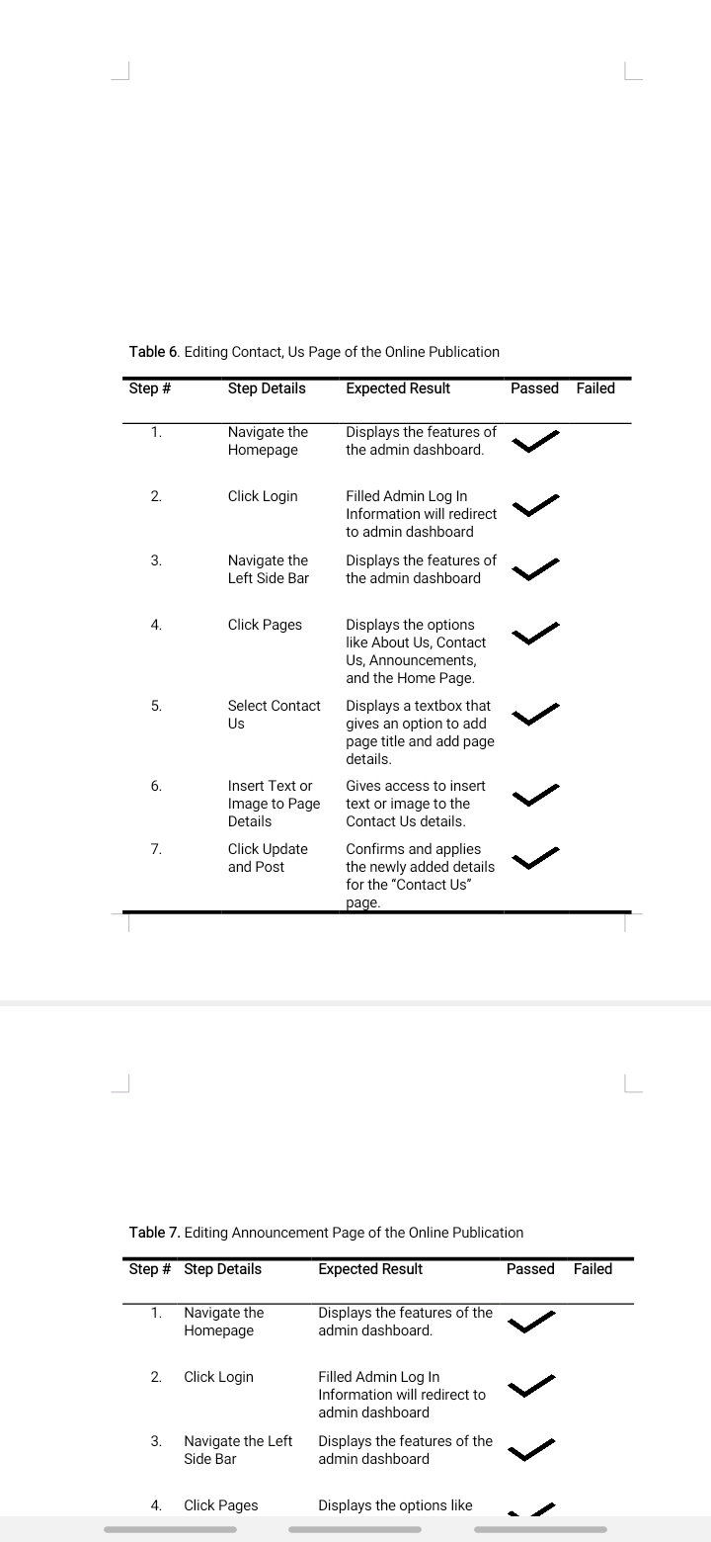**Figure 40.** Show the testing questionnaire results of IT experts for Editing About Us Page functionality that can be found in the GEARS Online publication.

**Figure 41.** Show the testing questionnaire results of IT experts for Editing Contact Us Page functionality that can be found in the GEARS Online publication.

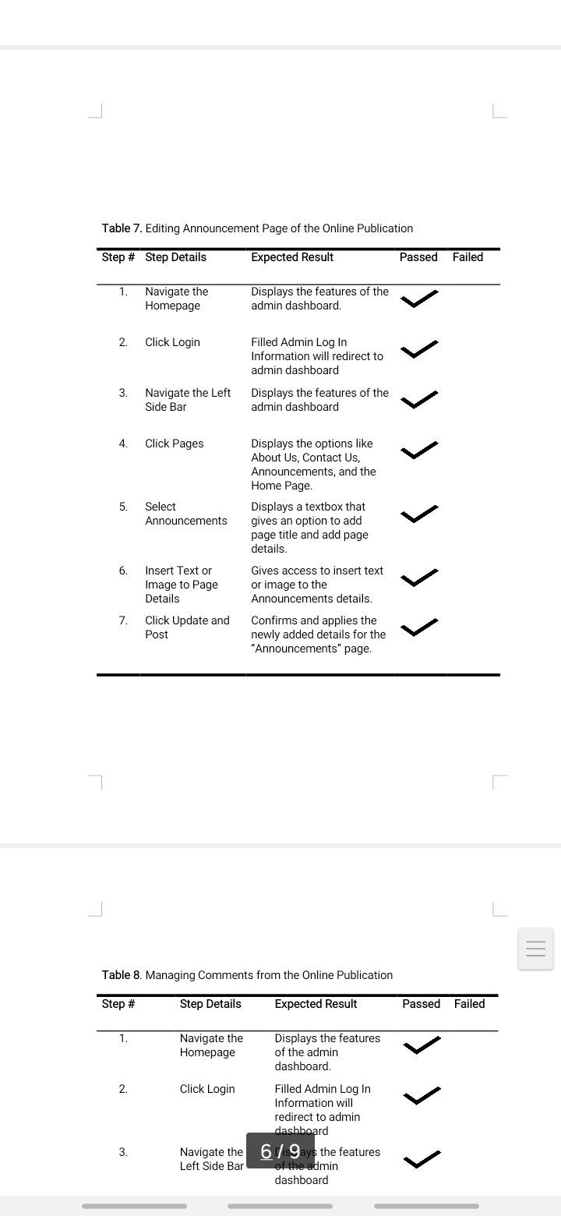

**Figure 42.** Show the testing questionnaire results of IT experts for Editing Announcement Page functionality that can be found in the GEARS Online publication.

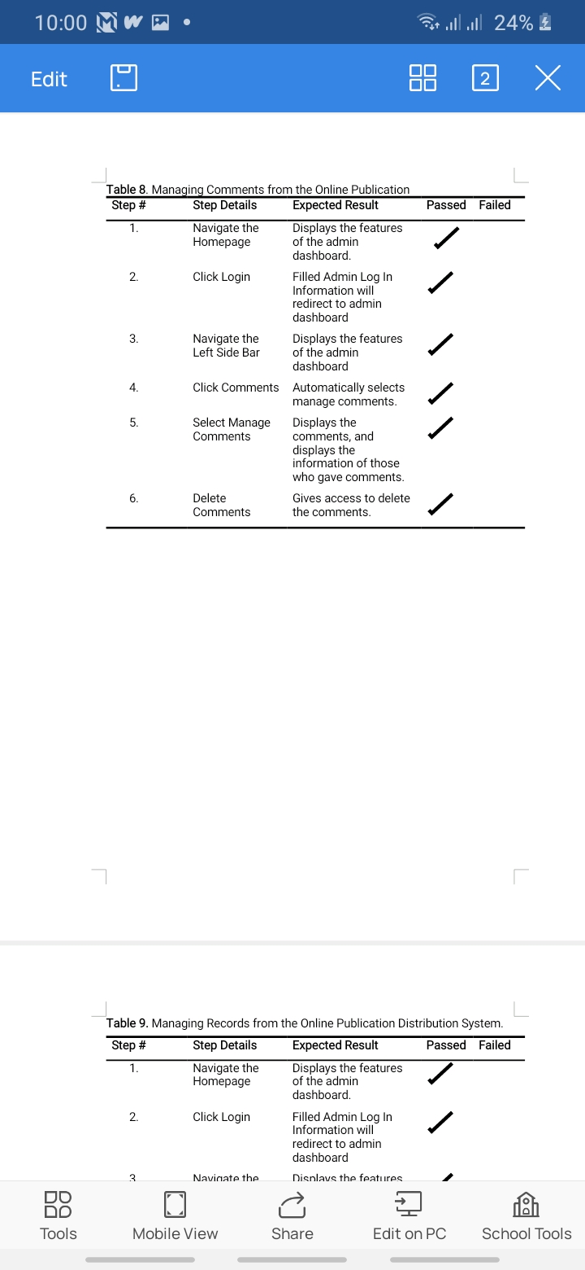

**Figure 43.** Show the testing questionnaire results of IT experts for Managing Comments functionality that can be found in the GEARS Online publication.

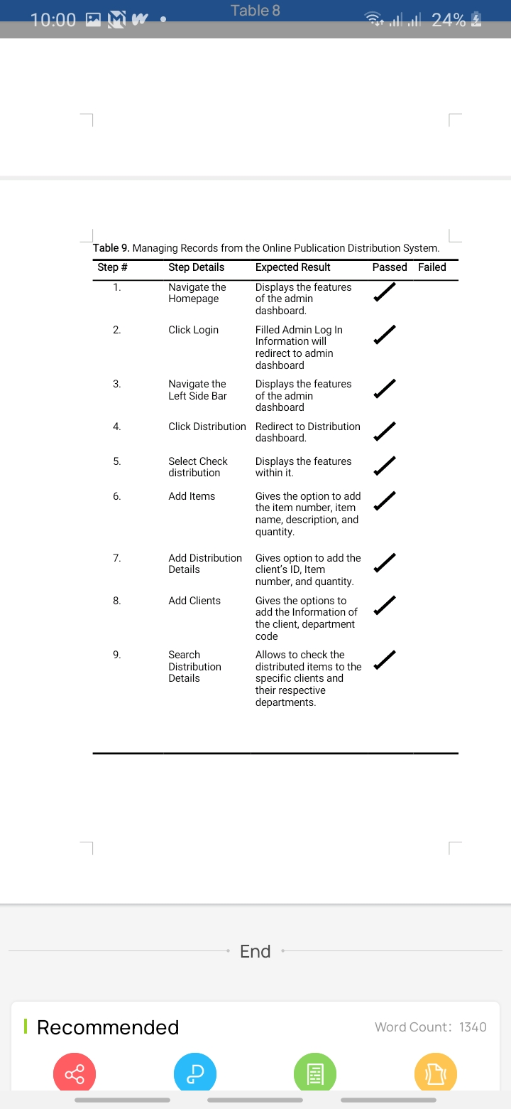

**Figure 44.** Show the testing questionnaire results of IT experts for Managing Records functionality that can be found in the GEARS Online publication.

Shows the result of the test questionnaire for the IT experts. The researchers conduct using google meet while sending the documents of forms to the tester. 3 out of 3 testers rate the test case for respondents’ forms passed.

**Research Objectives No.2:** How to 1) Test the functionalities of the GEARS Online Publication on its major features?

* 1. Post and make an Announcement.

By creating a website for them, the publishing of their news and other related outputs will be much easier and faster to spread throughout the students. Every student that would visit the website would be having a chance to comment on each article. They were allowed to post what’s on their mind or their feedback about the article.

1.2 Monitor the distribution of published articles.

The system will improve the old process, In the old process The GEARS Publication uses a printing press to print their outputs, and they distribute it manually and they used a log book to monitor the distribution of the articles that they published, sometimes human error cannot be avoided so if they use the system their monitoring accuracy will be higher and their work will be more efficient and easier. Now that we are facing a pandemic, this system will help work for them to be more efficient, accurate, more appealing, and more productive.

1.3 Records and Inventory of published articles.

It helps the users to lessen their work and uses it for the work of the staffs and members of the publication can work easier and well-organized than to the current process. The proposed system can help the users to make their works much convenient in terms of organizing, maintaining the records of articles and inventory of the publication better than the manual recording through log book and listing down the inventory of published articles manually.

**Research Objectives No.3:** How to Assess the GEARS Online Publication members with the user acceptance and behavioral intention using Technology Acceptance Model (TAM) criteria.

The researchers made the system user friendly as much possible for the administrators to use it on its full potential. The researchers used the Technology Acceptance Model to evaluate how the user accepts the use of technology by giving them different criteria regarding with the developed system. Based on Hamed (2018) the Technology Acceptance Model (TAM) is an information systems theory that models how users come to accept and use a technology. TAM has been applied to predict and understand users’ behavior. Thus, user acceptance is very important and undeniable key to have a successful implementation of any new technology. So, understanding the users’ perception could help the growth of the implementation of the new technology.

Likert Scale was used as a legend for the verbal interpretation in which the researchers can determine if the respondent is Acceptable, Slightly Acceptable, Neutral, Slightly Unacceptable and Unacceptable.

The result of the GEARS Online Publication as perceived by the respondents in terms of 2.1 Quality Factors, 2.2 Perceived Ease of Use, 2.3 Perceived Usefulness, 2.4 Actual Use and 2.5 Maintainability of the System.

The tables below represent the results of the evaluation conducted in order to assess the user’s acceptance towards the developed study. The data gathered during the demonstration was analyzed and interpreted and was visually represents as the graphs below.

**Table17.** Quality Factors

|  |  |  |  |
| --- | --- | --- | --- |
| **Statements** | **Mean** | **SD** | **Verbal Interpretation** |
| 1. The system can easily manage the records of the released published articles and news to be distributed. | 4.62 | 0.65 | Acceptable |
| 1. The system can easily monitor the number of articles that was distributed and not distributed. | 4.64 | 0.48 | Acceptable |
| 1. The system is able to keep the record and monitor all the article and news. | 4.62 | 0.75 | Acceptable |
| 1. The system helps the user to minimize the number of article and news. | 4.51 | 0.76 | Acceptable |
| **Total Average** | 4.6 | 0.52 | Acceptable |

Table 17. Shows perceptions of the respondents of the study in terms of Quality Factors. As the table shows the question number one has weighed 4.62, the second question weighed 4.64, the third question weighed 4.62 and the last question weighed 4.51 which are Acceptable. The result of the questionnaire for is that there is an average mean of 4.6 on the criteria of Quality Factors of the website with standard deviation of 0.52 which are Acceptable.

**Table 18.** Perceive ease of use

|  |  |  |  |
| --- | --- | --- | --- |
| **Statements** | **Mean** | **SD** | **Verbal Interpretation** |
| 1. The Online Publication flow is easy to understand and it does not require much times in terms of using it. | 4.66 | 0.51 | Acceptable |
| 1. The Online Publication can be used by the user without technical or software knowledge. | 4.42 | 0.65 | Acceptable |
| 1. The Online Publication provides information for the GEARS Publication. | 4.84 | 0.40 | Acceptable |
| **Total Average** | 4.64 | 0.39 | Acceptable |

Table 18. Shows perceptions of the respondents of the study in terms of Perceive of ease use. As the table shows the question number one has weighed 4.66, the second question weighed 4.42 and the last question weighed 4.84 which are Acceptable. For the criteria of Perceive Ease of Use, the result of the questionnaire that there is an average mean of 4.64 with standard deviation of 0.39 which are Acceptable.

**Table 19.** Perceived Usefulness

|  |  |  |  |
| --- | --- | --- | --- |
| **Statements** | **Mean** | **SD** | **Verbal Interpretation** |
| 1. The features of the system are well organized and user friendly. | 4.66 | 0.56 | Acceptable |
| 1. The design of the system is pleasant to the eyes. | 4.57 | 0.62 | Acceptable |
| 1. The system helps the user to lessen the time in generating the records of the published article that was distributed and keep their records. | 4.68 | 0.60 | Acceptable |
| **Total Average** | 4.64 | 0.44 | Acceptable |

Table 19. Shows perceptions of the respondents of the study in terms Perceived Usefulness. As the table shows the question number one has weighed 4.66, the second question weighed 4.57 and the last question weighed 4.68 which are Acceptable. The result of the questionnaire is that there is an average mean 4.64 on the criteria of Perceived Usefulness with standard deviation of 0.44 which are Acceptable.

**Table 20.** Actual Use

|  |  |  |  |
| --- | --- | --- | --- |
| **Statements** | **Mean** | **SD** | **Verbal Interpretation** |
| 1. The user can operate the system properly. | 4.6 | 0.58 | Acceptable |
| 1. The system will improve the current process. | 4,68 | 0.51 | Acceptable |
| 1. The system can be learned with minimum instructions. | 4.64 | 0.57 | Acceptable |
| 1. The system is effective and efficient to the user in terms of record management. | 4.64 | 0.53 | Acceptable |
| **Total Average** | 4.64 | 0.42 | Acceptable |

Table 20. Shows perceptions of the respondents of the study in terms of Actual Use. As the table shows the question number one has weighed 4.6, the second question weighed 4.68, the third question weighed 4.64 and the last question weighed 4.64 which are Acceptable. The result of the questionnaire for is that there is an average mean of 4.6 on the criteria of Actual Use of the website with standard deviation of 0.42 which are Acceptable.

**Table 21.** Maintainability of the system

|  |  |  |  |
| --- | --- | --- | --- |
| **Statements** | **Mean** | **SD** | **Verbal Interpretation** |
| 1. The system can be maintained easily even with users that are not entirely familiar with the system. | 4.4 | 0.68 | Acceptable |
| 2. The system error can be fixed easily. | 4.22 | 0.76 | Acceptable |
| **Total Average** | 4.31 | 0.65 | Acceptable |

Table 21. Shows perceptions of the respondents of the study in terms of Maintainability of the system. As the table shows the question number one has weighed 4.4 and the last question weighed 4.22 which are Acceptable. The result of the questionnaire is that there is an average mean 4.31 on the criteria of Maintainability of the System with standard deviation of 0.65 which are Acceptable.

**Table 22.** Overall Mean Result

|  |  |  |
| --- | --- | --- |
| **Questions** | **Mean** | **Interpretation** |
| Quality Factors | 4.6 | Acceptable |
| Perceive Ease of Use | 4.64 | Acceptable |
| Perceived Usefulness | 4.64 | Acceptable |
| Actual Use | 4.64 | Acceptable |
| Maintainability of the system | 4.31 | Acceptable |
| **Overall** | 4.51 | **Acceptable** |

Table 22. Shows the overall evaluation result of the GEARS Online Publication. The overall mean was attained by the researchers by adding all the composite mean then dividing it to the total number of categories which is 5, (1) Quality Factors, (2) Perceive Ease of Use, (3) Perceived Usefulness, (4) Actual Use, (5) Maintainability of the System. Then the researchers interpret that overall mean into the verbal interpretation using data verbal interpretation guide. The evaluation resulted with the overall mean of 4.51 and has verbal interpretation of Acceptable, which means that the respondents “Acceptable” to the developed system

**CHAPTER V**

**SUMMARY, CONCLUSION AND RECOMMENDATION**

This chapter represents the summary of main findings of the study. It also presents the significance of the study and relates findings to the objectives and problems written in the first chapter of the study. Conclusions and recommendations are also stated in this chapter.

Summary

The researchers developed a system that can help the publication of Laguna State Polytechnic University named the GEARS. The Publication was known forproviding information in every events and activity that happen inside the campus for a sustainable amount of time. The GEARS is the main publication of the university that creates newspaper, magazines, tabloids, literary folio that is used for press conference. In addition, they release newsletters monthly inside the school which are distributed for all the school officesand departments.

The General Objectives objective of the study is to design and develop a GEARS Publication History and Achievements. System that would serve as proposal to help the LSPU the GEARS Publication for their operation and provides an easier, faster, more organized, secured and accurate system. Specifically, the objectives were; 1) Test the functionalities of the GEARS Online Publication on its major features: 1.1 Post and make an Announcement. 1.2 Monitor the distribution of published articles. 1.3 Records and Inventory of published articles. 2) Assess the GEARS Online Publication members with the user acceptance and behavioral intention using Technology Acceptance Model (TAM) criteria. 2.1 Quality Factors. 2.2 Perceived Ease of Use. 2.3 Perceived Usefulness. 2.4 Actual Use. 2.5 Maintainability of the System.

The study aimed to develop a website for the student journalist of the GEARS Publication for faster and easier way of communicating through their readers, monitor the distribution of articles and preserve the GEARS Publication history. By creating a website for them, the publishing of their news and other related outputs will be much easier and faster to spread throughout the students and there’s no need to use a log book for the monitoring of the distribution of article. Every student that would visit the website would be having a chance to comment on each article. They were allowed to post what’s on their mind or their feedback about the article.

The system features the following functions: adding posts, comments, view post, search post, post announcements, edit post of article, add post, delete post, add categories, delete categories, manage pages, and monitoring distribution. The researchers conducted interviews to gather a data that used for the development of the system. The related literature was also taken into consideration in basis in developing the website. The researchers used programming language that help the developer to develop the system. They used PHP, HTML, JAVASCRIPT, CSS and XAMPP in developing the system.

Conclusions

The feedback gathered after the testing implementation conducted by the  
researchers proved that the respondents were satisfied and determined to use the  
developed system. In conclusion to the study, the system was able to answer its main  
objective which is to develop a solution that can resolve the problem of the GEARS Publication in terms of Online Publication.

The enumerated objectives of the study have been achieved and attained through  
the model used in developing the study which is the Agile Software Development Model. By developing the system, the study meets its aim objectives. The system gave a timely and accurate news report for the students of Laguna State Polytechnic University and more effective in monitoring the distribution of the released publish articles. And last, the system lessens the amount of effort and time to every staff of the publication.

Recommendations

Generally, the system was developed and designed for the Laguna State Polytechnic University the GEARS Publication to monitor and keeping the records of the Publication and other related information needed for the scope of this field. For enhancement of the developed of the GEARS Online Publication the following are recommended below.

1. Future researchers may improve the design of the system making it more appealing.
2. Future researchers may add a feature to upload video contents.

**BIBLIOGRAPHY**

ADEYANJU, APEJOYE. (2020), Online news commenting platforms as space for democratic deliberation: a study selected Nigerian Online news websites. Retrieved from <http://usir.salford.ac.uk/id/eprint/58031/>

ALICIA KATE S. IMPERIAL. GERARD JOSEPH F. SOLIS. TIMOTHY RYAN B. GUEVARA. GIUSEPPE NG. (2020) Development of a Pharmaceutical Inventory System using an Agile Methodology. Retrieved from <https://www.researchgate.net/publication/348915561_Development_of_a_Pharmaceutical_Inventory_System_using_an_Agile_Methodology>

ANDRÉS NAVARRO-GALERA. FRANCISCO JOSÉ ALCARAZ-QUILES. DAVID ORTIZ-RODRÍGUEZ. (2016). Online dissemination of information on sustainability in regional governments. Effects of technological factors (PDF Version). Retrieved from <https://www.researchgate.net/publication/289694197_Online_dissemination_of_information_on_sustainability_in_regional_governments_Effects_of_technological_factors>

ANTA AFSANA, MD ISLAM. (2018). Credibility of Online Newspapers: A Study on the University Students in Dhaka. Retrieved from <https://papers.ssrn.com/sol3/papers.cfm?abstract_id=3539477>

ASHURI. (2016). When Online News was New Online technology use and constitution of structures in journalism.

[BAEK, KANGHUI](http://doi.or.kr/10.PSN/ADPER8901590489). (2018.) A Study of the Relationships among Types of Web Portal Usage, Credibility of News on Web Portals, and Credibility of News Media Outlets. Retrieved from <https://www.koreascience.or.kr/article/JAKO201931961769323.page>

BO WANG. YING SONG. YUZHONG SUN. JUN LIU. (2016). Improvements to Online Distributed Monitoring Systems. Retrieved from <https://www.researchgate.net/publication/313545049_Improvements_to_Online_Distributed_Monitoring_Systems>

BUGRAF. TRILLING. (2017). Through a different gate: An automated content analysis of how online news and print news differ

CARLOS JOAQUÍN TORRECILLA-SALINAS, JORGE SEDEÑO, MJ ESCALONA, MANUEL MEJÍAS. (2015). Estimating, planning and managing Agile Web Development projects under a value-based perspective. Retrieved from <https://www.sciencedirect.com/science/article/abs/pii/S0950584915000142>

CAMILLE, JOHNSON. (2016). Retrieved from <https://www.google.com.ph/amp/s/techterms.com/amp/definition/web_publishing>

CUADRA. (2017) Retrieved from <https://www.researchgate.net/publication/303684814_THE_EVOLUTION_OF_ELECTRONIC_PUBLISHING_A_LITERATURE_REVIEW>

DANILO I BRANDAO, MARCELO G SIMÕES, FELIX A FARRET, HÉLIO MA ANTUNES, SIDELMO M SILVA. (2018). Distributed generation systems: an approach in instrumentation and monitoring. Retrieved from <https://www.tandfonline.com/doi/abs/10.1080/15325008.2018.1563954>

DEIN, REYNOLD. (2017). Retrieved from <https://www.linnworks.com/blog/inventory-management-benefits>

DONG GEUN LEE, IN CHEOL MIN. (2021). Diversity of online news media. Retrieved from <https://books.google.com.ph/books?hl=en&lr=&id=i60eEAAAQBAJ&oi=fnd&pg=PA13&dq=info:dOU_1c00mmEJ:scholar.google.com/&ots=toqkht12lE&sig=RHV5FWddGMTBoCxYCMnLOf4JgW8&redir_esc=y#v=onepage&q&f=false>

DR. J DURGA PRASAD RAO. (2016). A study of web portal features as a knowledge management system in school education.

FATON, ISMAJLI. 2020. Transforming News Journalism from Newspapers into Online Media in Kosovo. Retrieved from <https://papers.ssrn.com/sol3/papers.cfm?abstract_id=3528432>

FITZ, GIBON. 2016. Retrieved from <http://www.nfrastructure.com/services/operate/systems-monitoring/>

GERARD O'REGAN. (2017). Agile Methodology. Retrieved from <https://www.researchgate.net/publication/318136368_Agile_Methodology>

GOPAL SAKARKAR. PRIYANKA RANGANI. 2019. Online News Portal. Retrieved from <https://www.researchgate.net/publication/332539376_News_Portal_centraltimesin>

[HARTE](https://scholar.google.com/citations?user=AEdS-J4AAAAJ&hl=en&oi=sra). 2018. [Hyperlocal Journalism: The decline of local newspapers and the rise of online community news](https://books.google.com/books?hl=en&lr=&id=aQxjDwAAQBAJ&oi=fnd&pg=PT8&dq=online+community+news+%22local+newspapers%22&ots=fMs97yrq6M&sig=FIin84l6KIl02tiOGLjyj3SOWrA)

HY, YOON. 2016. User Acceptance of Mobile Library Applications in Academic Libraries: An Application of the Technology Acceptance Model. Retrieved from

<https://www.sciencedirect.com/science/article/abs/pii/S0099133316301707>

IQBAL, BHATTI (2015). An Investigation of University Student Readiness Towards M-learning Using Technology Acceptance Model (PDF VERSION). Retrieved from; https://files.eric.ed.gov/fulltext/EJ1082185.pdf

JIM, FOUST. (2017). [Online journalism-principles and practices of news for the Web](https://books.google.com/books?hl=en&lr=&id=dkErDwAAQBAJ&oi=fnd&pg=PP1&dq=web+journalism&ots=_4vXygBf6y&sig=Wl_viSv7aTq8JwsgSOjMjsnHwp8). Retrieved from <https://books.google.com.ph/books?hl=en&lr=&id=dkErDwAAQBAJ&oi=fnd&pg=PP1&dq=Online+journalism-principles+and+practices+of+news+for+the+Web&ots=_4w_Eaxm5t&sig=SuoLcyTw7MbxI8KBKkAPWFV9Zdk&redir_esc=y#v=onepage&q=Online%20journalism-principles%20and%20practices%20of%20news%20for%20the%20Web&f=false>

JOEY KA-CHING CHAN, LOUIS LEUNG. 2016. Lifestyles, reliance on traditional news media and online news adoption. Retrieved from <https://journals.sagepub.com/doi/abs/10.1177/1461444805052281>

KANGHUI. 2018. A Study of the Relationships among Types of Web Portal Usage, Credibility of News on Web Portals, and Credibility of News Media Outlets.

KUYUCU, M. 2016. The Online Journal of Communication and Media, about the contents of Online Magazine Portal (PDF VERSION). Retrieved from <http://www.tojcam.net/journals/tojcam/articles/v02i04/v02i04-03.pdf>

LANCE, MATTHEWS. (2017). Retrieved from <https://www.google.com.ph/amp/s/dotcomdist.com/the-benefits-and-importance-of-managing-inventory/amp/>

MANOBENDRONATH, HALDAR. (2020). Online News Portal. Retrieved from <http://dspace.daffodilvarsity.edu.bd:8080/handle/123456789/5304>

MARCO, FERRER. (2018). Retrieved from <https://www.boxstorm.com/blog/advantages-of-online-inventory-management/>

MEHTA R BANSI. (2019). Online News Portal. Retrieved from <https://scholar.google.com/scholar?start=10&q=agile+in+web+portal+online+newspapers&hl=en&as_sdt=0,5&as_ylo=2017#d=gs_qabs&u=%23p%3DmFt5Ra9WDsYJ>

MICHAEL B SALWEN, BRUCE GARRISON, PAUL D DRISCOLL. (2016). Online news and the public. Retrieved from <https://books.google.com.ph/books?hl=en&lr=&id=XnORAgAAQBAJ&oi=fnd&pg=PP1&dq=info:FYx9KHwbdk0J:scholar.google.com/&ots=c6s4zmEW68&sig=f2s-VplSiMqF1-ydaXBJnpKyz98&redir_esc=y#v=onepage&q&f=false>

MICHAEL SCHARKOW, FRANK MANGOLD, SEBASTIAN STIER, AND JOHANNES BREUER. (2020). How social network sites and other online intermediaries increase exposure to news (PDF Version). Retrieved from <https://www.pnas.org/content/117/6/2761.short>

M. T. BASHORUN. PRITI JAIN. PETER SEBINA. TRYWELL KALUSOPA. (2016). The evolution of electronic publishing: a literature review. Retrieved from <https://www.researchgate.net/publication/303684814_THE_EVOLUTION_OF_ELECTRONIC_PUBLISHING_A_LITERATURE_REVIEW>

NAMYUN, KIM. 2020. Extracting and searching news articles in web portal news pages. Retrieved from <https://www.inderscienceonline.com/doi/abs/10.1504/IJCVR.2020.107241>

NARAYANGONJ, RAIHAN. MOHAMMAD, SAGAR. 2019. Online News Portal. Retrieved from <http://dspace.daffodilvarsity.edu.bd:8080/handle/123456789/3343>

NAZLI ISMAIL NAWANG, ABDUL MAJID TAHIR MOHAMED, AMINUDDIN MUSTAFFA. 2020. Online news portals in malaysia-a revisit of the regulatory regime governing the media in the era of media convergence (PDF Version). Retrieved from

<http://www.e-journal.uum.edu.my/index.php/uumjls/article/view/8263>

OTIENO, FAO. 2019.The Roles of Monitoring and Evaluation in Projects (PDF VERSION). Retrieved from

<https://www.academia.edu/39245874/The_Roles_of_Monitoring_and_Evaluation_in_Projects>

PANAGIOTIDIS. 2020. A Participatory Journalism Management Platform: Design, Implementation and Evaluation

PAULUSSEN. 2017. Online News Production in Flanders: How Flemish Online Journalists Perceive and Explore the Internet's Potential

PULVERER. 2016. EMBO Press, a new way to publish

RUI LIU. YUNGENG XIE. YIXUAN XIE. 2017. Study of Online Public Opinion in New Media Environment. Retrieved from <https://www.researchgate.net/publication/320218363_A_Study_of_Online_Public_Opinion_in_New_Media_Environment>

SAULE BARLYBAYEVA, MANSHUK YESSIMOVA. 2018. The Impact of Communication Technology on the Development of Modern Journalism in Kazakhstan (PDF VERSION). Retrieved from

<http://www.jocm.us/uploadfile/2019/0930/20190930025458988.pdf>

STEFAN CIUCU. 2017. Online dissemination of news in Nicolae Titulescu University. Retrieved from <https://www.researchgate.net/publication/262911077_Online_dissemination_of_news_in_Nicolae_Titulescu_University>

SOONHO, KIM. 2016. Managing a web portal adapting to new technologies. Retrieved from <https://www.researchgate.net/publication/299447302_Managing_a_web_portal_adapting_to_new_technologies>

THERESA A CULLEN. 2021. Agile Design Processes and Project Management. Retrieved from <https://edtechbooks.org/id/agile_design_process>

TIAGO, MARTINS. VÍTOR. CARVALHO. FILOMENA O. SOARES. 2016. Web Portal. Retrieved from <https://www.researchgate.net/publication/276185375_Web_Portal>

UJUNWA IFEOMA NDUANYA. FRANCIS A. OKOYE. NDUBUISI JOHN NGENE. 2020. Online Building Materials Inventory System. Retrieved from <https://www.researchgate.net/publication/341726285_Online_Building_Materials_Inventory_System>

VALERIY NIKOLAYEVICH OSIPOV. 2021. Compliance with journalistic standards in the headlines of print and online publications. Retrieved from <https://www.researchgate.net/publication/348940271_Compliance_with_journalistic_standards_in_the_headlines_of_print_and_online_publications>

VICTOR GARCIA PERDOMO. MARIA ISABEL MAGANA. 2020. Adoption of technology and Innovation Among Native Online News Media in Columbia. Retrieved from <http://ijoc.org/index.php/ijoc/article/view/12124>

VINEET, KAUL. 2016. Journalism in the Age of Digital Technology. Retrieved from <https://www.ceeol.com/search/article-detail?id=251218>

WI-GEUN. 2016. The Influence of Portal Site News Services on Online Journalism in Korea: The Structural Transformation or the Power Change in the News Distribution

YANIAR RAHMAH, ABDUL AZIZ. 2016. Portal system for Indonesian online newspaper. Retrieved from <https://ieeexplore.ieee.org/abstract/document/7873832>

ZHALA JAMEEL. SUBHI R. M. ZEEBAREE. 2021. Recourses Utilization in a Distributed System: A Review. Retrieved from <https://www.researchgate.net/publication/348750350_Recourses_Utilization_in_a_Distributed_System_A_Review>

**APPENDICES**

**FLOW CHART**

**Current process of the LSPU Main Campus**

**For Publishing News/Articles**

PROCESS STATE HOLDER RESPONSIBLE DESCRIPTION

Coordinator/OSAS/

Campus Director

OSAS/Campus Director

Publish

Checking

Staff

Editorial Boards

Staff

Editorial Board/Coordinator

Staff

News Editor

Coordinator

Give the report

Assign

Final

Read

Print

Layout

Read

Assign students to cover photo journalist and writer.

Give the report to News editor for copy reading.

Read compilations of output.

Layout of output.

Printing of sample.

Copy reading of Editorial Board and Coordinator.

Final Output and will pass to OSAS and Campus Director.

Checking of OSAS and Campus Director.

After checking it will be published.

**Current process of the LSPU Main Campus**

**For Distribution of Published News/Articles**

PROCESS STATE HOLDER RESPONSIBLE DESCRIPTION

OSAS/Coordinator

Approved by the OSAS and Coordinator to be published.

Meeting for the budget and number of outputs to be print out.

Manage the number of article/news to be distributed by department

Limit printed outputs to be distributed by departments depends on the budget.

Record the number of article and News distributed by department

Logbook

Editorial Board/Staff

Editorial Board/Staff

Distribute by Department

Printed output

Editorial Boards

Give the report to the accounting office

Editorial Board

Article/

News

**Current process of the LSPU Main Campus**

**For Record Keeping**

PROCESS STATE HOLDER RESPONSIBLE DESCRIPTION

Keeping the record so they will know if all the department receive the copy of the released published article by the GEARS Publication

Checking and monitor if all the department has received the printout news and articles

Editorial Board/Staff

Editorial Board/Staff

Approved Published Article/News to be disseminated by department

The GEARS Publication

Given the released publish articles and news by department

Release Article

Record it using Logbook

**Proposed process of the LSPU Main Campus**

**For Publishing News/Articles**

PROCESS STATE HOLDER RESPONSIBLE DESCRIPTION

After checking it will be published online through the GEARS Online Publication

Checking of OSAS and Campus Director.

Final Output and will pass to OSAS and Campus Director.

Copy reading of Editorial Board and Coordinator.

Printing of sample.

Layout of output.

Read compilations of output.

Give the report to News editor for copy reading.

Assign students to cover photo journalist and writer.

Coordinator/OSAS/

Campus Director

OSAS/Campus Director

Staff

Editorial Board/Coordinator

Staff

Editorial Boards

News Editor

Staff

Coordinator

Publishing Online through the GEARS Online Publi

Checking

Final

Read

Print

Layout

Read

Give the report

Assign

**Proposed process of the LSPU Main Campus**

**For Distribution of Published News/Articles**

PROCESS STATE HOLDER RESPONSIBLE DESCRIPTION

Show the amounts of the Inventory Article /News that was distributed and not distributed through the GEARS Online Publication

Editorial Board/Staff

Recorded

Record Online through the GEARS Online Publication

Approved by the OSAS and Coordinator to be published.

Meeting for the budget and number of outputs to be print out.

Limit printed outputs to be distributed by departments depends on the budget.

Manage the number of article/news to be distributed by department

Record the number of article and News distributed by department

Editorial Board/Staff

Editorial Board/Staff

Editorial Boards

Editorial Board

OSAS/Coordinator

Distribute by Department

Printed output

Give the report to the accounting office

Article/News

**Proposed process of the LSPU Main Campus**

**For Record Keeping**

PROCESS STATE HOLDER RESPONSIBLE DESCRIPTION

Record online through the GEARS Publication Distribution system

Keeping the record so they will know if all the department receive the copy of the released published article by the GEARS Publication

Checking and monitor if all the department has received the printout news and articles

Editorial Board/Staff

Editorial Board/Staff

Approved Published Article/News to be disseminated by department

The GEARS Publication

Given the released publish articles and news by department

Release Article

**USE CASE DIAGRAM**

**Use Case Diagram**

**The GEARS Online Publication**

Admin

**The GEARS Online Publication**

Super User

**DATA DICTIONARY**

**Data fields for Admin Log In**

|  |  |  |
| --- | --- | --- |
| NAME | DESCRIPTION | DATA TYPE |
| ID KEY | ID KEY | Int (11) |
| AdminUserName | AdminUserName | Varchar(255) |
| AdminPassword | AdminPassword | Varchar(255) |
| AdminEmailID | AdminEmailID | Varchar(255) |
| Is_Active | Is_Active | Int(11) |
| CreationDate | CreationDate | Timestamp |
| UpdationDate | UpdationDate | timestamp |

**Data Fields for Categories**

|  |  |  |
| --- | --- | --- |
| NAME | **DESCRIPTION** | **DATA TYPE** |
| ID KEY | ID KEY | Int(11) |
| CategoryName | CategoryName | Varchar(200) |
| Description | Description | Mediumtext |
| PostingDate | PostingDate | Timestamp |
| UpdationDate | UpdationDate | Timestamp |
| Is_Active | Is_Active | Int(1) |

**Data Fields for Comments**

|  |  |  |
| --- | --- | --- |
| **NAME** | **DESCRIPTION** | **DATA TYPE** |
| Id key | Id key | Int(11) |
| Post Id | Post Id | Char(11) |
| Name | Name | Varchar(120) |
| Email | Email | Varchar(150) |
| Comment | Comment | Mediumtext |
| Postingdate | PostingDate | Timestamp |
| Status | Status | Int(1) |

**Data Fields for Pages**

|  |  |  |
| --- | --- | --- |
| **NAME** | **DESCRIPTION** | **DATA TYPE** |
| Id key | Id key | Int(11) |
| Pagename | Pagename | Varchar(200) |
| Pagetitle | Pagetitle | Mediumtext |
| Description | Description | Longtext |
| Posting date | Posting date | Timestamp |
| Updation date | Updation date | timestamp |

**Data Fields for Posts**

|  |  |  |
| --- | --- | --- |
| **NAME** | **DESCRIPTION** | **DATA TYPE** |
| Id key | Id key | Int(11) |
| Posttitle | Posttitle | Longtext |
| Categoryid | Categoryid | Int(11) |
| Subcategoryid | Subcategoryid | Int(11) |
| Postdetails | Postdetails | longtext |
| Postingdate | Postingdate | Timestamp |
| Updationdate | Updationdate | Timestamp |
| Is_active | Is_active | Int(1) |
| Posturl | Posturl | Mediumtext |
| Postimage | Postimage | Varchar(255) |

**Data Fields for Subcategory**

|  |  |  |
| --- | --- | --- |
| **NAME** | **DESCRIPTION** | **DATA TYPE** |
| Subcategoryid | Subcategoryid | Subcategoryid |
| Categoryid | Categoryid | Categoryid |
| Subcategory | Subcategory | Subcategory |
| Subcatdescription | Subcatdescription | Subcatdescription |
| Postingdate | Postingdate | Postingdate |
| Updationdate | Updationdate | Updationdate |
| Is_active | Is_active | Is_active |

**HIPO MODEL**

**INITIAL PLANNING**

Research

**PLANNING**

Innovative Idea

**DEPLOYMENT**

**TITLE**



**ANALYSIS AND DESIGN**

Coding





**IMPLEMENTATION**

Trial Run

**TESTING AND EVALUATION**

Debugging



Figure 45. The figure above is the input, process, and output model of the developed system. The conceptual framework defines the relationship between specific details mentioned and the flow of the developed system.

**PROJECT SCHEDULE**

**Gantt Chart- THE GEARS ONLINE PUBLICATIONS**

|  |  |  |  |  |  |  |  |  |  |  |  |  |  |  |  |  |
| --- | --- | --- | --- | --- | --- | --- | --- | --- | --- | --- | --- | --- | --- | --- | --- | --- |
| Activity | Percent Complete | Weeks | | | | | | | | | | | | | | |
| 1 | 2 | 3 | 4 | 5 | 6 | 7 | 8 | 9 | 10 | 11 | 12 | 13 | 14 |
| Requirement Gathering | 100% |  |  |  |  |  |  |  |  |  |  |  |  |  |  |
| Analysis | 90% |  |  |  |  |  |  |  |  |  |  |  |  |  |  |
| Design | 50% |  |  |  |  |  |  |  |  |  |  |  |  |  |  |
| Development | 10% |  |  |  |  |  |  |  |  |  |  |  |  |  |  |

Plan Duration Actual Start % Complete Actual (beyond plan) % Complete (beyond plan)

**TESTING AND EVALUATION INSTRUCTION**

**Tester Name: Date:**

**Course:**

**School Graduated:**

**Work (Please specify where):**

**THE GEARS ONLINE PUBLICATION**

**Testing Questionnaire**

**(Pass/Fail/Not Executed)**

**Table 23.** Adding Post to the Online Publication

|  |  |  |  |  |
| --- | --- | --- | --- | --- |
| **Step #** | **Step Details** | **Expected Result** | **Passed** | **Failed** |
|  | Navigate the Homepage | Displays “Admin Log In” dashboard |  |  |
|  | Click Login | Filled Admin Log In Information will redirect to admin dashboard |  |  |
|  | Navigate the Left Side Bar | Displays the features of the admin dashboard. |  |  |
|  | Click Posts | Open the features within it. |  |  |
|  | Select Add Post | Display the add post feature that consists of insert category, insert subcategory, and the post’s content that can be either text or images |  |  |

|  |  |  |  |  |
| --- | --- | --- | --- | --- |
| 6 | Insert Post Title | Give access to name the post’s title, |  |  |
| 7 | Select Category | Will give the option to choose what the main category of your post is. |  |  |
| 8 | Select Subcategory | Will give the option to choose what the subcategory of your post is. |  |  |
| 9 | Insert Post Details | Will give the option to insert the content of your post. |  |  |
| 10 | Upload Image | Should upload the image together with the details of the post. |  |  |
| 11 | Save Posts | Saves and confirms the post. |  |  |

**Table 24.** Adding categories to the Online Publication

|  |  |  |  |  |
| --- | --- | --- | --- | --- |
| **Step #** | **Step Details** | **Expected Result** | **Passed** | **Failed** |
|  | Navigate the Homepage | Displays the features of the admin dashboard. |  |  |
|  | Click Login | Filled Admin Log In Information will redirect to admin dashboard |  |  |
|  | Navigate the Left Side Bar | Displays the features of the admin dashboard |  |  |
| 4 | Click Category | Displays the options within it |  |  |
| 5 | Select Add Category | Displays the insert category name feature, the insert category description feature, and the submit button. |  |  |
| 6 | Insert Category Name | Gives access to name the category |  |  |
| 7 | Insert Category Description | Gives access to describe the category. |  |  |
| 8 | Click Submit | Confirms submitting the newly added category |  |  |

**Table 25.** Adding subcategories to the Online Publication

|  |  |  |  |  |  |  |  |  |  |
| --- | --- | --- | --- | --- | --- | --- | --- | --- | --- |
| **Step #** | | **Step Details** | | **Expected Result** | | **Passed** | | **Failed** | |
|  | | Navigate the Homepage | | Displays the features of the admin dashboard. | |  | |  | |
|  | | Click Login | | Filled Admin Log In Information will redirect to admin dashboard | |  | |  | |
|  | | Navigate the Left Side Bar | | Displays the features of the admin dashboard | |  | |  | |
|  | | Click Subcategory | | Displays the options within it. | |  | |  | |
|  | | Select Add Subcategory | | Displays the insert subcategory name feature, the insert subcategory description feature, and the submit button. | |  | |  | |
| 6 | | Select Category | | Will give the option to choose what the main category of your post is. | |  | |  | |
| 7 | | Insert Subcategory Name | | Gives access to name the subcategory | |  | |  | |
| 8 | | Insert Subcategory Description | | Gives access to describe the subcategory | |  | |  | |
| 9 | | Submit | | Confirms submitting the newly added subcategory. | |  | |  | |

**Table 26.** Editing Homepage of the Online Publication

|  |  |  |  |  |
| --- | --- | --- | --- | --- |
| **Step #** | **Step Details** | **Expected Result** | **Passed** | **Failed** |
|  | Navigate the Homepage | Displays the features of the admin dashboard. |  |  |
|  | Click Login | Filled Admin Log In Information will redirect to admin dashboard |  |  |
|  | Navigate the Left Side Bar | Displays the features of the admin dashboard |  |  |
|  | Click Pages | Displays the options like About Us, Contact Us, Announcements, and the Home Page |  |  |

|  |  |  |  |  |
| --- | --- | --- | --- | --- |
| 5 | Select Homepage | Displays a textbox that gives option to edit the content. |  |  |
| 6 | Insert Text or Image to Page Details | Gives access to insert text or image to the Page details. |  |  |
| 7 | Click Update and Post | Confirms and applies the newly added details for the home page |  |  |

**Table 27.** Editing About Us Page of the Online Publication

|  |  |  |  |  |
| --- | --- | --- | --- | --- |
| **Step #** | **Step Details** | **Expected Result** | **Passed** | **Failed** |
|  | Navigate the Homepage | Displays the features of the admin dashboard. |  |  |
|  | Click Login | Filled Admin Log In Information will redirect to admin dashboard |  |  |
|  | Navigate the Left Side Bar | Displays the features of the admin dashboard |  |  |
|  | Click Pages | Displays the options like About Us, Contact Us, Announcements, and the Home Page. |  |  |
|  | Select About Us | Displays a textbox that gives an option to add page title and add page details. |  |  |
| 6 | Insert Text or Image to Page Details | Gives access to insert text or image to the About Us details. |  |  |
| 7 | Click Update and Post | Confirms and applies the newly added details for the “About Us” page. |  |  |

**Table 28**. Editing Contact, Us Page of the Online Publication

|  |  |  |  |  |
| --- | --- | --- | --- | --- |
| **Step #** | **Step Details** | **Expected Result** | **Passed** | **Failed** |
|  | Navigate the Homepage | Displays the features of the admin dashboard. |  |  |
|  | Click Login | Filled Admin Log In Information will redirect to admin dashboard |  |  |
|  | Navigate the Left Side Bar | Displays the features of the admin dashboard |  |  |
|  | Click Pages | Displays the options like About Us, Contact Us, Announcements, and the Home Page. |  |  |
|  | Select Contact Us | Displays a textbox that gives an option to add page title and add page details. |  |  |
|  | Insert Text or Image to Page Details | Gives access to insert text or image to the Contact Us details. |  |  |
|  | Click Update and Post | Confirms and applies the newly added details for the “Contact Us” page. |  |  |

**Table 29.** Editing Announcement Page of the Online Publication

|  |  |  |  |  |
| --- | --- | --- | --- | --- |
| **Step #** | **Step Details** | **Expected Result** | **Passed** | **Failed** |
|  | Navigate the Homepage | Displays the features of the admin dashboard. |  |  |
|  | Click Login | Filled Admin Log In Information will redirect to admin dashboard |  |  |
|  | Navigate the Left Side Bar | Displays the features of the admin dashboard |  |  |
|  | Click Pages | Displays the options like About Us, Contact Us, Announcements, and the Home Page. |  |  |
|  | Select Announcements | Displays a textbox that gives an option to add page title and add page details. |  |  |
|  | Insert Text or Image to Page Details | Gives access to insert text or image to the Announcements details. |  |  |
|  | Click Update and Post | Confirms and applies the newly added details for the “Announcements” page. |  |  |

**Table 30**. Managing Comments from the Online Publication

|  |  |  |  |  |
| --- | --- | --- | --- | --- |
| **Step #** | **Step Details** | **Expected Result** | **Passed** | **Failed** |
|  | Navigate the Homepage | Displays the features of the admin dashboard. |  |  |
|  | Click Login | Filled Admin Log In Information will redirect to admin dashboard |  |  |
|  | Navigate the Left Side Bar | Displays the features of the admin dashboard |  |  |
|  | Click Comments | Automatically selects manage comments. |  |  |
|  | Select Manage Comments | Displays the comments, and displays the information of those who gave comments. |  |  |
|  | Delete Comments | Gives access to delete the comments. |  |  |

**Table 31.** Managing Records from the Online Publication Distribution System.

|  |  |  |  |  |
| --- | --- | --- | --- | --- |
| **Step #** | **Step Details** | **Expected Result** | **Passed** | **Failed** |
|  | Navigate the Homepage | Displays the features of the admin dashboard. |  |  |
|  | Click Login | Filled Admin Log In Information will redirect to admin dashboard |  |  |
|  | Navigate the Left Side Bar | Displays the features of the admin dashboard |  |  |
|  | Click Distribution | Redirect to Distribution dashboard. |  |  |
|  | Select Check distribution | Displays the features within it. |  |  |
|  | Add Items | Gives the option to add the item number, item name, description, and quantity. |  |  |
|  | Add Distribution Details | Gives option to add the client’s ID, Item number, and quantity. |  |  |
|  | Add Clients | Gives the options to add the Information of the client, department code |  |  |
|  | Search Distribution Details | Allows to check the distributed items to the specific clients and their respective departments. |  |  |

**Name of the Respondents (optional):** __________________________________

**Year/Section:** _____________________________________________________

**Position: _________________________________________________________**

The purpose of the questionnaire to assess the user acceptance and behavioral intention of using the developed system **“The GEARS Online Publication** “. This study is conducted to enhance and develop the Online Publication that will improve the old process of the GEARS Publication.

**Directions:** Please fill in the following information

**Technology Acceptance Questionnaire**

**Directions:** Kindly put CHECK ( ) on the corresponding scale to indicate your level of acceptance relative to each question. Indicate your acceptability with the following statement using the following scale:

4,Slighlty acceptable, -3 Neutral, -2 Slighlty unceptable, 1- Unaceptable

**5** – Acceptable,

You may also indicate your comment and suggestions at the last part of the questionnaire.

|  |  |  |  |  |  |
| --- | --- | --- | --- | --- | --- |
| **QUALITY FACTORS** | **5** | **4** | **3** | **2** | **1** |
| 1. The system can easily manage the records of the released published articles and news to be distributed. |  |  |  |  |  |
| 1. The system can easily monitor the amount of article that was distributed and not distributed. |  |  |  |  |  |
| 1. The system is able to keep the record and monitor all the article and news. |  |  |  |  |  |
| 1. The system helps the user to minimize the number of article and news. |  |  |  |  |  |
| **PERCEIVE EASE OF USE** | 5 | 4 | 3 | 2 | 1 |
| 1. The Online Publication flow is easy to understand and it does not require much times in terms of using it. |  |  |  |  |  |
| 1. The Online Publication can be used by the user without technical or software knowledge. |  |  |  |  |  |
| 1. The Online Publication provides information for the GEARS Publication. |  |  |  |  |  |
| **PERCEIVED USEFULNESS** | 5 | 4 | 3 | 2 | 1 |
| 1. The features of the system are well organized and user friendly. |  |  |  |  |  |
| 1. The design of the system is pleasant to the eyes. |  |  |  |  |  |
| 1. The system helps the user to lessen the time in generating the records of the published article that was distributed and keep their records. |  |  |  |  |  |
| **ACTUAL USE** | 5 | 4 | 3 | 2 | 1 |
| 1. The user can operate the system properly. |  |  |  |  |  |
| 1. The system will improve the current process. |  |  |  |  |  |
| 1. The system can be learned with minimum instructions. |  |  |  |  |  |
| 1. The system is effective and efficient to the user in terms of record management. |  |  |  |  |  |

**Evaluated By:**

|  |
| --- |
|  |
| **Respondents** |

**THE GEARS ONLINE PUBLICATION USER MANUAL**

**SYSTEM OVERVIEW**

An Online monitoring system that will help THE GEARS PUBLICATION for their work to be more efficient, to have effective interaction with their readers, and their distribution to be more accurate.

1. Online Presence/Posting

* Admin
* Dashboard
* Adding Categories/ Sub Categories
* Manage Categories
* Add Post
* Manage Post
* Manage Comments

1. Distribution

* Monitoring
* Details
* Report

**USER GUIDE (Posting)**

Home Page



**Figure 46.** Shows the Home Page of the online publication.

Admin Log In Page

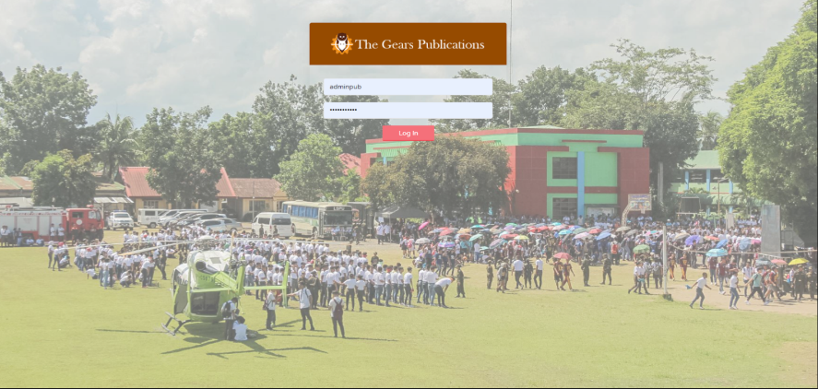

**Figure 47.** Shows the Admin Log In Page of the online publication input name and password.

****Dashboard Page

**Figure 48.** Shows the dashboard where all the content of the online publication can be seen.

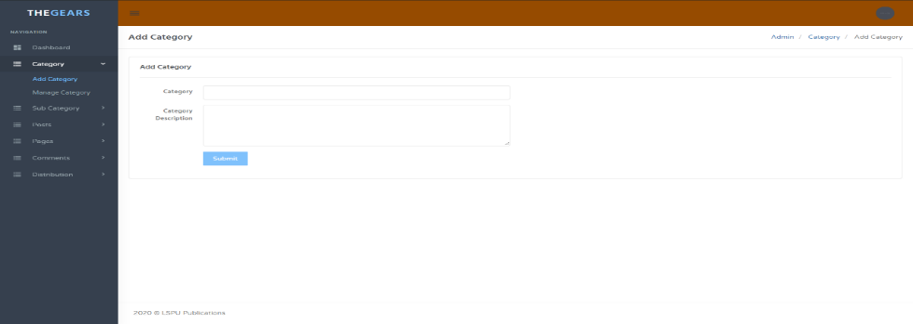Add Category Page

**Figure 49.** Shows the Add Category Page where you can add category like Politics, Literature, Classes, Newa, SportFest, E-Sports

****Sub-Category Page

**Figure 50.** Shows the Sub-Category Page where you can add Sub category like Senate, Poetry, News, Games, Baseball, International

Manage Sub-Category Page

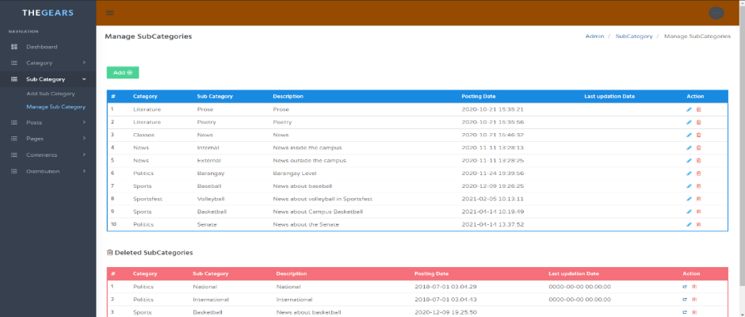

**Figure 51.** Shows how you can choose among different categories.

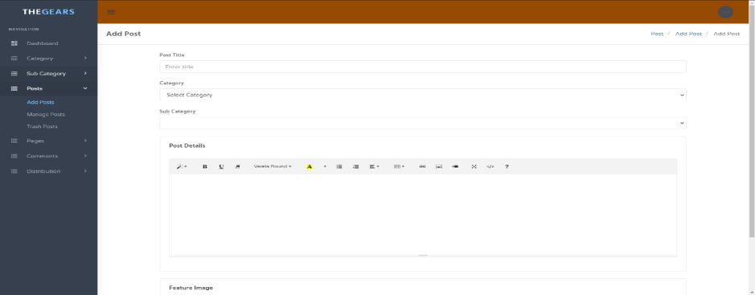Add Post

**Figure 52.** Shows an add post feature where admins can post stuff in the system.

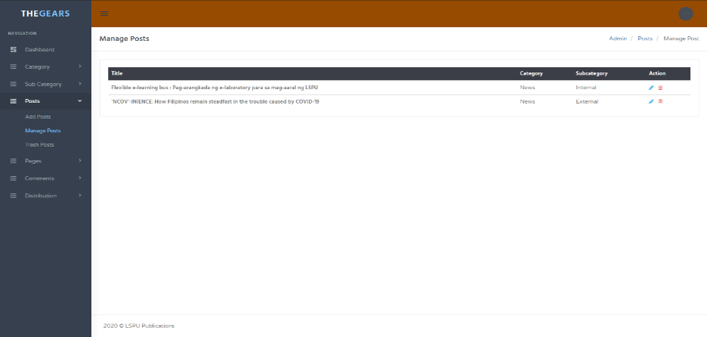Manage Post

**Figure 53.** Shows how people with access to the system can manage posts.

Manage Comment Page

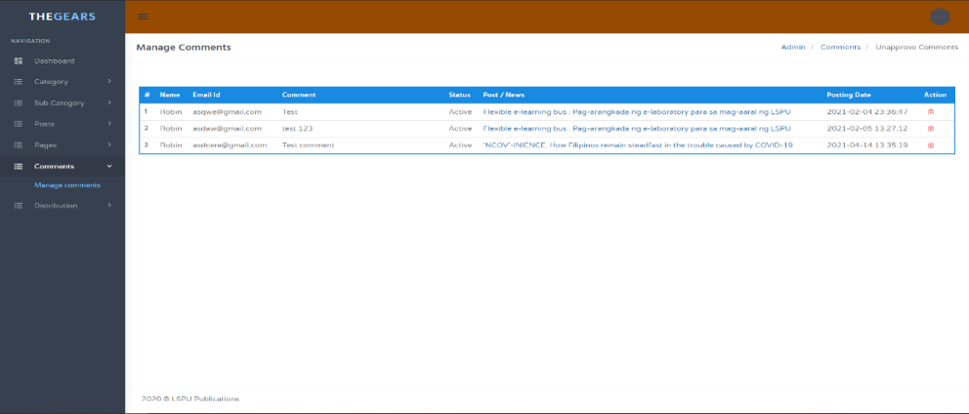

**Figure 54.** Shows how a person with authority can manage the comments in the system.

****Publication Reports Distribution

**Figure 55.** Shows the records of the released published article/news to be distributed.

Distribution Item Page



**Figure 56.** Shows where the items details manage the inventory of distribution articles/news.

Distribution Details Page

**Figure 57**. Shows where they manage the distribution details Client Name, Id, Department, Itemnumber, Item name and Quantity

Client Detail Page

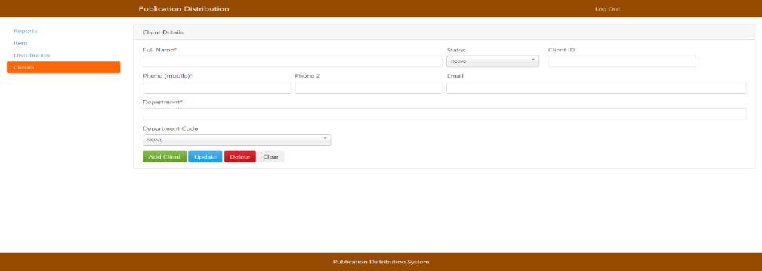

**Figure 58**. Shows where they manage the client details of distribution.

**RELEVANT SOURCE CODE**

</div>

</div>

<div class="form-group account-btn text-center">

<div class="col-xs-12">

<button class="btn w-md btn-bordered btn-danger waves-effect waves-light" type="submit" name="login">Log In</button>

</div>

</div>

</form>

<div class="clearfix"></div>

</div>

</div>

<!-- end card-box-->

</div>

<!-- end wrapper -->

</div>

</div>

</div>

</section>

<!-- END HOME -->

<script>

var resizefunc = [];

</script>

<!-- jQuery -->

<script src="assets/js/jquery.min.js"></script>

<script src="assets/js/bootstrap.min.js"></script>

<script src="assets/js/detect.js"></script>

<script src="assets/js/fastclick.js"></script>

<script src="assets/js/jquery.blockUI.js"></script>

<script src="assets/js/waves.js"></script>

<script src="assets/js/jquery.slimscroll.js"></script>

<script src="assets/js/jquery.scrollTo.min.js"></script>

<!-- App js -->

<script src="assets/js/jquery.core.js"></script>

<script src="assets/js/jquery.app.js"></script>

href="assets/css/responsive.css" rel="stylesheet" type="text/css" />

<script src="assets/js/modernizr.min.js"></script>

</head>

<body class="bg-transparent" style="background-image: url(../images/bg1.png); background-repeat: no-repeat;

background-attachment: fixed; background-position: bottom right;">

<!-- HOME -->

<style>

.account-logo-box{

background-color: #964B00;

}

</style>

<section>

<div class="container-alt">

<div class="row">

<div class="col-sm-12">

<div class="wrapper-page">

<div class="m-t-40 account-pages">

<div class="text-center account-logo-box">

<h2 class="text-uppercase">

<a href="../" class="text-success">

<span><img src="assets/images/thegearslogin.png" alt="" height="56"></span>

</a>

</h2>

<!--<h4 class="text-uppercase font-bold m-b-0">Sign In</h4>-->

</div>

<div class="account-content">

<form class="form-horizontal" method="post">

<div class="form-group ">

<div class="col-xs-12">

<input class="form-control" type="text" required="" name="username" placeholder="Username or email" autocomplete="off">

</div>

</div>

<div class="form-group">

<div class="col-xs-12">

<input class="form-control" type="password" name="password" required="" placeholder="Password" autocomplete="off">

<div class="form-group account-btn text-center">

<div class="col-xs-12">

<button class="btn w-md btn-bordered btn-danger waves-effect waves-light" type="submit" name="login">Log In</button>

</div>

</div>

<?php

session_start();

//Database Configuration File

include('includes/config.php');

//error_reporting(0);

if(isset($_POST['login']))

{

// Getting username/ email and password

$uname=$_POST['username'];

$password=$_POST['password'];

// Fetch data from database on the basis of username/email and password

$sql =mysqli_query($con,"SELECT AdminUserName,AdminEmailId,AdminPassword FROM tbladmin WHERE (AdminUserName='$uname' || AdminEmailId='$uname')");

$num=mysqli_fetch_array($sql);

if($num>0)

{

$hashpassword=$num['AdminPassword']; // Hashed password fething from database

//verifying Password

if (password_verify($password, $hashpassword)) {

$_SESSION['login']=$_POST['username'];

echo "<script type='text/javascript'> document.location = 'dashboard.php'; </script>";

} else {

echo "<script>alert('Wrong Password');</script>";

}

}

//if username or email not found in database

else{

echo "<script>alert('User not registered with us');</script>";

}

}

?>

<!DOCTYPE html>

<html lang="en">

<head>

<meta charset="utf-8">

<meta name="viewport" content="width=device-width, initial-scale=1.0">

<meta name="description" content="News Portal.">

<!-- App title -->

<title>LSPU Publications | Admin Panel</title>

<!-- App css -->

<link href="assets/css/bootstrap.min.css" rel="stylesheet" type="text/css" />

<link href="assets/css/core.css" rel="stylesheet" type="text/css" />

<link href="assets/css/components.css" rel="stylesheet" type="text/css" />

<link href="assets/css/icons.css" rel="stylesheet" type="text/css" />

<link href="assets/css/pages.css" rel="stylesheet" type="text/css" />

<link href="assets/css/menu.css" rel="stylesheet" type="text/css" />

<link

</div>

</div>

</div>

<!-- end row -->

<div class="row">

<a href="manage-categories.php">

<div class="col-lg-4 col-md-4 col-sm-6">

<div class="card-box widget-box-one">

<i class="mdi mdi-chart-areaspline widget-one-icon"></i>

<div class="wigdet-one-content">

<p class="m-0 text-uppercase font-600 font-secondary text-overflow" title="Statistics">Categories Listed</p>

<?php $query=mysqli_query($con,"select * from tblcategory where Is_Active=1");

$countcat=mysqli_num_rows($query);

?>

<h2><?php echo htmlentities($countcat);?> <small></small></h2>

</div>

</div>

</div></a><!-- end col -->

<a href="manage-subcategories.php">

<div class="col-lg-4 col-md-4 col-sm-6">

<div class="card-box widget-box-one">

<i class="mdi mdi-layers widget-one-icon"></i>

<div class="wigdet-one-content">

<p class="m-0 text-uppercase font-600 font-secondary text-overflow" title="User This Month">Listed Subcategories</p>

<?php $query=mysqli_query($con,"select * from tblsubcategory where Is_Active=1");

$countsubcat=mysqli_num_rows($query);

?>

<h2><?php echo htmlentities($countsubcat);?> <small></small></h2>

</div>

</div>

</div><!-- end col -->

</a>

<a href="manage-posts.php">

lass="m-0 text-uppercase font-600 font-secondary text-overflow" title="User This Month">Live News</p>

<?php $query=mysqli_query($con,"select * from tblposts where Is_Active=1");

$countposts=mysqli_num_rows($query);

?>

<h2><?php echo htmlentities($countposts);?> <small></small></h2>

</div>

</div>

</div><!-- end col -->

</a>

class="mdi mdi-layers"></i></a>

<!-- Image logo -->

<!--<a href="index.html" class="logo">-->

<!--<span>-->

<!--<img src="assets/images/logo.png" alt="" height="30">-->

<!--</span>-->

<!--<i>-->

<!--<img src="assets/images/logo_sm.png" alt="" height="28">-->

<!--</i>-->

<!--</a>-->

</div>

<!-- Button mobile view to collapse sidebar menu -->

<?php include('includes/topheader.php');?>

</div>

<!-- Top Bar End -->

<!-- ========== Left Sidebar Start ========== -->

<?php include('includes/leftsidebar.php');?>

<!-- Left Sidebar End -->

<!-- ============================================================== -->

<!-- Start right Content here -->

<!-- ============================================================== -->

<div class="content-page">

<!-- Start content -->

<div class="content">

<div class="container">

<div class="row">

<div class="col-xs-12">

<div class="page-title-box">

<h4 class="page-title">Dashboard</h4>

<ol class="breadcrumb p-0 m-0">

<li>

<a href="../">The Gears Publications</a>

</li>

<li>

<a href="#">Admin</a>

</li>

<li class="active">

Dashboard

</li>

</ol>

<div class="clearfix"></div>

</body>

</html>

<?php

session_start();

include('includes/config.php');

error_reporting(0);

if(strlen($_SESSION['login'])==0)

{

header('location:index.php');

}

else{

?>

<!DOCTYPE html>

<html lang="en">

<head>

<meta charset="utf-8">

<meta name="viewport" content="width=device-width, initial-scale=1.0">

<meta name="description" content="A fully featured admin theme which can be used to build CRM, CMS, etc.">

<meta name="author" content="Coderthemes">

<!-- App title -->

<title>News Portal | Dashboard</title>

<link rel="stylesheet" href="../plugins/morris/morris.css">

<!-- App css -->

<link href="assets/css/bootstrap.min.css" rel="stylesheet" type="text/css" />

<link href="assets/css/core.css" rel="stylesheet" type="text/css" />

<link href="assets/css/components.css" rel="stylesheet" type="text/css" />

<link href="assets/css/icons.css" rel="stylesheet" type="text/css" />

<link href="assets/css/pages.css" rel="stylesheet" type="text/css" />

<link href="assets/css/menu.css" rel="stylesheet" type="text/css" />

<link href="assets/css/responsive.css" rel="stylesheet" type="text/css" />

<link rel="stylesheet" href="../plugins/switchery/switchery.min.css">

<script src="assets/js/modernizr.min.js"></script>

</head>

<body class="fixed-left">

<!-- Begin page -->

<div id="wrapper">

<!-- Top Bar Start -->

<div class="topbar">

<!-- LOGO -->

<div class="topbar-left">

<a href="index.html"

<p class="m-b-0 text-muted"><small>Show your status to all</small></p>

</div>

<div class="col-xs-4 text-right">

<input type="checkbox" checked data-plugin="switchery" data-color="#7fc1fc" data-size="small"/>

</div>

</div>

</div>

</div>

<!-- /Right-bar -->

</div>

<!-- END wrapper -->

<script>

var resizefunc = [];

</script>

<!-- jQuery -->

<script src="assets/js/jquery.min.js"></script>

<script src="assets/js/bootstrap.min.js"></script>

<script src="assets/js/detect.js"></script>

<script src="assets/js/fastclick.js"></script>

<script src="assets/js/jquery.blockUI.js"></script>

<script src="assets/js/waves.js"></script>

<script src="assets/js/jquery.slimscroll.js"></script>

<script src="assets/js/jquery.scrollTo.min.js"></script>

<script src="../plugins/switchery/switchery.min.js"></script>

<!-- Counter js -->

<script src="../plugins/waypoints/jquery.waypoints.min.js"></script>

<script src="../plugins/counterup/jquery.counterup.min.js"></script>

<!--Morris Chart-->

<script src="../plugins/morris/morris.min.js"></script>

<script src="../plugins/raphael/raphael-min.js"></script>

<!-- Dashboard init -->

<script src="assets/pages/jquery.dashboard.js"></script>

<!-- App js -->

<script src="assets/js/jquery.core.js"></script>

<script src="assets/js/jquery.app.js"></script>

</body>

</html>

<?php } ?>

<?php

session_start();

include('includes/config.php');

error_reporting(0);

if(strlen($_SESSION['login'])==0)

<!-- Right Sidebar -->

<div class="side-bar right-bar">

<a href="javascript:void(0);" class="right-bar-toggle">

<i class="mdi mdi-close-circle-outline"></i>

</a>

<h4 class="">Settings</h4>

<div class="setting-list nicescroll">

<div class="row m-t-20">

<div class="col-xs-8">

<h5 class="m-0">Notifications</h5>

<p class="text-muted m-b-0"><small>Do you need them?</small></p>

</div>

<div class="col-xs-4 text-right">

<input type="checkbox" checked data-plugin="switchery" data-color="#7fc1fc" data-size="small"/>

</div>

</div>

<div class="row m-t-20">

<div class="col-xs-8">

<h5 class="m-0">API Access</h5>

<p class="m-b-0 text-muted"><small>Enable/Disable access</small></p>

</div>

<div class="col-xs-4 text-right">

<input type="checkbox" checked data-plugin="switchery" data-color="#7fc1fc" data-size="small"/>

</div>

</div>

<div class="row m-t-20">

<div class="col-xs-8">

<h5 class="m-0">Auto Updates</h5>

<p class="m-b-0 text-muted"><small>Keep up to date</small></p>

</div>

<div class="col-xs-4 text-right">

<input type="checkbox" checked data-plugin="switchery" data-color="#7fc1fc" data-size="small"/>

</div>

</div>

<div class="row m-t-20">

<div class="col-xs-8">

<h5 class="m-0">Online Status</h5>

<div class="col-lg-4 col-md-4 col-sm-6">

<div class="card-box widget-box-one">

<i class="mdi mdi-layers widget-one-icon"></i>

<div class="wigdet-one-content">

<p class="m-0 text-uppercase font-600 font-secondary text-overflow" title="User This Month">Live News</p>

<?php $query=mysqli_query($con,"select * from tblposts where Is_Active=1");

$countposts=mysqli_num_rows($query);

?>

<h2><?php echo htmlentities($countposts);?> <small></small></h2>

</div>

</div>

</div><!-- end col -->

</a>

</div>

<!-- end row -->

<div class="row">

<a href="trash-posts.php"> <div class="col-lg-4 col-md-4 col-sm-6">

<div class="card-box widget-box-one">

<i class="mdi mdi-layers

text-overflow" title="User This Month">Trash News</p>

<?php $query=mysqli_query($con,"select * from tblposts where Is_Active=0");

$countposts=mysqli_num_rows($query);

?>

<h2><?php echo htmlentities($countposts);?> <small></small></h2>

</div>

</div>

</div></a>

</div>

</div> <!-- container -->

</div> <!-- content -->

<?php include('includes/footer.php');?>

</div>

<!-- ============================================================== -->

<!-- End Right content here -->

<!-- ============================================================== -->

<hr />

<div class="row">

<div class="col-sm-6">

<!---Success Message--->

<?php if($msg){ ?>

<div class="alert alert-success" role="alert">

<strong>Well done!</strong> <?php echo htmlentities($msg);?>

</div>

<?php } ?>

<!---Error Message--->

<?php if($error){ ?>

<div class="alert alert-danger" role="alert">

<strong>Oh snap!</strong> <?php echo htmlentities($error);?></div>

<?php } ?>

</div>

</div> <div class="row">

<div class="col-md-6">

<form class="form-horizontal" name="category" method="post">

<div class="form-group">

<label class="col-md-2 control-label">Category</label>

<div class="col-md-10">

<input type="text" class="form-control" value="" name="category" required>

</div>

</div>

<div class="form-group">

<label class="col-md-2 control-label">Category Description</label>

<div class="col-md-10">

<textarea class="form-control" rows="5" name="description" required></textarea>

</div>

</div>

<div class="form-group">

<label class="col-md-2 control-label">&nbsp;</label>

<div class="col-md-10">

<button type="submit" class="btn btn-custom waves-effect waves-light btn-md" name="submit">

Submit

</button>

</div>

script>

</head>

<body class="fixed-left">

<!-- Begin page -->

<div id="wrapper">

<!-- Top Bar Start -->

<?php include('includes/topheader.php');?>

<!-- Top Bar End -->

<!-- ========== Left Sidebar Start ========== -->

<?php include('includes/leftsidebar.php');?>

<!-- Left Sidebar End -->

<div class="content-page">

<!-- Start content -->

<div class="content">

<div class="container">

<div class="row">

<div class="col-xs-12">

<div class="page-title-box">

<h4 class="page-title">Add Category</h4>

<ol class="breadcrumb p-0 m-0">

<li>

<a href="#">Admin</a>

</li>

<li>

<a href="#">Category </a>

</li>

<li class="active">

Add Category

</li>

</ol>

<div class="clearfix"></div>

</div>

</div>

</div>

<!-- end row -->

<div class="row">

<div class="col-sm-12">

<div class="card-box">

<h4 class="m-t-0 header-title"><b>Add Category </b></h4>

-sm-6">

<!---Success Message--->

<?php if($msg){ ?>

<script src="assets/js/jquery.app.js"></script>

</body>

</html>

<?php } ?>

<?php

session_start();

include('includes/config.php');

error_reporting(0);

if(strlen($_SESSION['login'])==0)

{

header('location:index.php');

}

else{

if(isset($_POST['submit']))

{

$category=$_POST['category'];

$description=$_POST['description'];

$status=1;

$query=mysqli_query($con,"insert into tblcategory(CategoryName,Description,Is_Active) values('$category','$description','$status')");

if($query)

{

$msg="Category created ";

}

else{

$error="Something went wrong . Please try again.";

}

}

?>

<!DOCTYPE html>

<html lang="en">

<head>

<title>Newsportal | Add Category</title>

<!-- App css -->

<link href="assets/css/bootstrap.min.css" rel="stylesheet" type="text/css" />

<link href="assets/css/core.css" rel="stylesheet" type="text/css" />

<link href="assets/css/components.css" rel="stylesheet" type="text/css" />

<link href="assets/css/icons.css" rel="stylesheet" type="text/css" />

<link href="assets/css/pages.css" rel="stylesheet" type="text/css" />

<link href="assets/css/menu.css" rel="stylesheet" type="text/css" />

<link href="assets/css/responsive.css" rel="stylesheet" type="text/css" />

<link rel="stylesheet" href="../plugins/switchery/switchery.min.css">

<script src="assets/js/modernizr.min.js"></

<div id="wrapper">

<!-- Top Bar Start -->

<?php include('includes/topheader.php');?>

<!-- ========== Left Sidebar Start ========== -->

<?php include('includes/leftsidebar.php');?>

<!-- Left Sidebar End -->

<!-- ============================================================== -->

<!-- Start right Content here -->

<!-- ============================================================== -->

<div class="content-page">

<!-- Start content -->

<div class="content">

<div class="container">

<div class="row">

<div class="col-xs-12">

<div class="page-title-box">

<h4 class="page-title">Manage Categories</h4>

<ol class="breadcrumb p-0 m-0">

<li>

<a href="#">Admin</a>

</li>

<li>

<a href="#">Category </a>

</li>

<li class="active">

Manage Categories

</li>

</ol>

<div class="clearfix"></div>

</div>

</div>

</div>

<!-- end row -->

<div class="row">

<div class="col-sm-6">

<?php if($msg){ ?>

<div class="alert alert-success" role="alert">

{

$query=mysqli_query($con,"update tblcategory set Is_Active='0' where id='$id'");

$msg="Category deleted ";

}

// Code for restore

if($_GET['resid'])

{

$id=intval($_GET['resid']);

$query=mysqli_query($con,"update tblcategory set Is_Active='1' where id='$id'");

$msg="Category restored successfully";

}

// Code for Forever deletionparmdel

if($_GET['action']=='parmdel' && $_GET['rid'])

{

$id=intval($_GET['rid']);

$query=mysqli_query($con,"delete from tblcategory where id='$id'");

$delmsg="Category deleted forever";

}

?>

<!DOCTYPE html>

<html lang="en">

<head>

<title> | Manage Categories</title>

<link href="assets/css/bootstrap.min.css" rel="stylesheet" type="text/css" />

<link href="assets/css/core.css" rel="stylesheet" type="text/css" />

<link href="assets/css/components.css" rel="stylesheet" type="text/css" />

<link href="assets/css/icons.css" rel="stylesheet" type="text/css" />

<link href="assets/css/pages.css" rel="stylesheet" type="text/css" />

<link href="assets/css/menu.css" rel="stylesheet" type="text/css" />

<link href="assets/css/responsive.css" rel="stylesheet" type="text/css" />

<link rel="stylesheet" href="../plugins/switchery/switchery.min.css">

<script src="assets/js/modernizr.min.js"></script>

</head>

<body class="fixed-left">

<!-- Begin page -->

</div>

</form>

</div>

</div>

</div>

</div>

</div>

<!-- end row -->

</div> <!-- container -->

</div> <!-- content -->

<?php include('includes/footer.php');?>

</div>

</div>

<script>

var resizefunc = [];

</script>

<!-- jQuery -->

<script src="assets/js/jquery.min.js"></script>

<script src="assets/js/bootstrap.min.js"></script>

<script src="assets/js/detect.js"></script>

<script src="assets/js/fastclick.js"></script>

<script src="assets/js/jquery.blockUI.js"></script>

<script src="assets/js/waves.js"></script>

<script src="assets/js/jquery.slimscroll.js"></script>

<script src="assets/js/jquery.scrollTo.min.js"></script>

<script src="../plugins/switchery/switchery.min.js"></script>

<!-- App js -->

<script src="assets/js/jquery.core.js"></script>

<script src="assets/js/jquery.app.js"></script>

</body>

</html>

<?php } ?>

<?php

session_start();

include('includes/config.php');

error_reporting(0);

if(strlen($_SESSION['login'])==0)

{

header('location:index.php');

}

else{

if($_GET['action']=='del' && $_GET['rid'])

$id=intval($_GET['rid']);

**REQUEST LETTER**

Republic of the Philippines

Laguna State Polytechnic University

Province of Laguna

March, 06 ,2020

Susanna Rose A. Labastilla

Coordinator, The Gears

Dear Mr./Ms. Susanna Labastilla,

We are the students of Computer Studies taking the Bachelor of Science in Information Technology from Laguna State Polytechnic University Santa Cruz Campus. As part of our requirements for the subject ITEP 313 (Methods of Research in IT) we are asked to construct a system that will possibly at the same time could help us with our subject requirement. This will also beneficial for your concern by providing you a system that may help your business be organized and well-managed.

Apart to this, we are requesting your good office to allow us to have our initial study including interview and observation for us to understand your problem and process. We assure you that whatever information will be given to us will be confidential and will be only be used for this project.

We are hoping for your kind and consideration. Thank you and Godbless!

Respectfully Yours,

Dy, Jeal Ann

Maceda, Ericca P.

Reyes, Robin

Approved by:

Villarica, Mia V,. DIT Susanna Rose Labastilla, MAED/LPT

MOR Instructor The Gears, Coordinator

**PROPOSAL APPROVAL**

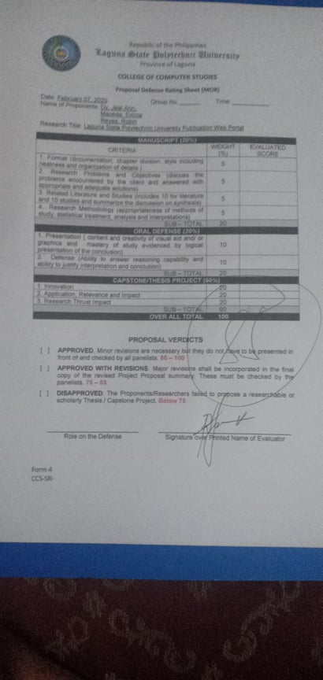



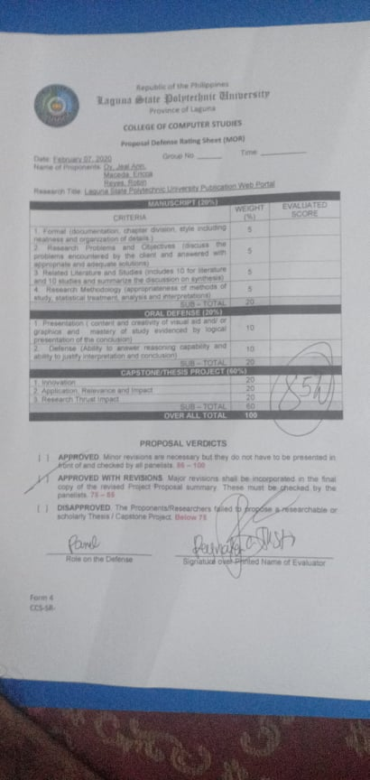

**RECOMMENDATION FOR FINAL ORAL DEFENSE**

**SUMMARY OF RECOMMENDATIONS**

**Final Oral Defense**

**Working Title:** **The Gears Online Publication**

**Group code: E07**

**Students: Dy, Jeal Ann E.**

**Maceda, Ericca P.**

**Reyes, Robin J.**

**Section: BSIT-4E**

**SCHEDULE: Thursday December 10, 2020 9:30**

Day Date Time

**LOCATION:** Via Gmeet

|  |  |  |
| --- | --- | --- |
| **Panel Member** | **Comments/Recommendations/Suggestions** | **Status** |
| Alliana M. Miranda | * Page number * Chapter 1 introduction only * Remove 2nd paragraph * How can technology help the gears? * Improve project context * How can you determine the possible advantages? * How can you create a solution on the lack of outputs * Explain conceptual framework * Introduce scope * Follow APA format * RRL is not explained * There’s RRL with no titles. * Arrange RRL’s by themes * Improve RRL * Remove the approval of the admin when commenting * Synthesis must present everything in chapter 2 * Research design and descriptive developmental * No references * Improve interface | All Edited |
| Ronnel Virticio | * Posting and monitoring * Updating and inventory of published and released articles * Distribution of the finish. |  |
| Mia Vilarica | * Inventory * Talk to the client * Understand the problem well * Analyze the problem * Improve the system |  |
| Maria Laureen B. Miranda | * Improve Interface |  |

Checked by:

|  |  |  |
| --- | --- | --- |
| ________________________  Maria Laureen B. Miranda  Panel Member | ________________________  Alliana M. Miranda  Panel Member |  |

|  |  |
| --- | --- |
| ________________________  Dr. Mia Villarica  Panel Member | ________________________  Reynalen C. Justo  Panel Member |

|  |  |
| --- | --- |
| ________________________  Ronnel Virtucio  Panel Member |  |

|  |  |
| --- | --- |
|  |  |
|  |  |

Noted by:

|  |  |
| --- | --- |
| _________________________  Dr. Mia Villarica  Advise | ______________________________  Reynalen C. Justo  Associate Dean |

**OPERATIONAL TERMS**

The proposed system has the following terms that has been operationally defined for a better understanding of the study

|  |  |
| --- | --- |
| **Database Schema** | We used this logically group objects such as tables, views, stored, procedures etc. |
| **Data Dictionary** | This were we described the contents, format and structure of a database and the relationship between its elements, used to control access to and manipulation of the database. |
| **Data Flow Diagrams** | We used this as graphical representation of the flow of data through an information system and modelling its proper aspects. |
| **Fishbone Diagram** | It refers to the visualization tool for categorizing the potential causes of a problem in order to identify its root causes. |
| **Process Flow Chart** | It is a diagram of the sequence of movements or actions of people or things involved in a complex system or activity. |
| **Project Schedule** | This chart was used in order to show the amount of work done or production completed in certain period of time. |
| **Use Case Diagram** | It is a presentation of a user’s interaction with the system that shows the relationship between the user and the different use cases in which the user is involved. |
| **System Context Diagram** | It defines the boundary between the system or part of the system. |

**TECHNICAL TERMS**

|  |  |
| --- | --- |
| **Computer** | This refer to an electronic device that accepts, processes, stores and outputs data at high speeds according to programmed instructions. |
| **HTML** | It is the standard markup language for creating web pages. |
| **JAVASCRIPT** | This refer to a programming language used in web development |
| **PHP** | It is a general-purpose scripting language especially suited to web development. |
| **Prototype** | An early sample, model, or release of a product built to test a concept or process. It is a term used in a variety of contexts, including semantics, design, electronics, and software programming |
| **Sublime** | this refer to a sophisticated text editor for code, markup and prose. |
| **Technology** | This refers to a broad term that refers both to artifacts created by humans, such as machines and the methods used to create those artifacts. |
| **Weighted Mean** | A weighted mean is a kind of average. Instead of each data point contributing equally to the final mean, some data points contribute more weight than others. |
| **XAMPP** | This refers to a broad term that refers both to artifacts created by humans, such as machines and the methods used to create those artifacts. |

**CURRICULUM VITAE**



Jeal Ann E. Dy

**Blk8 Lot20 Villa Concepcion, Brgy. Bagong Pook Pila, Laguna**

**0967 362 6907/0998 454 6659**

[**ann.jeal03@gmail.com**](mailto:ann.jeal03@gmail.com)

**Objective:** To work with a reputed organization in a position where I can develop and utilize my skill and prove my worth.

**PERSONAL INFORMATION**

Birthday: September 10, 1997

Gender: Female

Civil Status: Single

Religion: Christian (IFI)

Height: 5’0

Weight: 45kg

**EDUCATIONAL BACKGROUND**

TERTIARY Laguna State Polytechnic University (Sta Cruz-Main)

Bachelor of Science in Information Technology

(Present)

SECONDARY Pedro Guevara Memorial National Highschool

Sta Cruz, Laguna

2014-2014

PRIMARY Duhat Elementary School

Duhat Sta Cruz, Laguna

2009-2010

**SKILLS AND COMPETENCE**

* Computer Literate
* Proficient in Microsoft Word, Excel, and Powerpoint
* Good Interpersonal Skill
* Fast Learner with positive attitude

**CHARACTER REFERENCE**

Nico Jay S. Delgado

DEMO II

Regional Trial Court

Siniloan, Laguna

0906 756 3479

|  |
| --- |
|  |

**I hereby certify that the above information is true and correct to the best of my knowledge and belief.**

**Dy, Jeal Ann E.**



**ERICCA P. MACEDA**

Address: Poblacion Uno, Garcia Street Pagsanjan, Laguna

Mobile No:09465378336

Email: ericcamaceda171808@gmail.com

**OBJECTIVE** To acquire more knowledge in the field of Information Technology and use my educational background, organizational and leadership skills and my ability to work with other people in contributing to the company**.**

**PERSONAL INFORMATION:**

**Date of Birth:** April 21,1997

**Place of Birth:** Pagsanjan, Laguna

**Age:** 24

**Sex:** Female

**Civil Status:** Single

**Religion:** Roman Catholic

**Nationality:** Filipino

**Mother’s Name:** Corazon P. Maceda

**Father’s Name:** Ricardo A. Maceda

**EDUCATIONAL ATTAINMENT**

**TERTIARY:**

**LAGUNA STATE POLYTECHNIC UNIVERSITY**

Bachelor of Science in Information Technology

Santa Cruz, Laguna

2018 – 2021

**SECONDARY:**

**PAGSANJAN NATIONAL HIGH SCHOOL**

2010 - 2013

**ELEMENTARY:**

**Francisco Benitez Memorial School**

2004- 2010

**SKILLS and ABILITIES**

**Hard Skills**

HTML/CSS

Microsoft Office (Word, PPT, Excel)

**Soft Skills**

Commitment

Creativity

Decision Making

Dependability

Integrity

Motivation and Support

Problem-Solving

Team Player

Willingness to Learn

Fast learner

**CHARACTER REFFERENCES**

**MIA V. VILLARICA**

Professor

Laguna State Polytechnic University - SCC

**ALLIANA M. ABLAN**

Professor

Laguna State Polytechnic University - SCC

**CHERRY M. CARPIO**

Professor

Laguna State Polytechnic University - SCC

I hereby certify that the above information is true and correct to the best of my knowledge and belief.

**Maceda Ericca P.**



**ROBIN J. REYES**

**Address:** 02-053 Sitio Bagong Lipunan, Brgy. Duhat, Sta. Cruz, Laguna

**Mobile no:** 09494407093

**Email:** robinreyes.j14@gmail.com

**OBJECTIVE** To acquire more knowledge in the field of Information Technology and use my educational background, organizational and leadership skills and my ability to work with other people in contributing to the company**.**

**PERSONAL INFORMATION:**

**Date of Birth:** July 14, 1996

**Place of Birth:** Pasay City

**Age:** 24

**Sex:** Male

**Civil Status:** Single

**Religion:** Roman Catholic

**Nationality:** Filipino

**Mother’s Name:** Maria Belen C. Jazul

**Father’s Name:** Reynante A. Reyes

**EDUCATIONAL ATTAINMENT**

**TERTIARY:**

**LAGUNA STATE POLYTECHNIC UNIVERSITY**

Bachelor of Science in Information Technology

Santa Cruz, Laguna

2018 – 2021

**SECONDARY:**

**FELICISIMO T. SAN LUIS NATIONAL HIGH SCHOOL**

Brgy. Bubukal, Sta. Cruz, Laguna

2009-2013

**ELEMENTARY:**

**DUHAT ELEMENTARY SCHOOL**

Brgy. Duhat, Sta. Cruz, Laguna

2005-2009

**SKILLS AND ABILITIES**

**Microsoft Office Applications**

* Microsoft Word
* Microsoft Power Point
* Microsoft Excel

**Editing Softwares**

* Adobe Photoshop
* Adobe Lightroom
* Adobe Premiere Pro

**Basic Knowledge in Programing**

* C#
* HTML
* PHP
* CSS

**CHARACTER REFFERENCES**

**Mrs. Gualolarina C. Fernandez**

* Guidance Councilor
* Laguna University
* Contact No.: 09371201527 / 09374948691

I hereby certify that the above information is true and correct to the best of my knowledge and belief.

**Reyes, Robin J.**